To begin this course let's begin with a definition, that suggests ’social impact strategy is any effort to create public value that is systematic, sustainable and innovative. Effectively creating social imoact is an essential challenge to all organizations regardless of geograohy or sector' (Frumk\n 2020, n.p.).



On this page you will explore wnat social imoact are and why it is a key determinant for the way businesses ooerate in the 21st century.



Please complete the following:

1. Read tne text whot is socrol impact and answer tne questions.
2. Watch tne video not *do you measure* socia/ *impact* and reflect on the questions.



1. Check your understanding by comoleting the missing words activity.

### Readin g s

##### What is ’business' and what is 'social impact’?

here rs one end only one social msponsibifity ct business - to use its resources end engoge in ochvities *designed* to increase rts proofs so long os it



stsys within the *rules o{the game,* tvhich is to soy, engages in open *ond {see* competition without deception or trend."

— Milton Friedman. ('t9ó2). Caoitalism and Freedom. University of Chicago Press

1s this view on the purpose of business stfll accurate?

Over the last 50+ years, consumers, workers, investors and many businesses have come to disagree with tnis famous claim that the sole resoonsibility of business Ts to increase its profits.

This subject looks at how the puroose of business can be driven ay more tnan making money, out by considering social and environmental Impact as part of their core mission.

###### What is a Business?

The Economic Times (20241 defines Business as "an enterorTsing entity or organisation tnat carries out orofessfonal activities.' A business can nave the following characteristics:

* For-profit business entities do business to earn a profit, while non-orofit ones do it for a charitable mTssTon.



* Business ownership includes oartnerships, sole oroprietorshios, corporations, etc.
* Businesses can be small-scale or large-scale.
* Some of the biggest businesses in the world are Amazon and Walmart. What is Social lmpact?

At its core, social impact refers to the positive change organisations or individuals cause in a community, whether on a small local scale or a grand global one. Think of it as tne footprint of kindness and change we leave behind.



Social impact is the effect an individual or organisation's actions have on the social fabric of a community. It‘s a measure of the influence of an individual or group on tne well-being of society as a whole. This can include both positive and negative effects and can be seen locally, nationally, or globally. Organisations and individuals working towards social impact aim to improve the world by addressing social issues and promofing posifive change.



Social impact has historically been around in tne form of philanthrooy for many decades. However, in 1972, Bill Drayton, the father of social enterprise, started a new movement that gave rise to a new social impact approach. As a result, a social impact revolution is taking place, and COVID-19 has accelerated this trend by putting pressure on businesses, impact investors, and philanthropy.



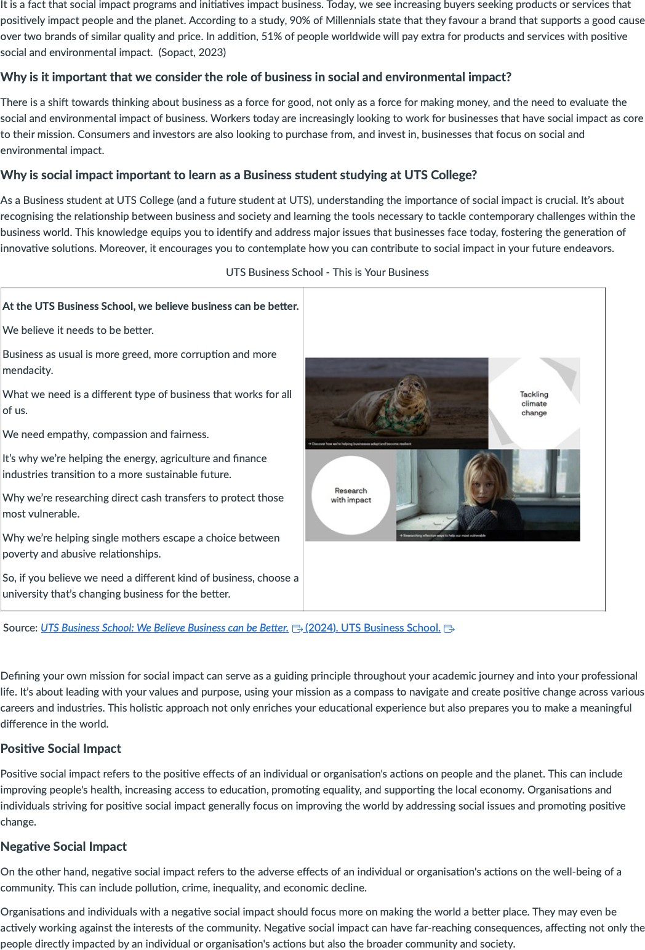 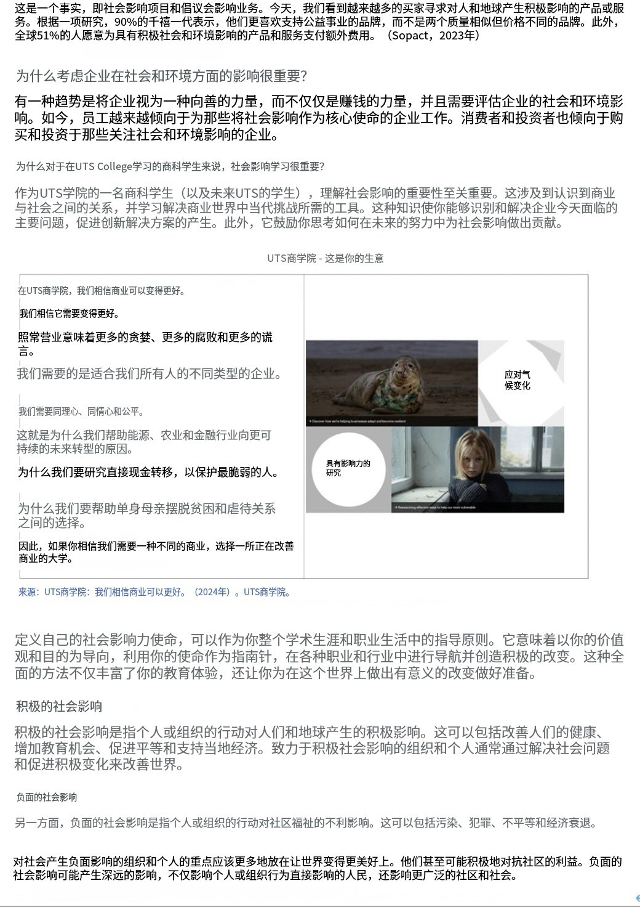

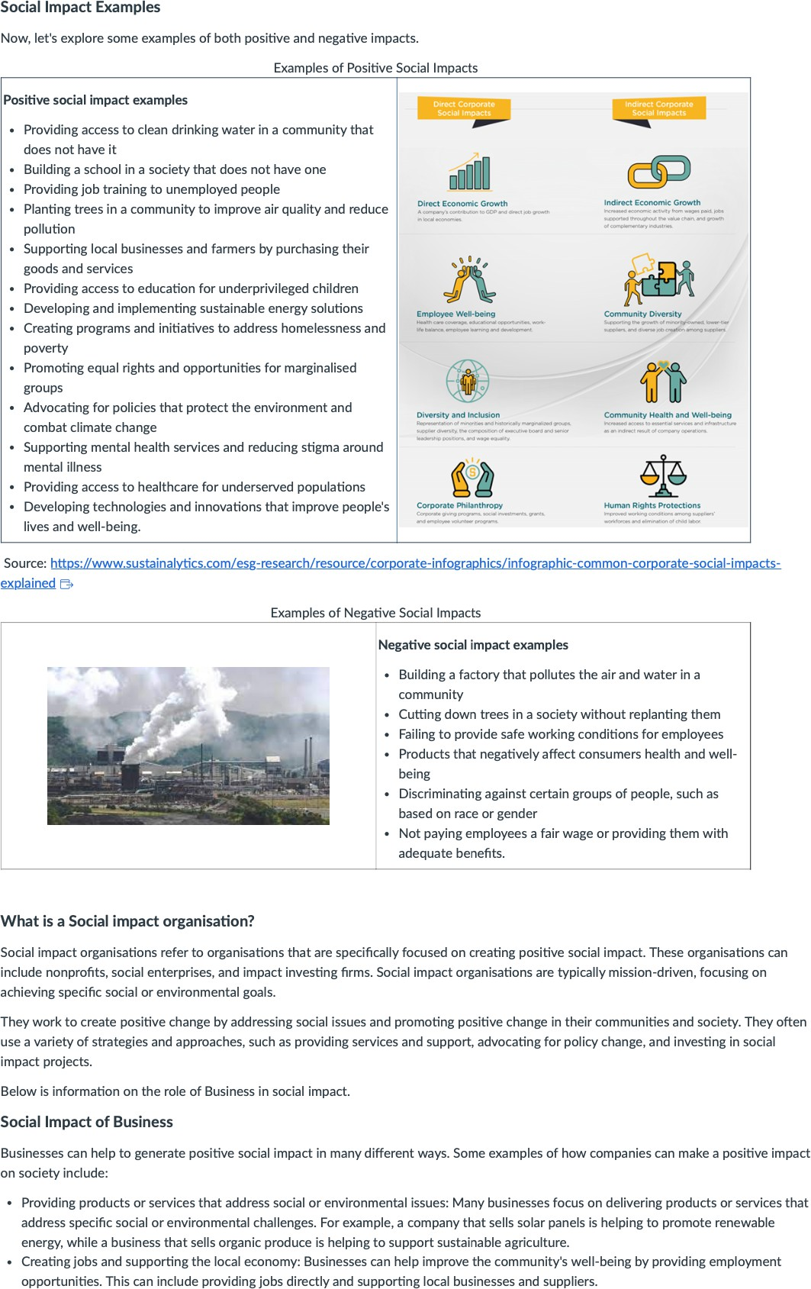 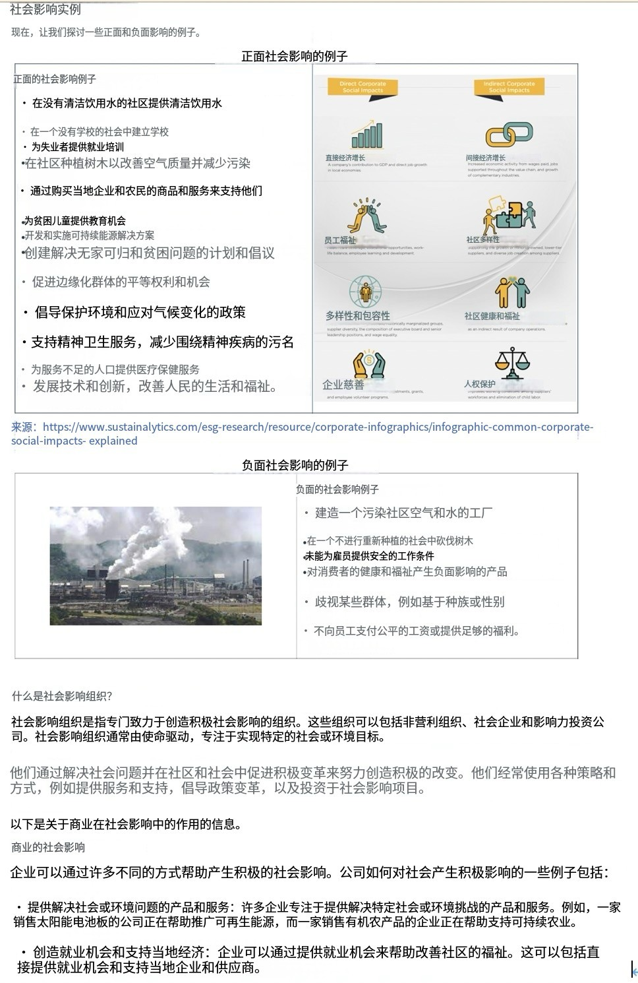

* Giving back to the community: I•1any businesses support their local communities through charitable giving and other forms of philanthropy. This can include financial support to local organisations. volunteering time and resources, and sponsoring community events.
* Promoting diversity and inclusion: By fostering diversity and inclusion @+ within their organisations. businesses can help to promote



Source: Sopact. (2023). J7ie Social Impact Pevo/uhon. Sopact. https / sopact com/social-impact @-

Why Should Businesses care about Social Impact?

*Stephanie Wilson,* from Lighthouse Lobs /WoIker and WI/lioms. 2024a explains some of the benefib ol'Social impact.







8%: Sopact (2023a), #iQA##2, Sopaa.hnps:§ww=sopactcom/soGahimpact



Engaging in social impact goes beyond hav‹ng a positive bottom line. Initiatives that better the world can help build customer bust, “ ' " • ' 202 ) ”

employee engagement. reduce risk and protect brand reputation. When consumers see companies with a solid soc‹aI impact strategy. they y;|tj• pp /g p ${|/g p -|e ${| p[yy p -|- zj gjgg§ jjg pg=gj|g y

are more likely to support your business as they may share your company's demonstrated values. You attract more talent to your company as gl] a/@ \ 'J§-@$§/@@@@B$B'j, ||§/@@T/} } |$$§ , @/||§| J {@/ {$ a/$§ fj|T@§l gg@$gQ;@ gg

* *Eng,aging* customers• Employees want to work for companies with a purpose. Companies with social impact programs have better

employee morale, productivity and retention rates

* Reducing risk: Businesses can reduce reputational, legal and regulatory risks by anticipating and addressing social challenges.
* Protecting brand: Companies with strong social impact programs are more resilient in crises and better able to weather negative

Source: Walker. A. & Williams. S. (2024). Social Impact and its Value for your Business. g g/soctaI-Jotgact-



#### Vid eo

't. To enhance our knowledge on what social impact means to business. please watch and answer the following quesfions on how do you



1. Why is it important for a business to manage social impact*
2. How can social impact be measured in the context of business*

How do you measure Social Impact*

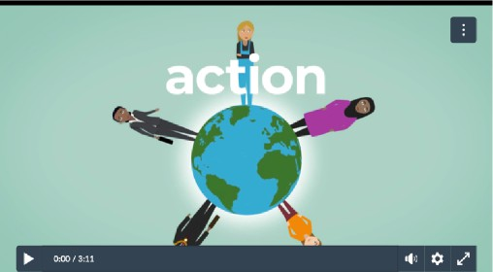

Source: Good Finance. (2Ot9, Dec 19). How do you measure socio/ impact* Video. YouTube. [https•//www.youtube.com/watch*](http://www.youtube.com/watch) v-KDCYc_Oh13g

v Ex nd Aii n Colla se All



"Social impact is the long-term difference your organization makes to the people or places you work in and with. Every organization can have a social impact. but for social enterprises and charities. the impact they create is intentional and fundamental to their governance. They have social impact at their core. Their driving force is to create positive change in order to create a better. fairer world.

Why is it important to manage and measure your social impact* Firsdy. your service users. supporters, funders. and stakeholders will want to know how you're helping improve lives. So it's not just a nice-to-do activity. Measuring impact for social investment is important as social investors consider both financial and social return. Social investors want to use their money to create impact, so they want to

eg: ap, .gIB j ts, S. (202a) , -Loa6pjtbe I jt@ [https://www.lighthouselabs.ca/en/blog/social-impact-business](http://www.lighthouselabs.ca/en/blog/social-impact-business)

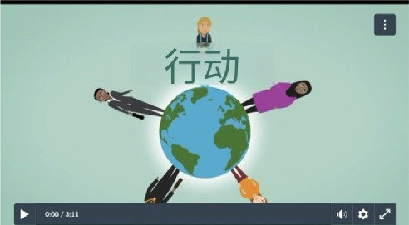



Qifi: Oood Finance. (20l9QlJ 18 ) . gi 11 ifi? YouTube. [https://www.youtube.com/](http://www.youtube.com/) watch? m—KDCYc_0hl3g

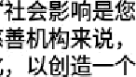



know how their money wi II make a difference. They want to know your social impact Many social investors are even social businesses themselves, so their money may also come from organizahons and individuals motivated by social change.



dlrcc tion It's nOt just about ma naging and measuring your impacI: it's about what yOu do with that information How will you put the



How do you actually measure social impact when th'ere are so many tools, metrics, and techniques* A simple framework is Plan, Do, Review. start ay really p inning down the change you want to make. Plan how to create this desired impact. Use a theory of change to help map this out.





Lastly, review your worK What more do you need to do* What needs to change now* How can you share your results elf ecfively to the right audiences* Focus on your goals. Only measure what you and your stakeholders really value. Measure what's central to your mission. there are no numbers without stories, nor stories without numbers Being able to give real examples alongside numerical data will really



Remember. managing and measuring social impact isn't just impor tant for social investment: it also helps you look at your whole organization and conLinue to improve on your mission.

For more information, visit [www.good finance.org](http://www.goodfinance.org/) uk" @ @@g. &, ia [lâlwww.goodfinance.org.uk"](http://www.goodfinance.org.uk/)

What social and environmental probhems do you think businesses should be addres sing as part of their business mission you can find out by y g y y reaoi ng the bcJow next to better unoerstand why business are nowadays having to incorporate social ano environmental outcomes as part ol j-|-{ ,< ; y

their mission statements.

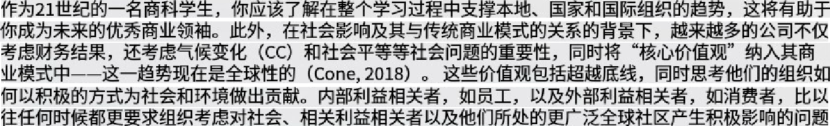As a business student in the 21st century, you should be aware of the trends that underpin local, national and international organisations throughout your studies that will assist you to become a better business leader in the future. Further. in the context of social impacts and its reIat•ionship with traditional business models, there has been a significant uptake of companies who now consider not only financial outcomes, but also consider the importance of social issues such as climate change {CCI and social equality while employing 'core valves' into their business models - thi* trend is now worldwide (Cone. 2018). Such values include Boing beyond the bonom-GnewhitetWnlngabouthowiheirorganIsaGoucontribues1othesoceginaposiGvefahion,andtheenviroumen‹1hey operate in. Internal stakeholders such as staff, and external stakeholders like the consumer, are more than ever, demanding organisations consider issues that impact positively on the society, relevant stakeholders; and the broader global community they

The concept of ‘social impact’ has been incrementally changing our lives during the last decade underpinned by a paradigm shift in attitudes from the consumer to the producer. This includes how we purchase our goods, to how we condMct our operations.



The above challenges are now central to any contemporary business while addressing urgent social issues as previously mentioned. We now see many organisations embracing tne opportunity to make a difference to the way they do business in order to achieve better social outcomes for the society they live in.



* Sodaimpactimpactseveryoneinmanywayswemaynotmalse; Otherlifebmsoneahhcaahohaetechanceotflri:



C hec k y o u r un a e rstan di ng

roar sr oacboox did no‹ conrrm mce. v.ng rn›s o ‹»moz x

Fill in the missing words

Social imoact straleqy is any eflort la create public value that is syslematic. g x sustainable:

The concept ol q x *social impact: is designed to make positive social changes in society

Social imoact created e x :opportunItlee tnat are otharwi6e unavailable to the m nor ties or

Social imoact impacts a a ,everyone in many ways we may not realise

Other D x . IiTeforms on earlh can also have the chance to thrive

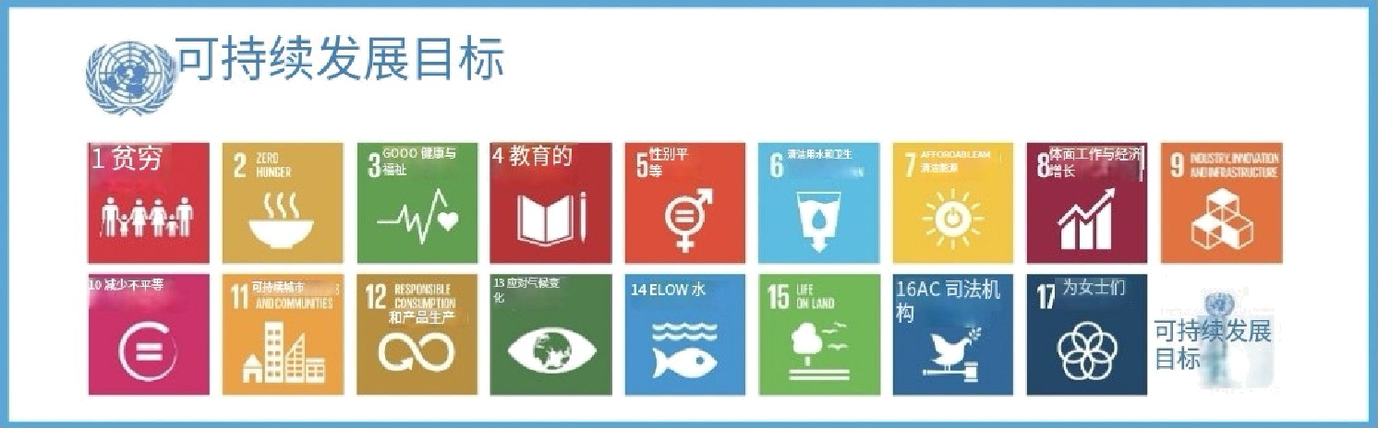On this concept page you will review the Post-2015 (t7) Sustainable Development Goals (SDGsl which are considered the foundations and drivers of sacial impact and businesses across the world. The goals were agreed upon in New York City at the United Nations headquarters by 193 nation-sŁates from across the globe in 2015. The SDGs are intended to improve the lives of every person in both the developing and developed world, underpinned by 21st century sacial issues such as climate change and gender equality.

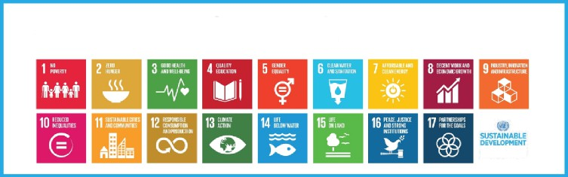

‹ëaDïź á'ê'N'G‹îãALS

G¢2ALS



Please complete the following on Fhis page:

Î. Watch the videD and answer the questions.



1. Read the text and answer the questions.
2. Follow the link and review the 17 SDGs.
3. Complete the true/false questions.

#### Vi deo

The video below outlines the t7 SusŁainable Development (SDGs) Goals. Watch the video and answer Ehe three questions below in the Discussion board.

1. Why is Goal 17 important to business’
2. How can Goal 13 be adopted into your business*
3. Goal 15 is important to our society as a whole, explain.

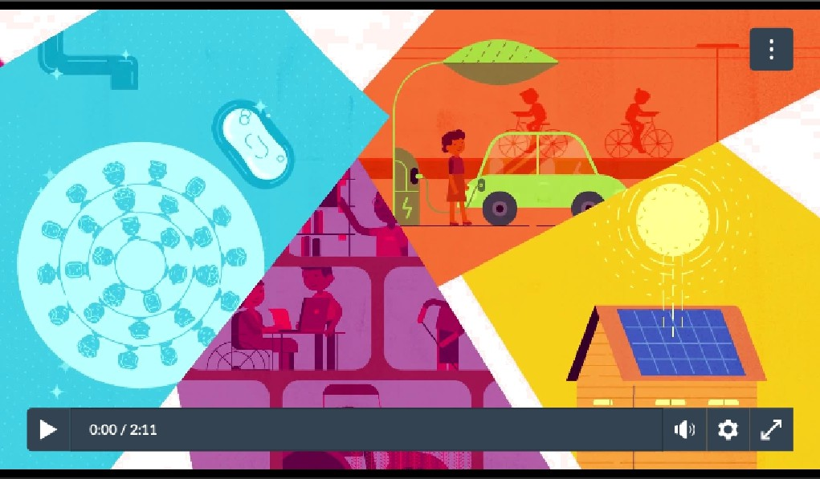

Source: UNICEF Georgia. (201B, April, 25). UN Sustainable Development Goals - Overview. video]. YouTube. [https:/www.youtube.com/watch*v=M-iJMO2m_Hg](http://www.youtube.com/watch)

țß@

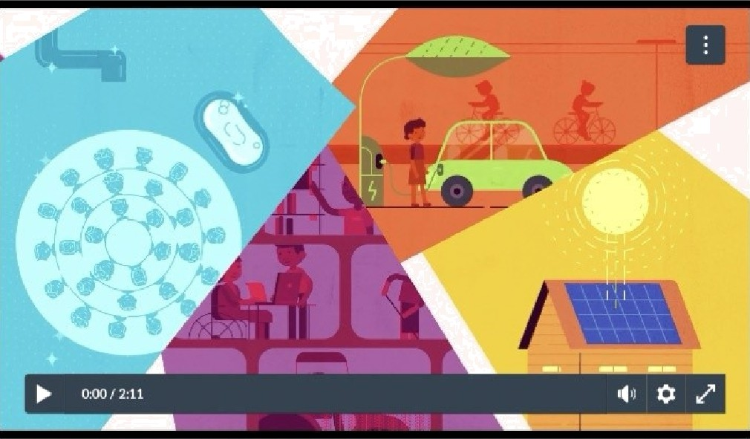



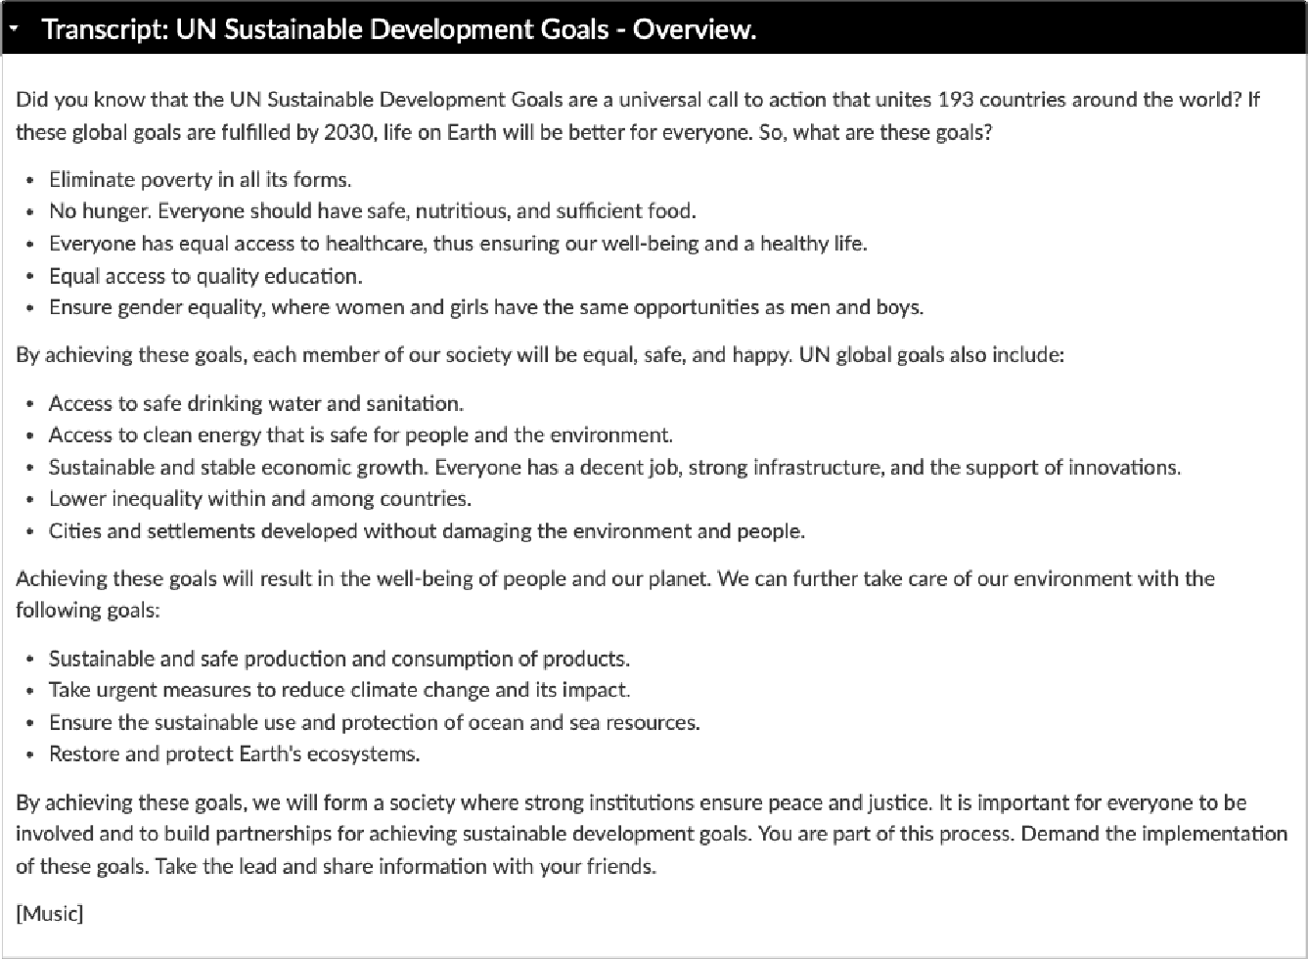 

##### Read ing s

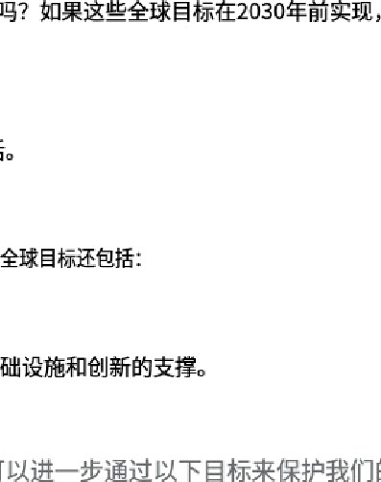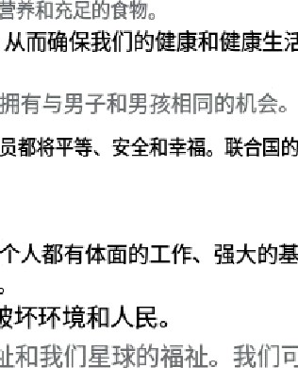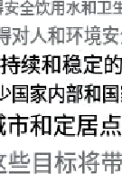

What is Sustainable Development?



In 't987, the United hfntions Brunrlttand Commission. E'• defined sustainability as “meeting ft enaeds of the pzesenf wfttiour compromising the o6i/ify of fufure generoflons to meet ff›e*rowri needs." Today. there are aInx›st 140 devdoping counbles in the world seeking ways of meeting their development needs. but with the increasing threat of dimate change. concrete efforts must be made to ensure development today does not negatively affect future generai•ions.

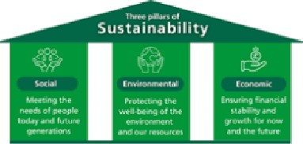

John Elldngton. founder of Sustainability. a British consultancy. coined the phrase 'triple bottom line' in the 1990s. The trlple bottem line is a business concept that states fims should ammit to measuring their social and environmental impact—in addition to their financial performance—lather than solely focusing on generating piofJt. or the standarcl "bottom line.’





1987&,

Bsa

###### }I2@@@&@0}1figj@ (Sanders &Wood, 2019, p.3)

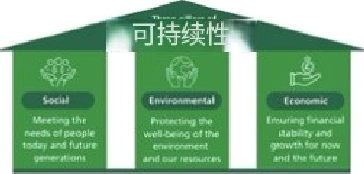



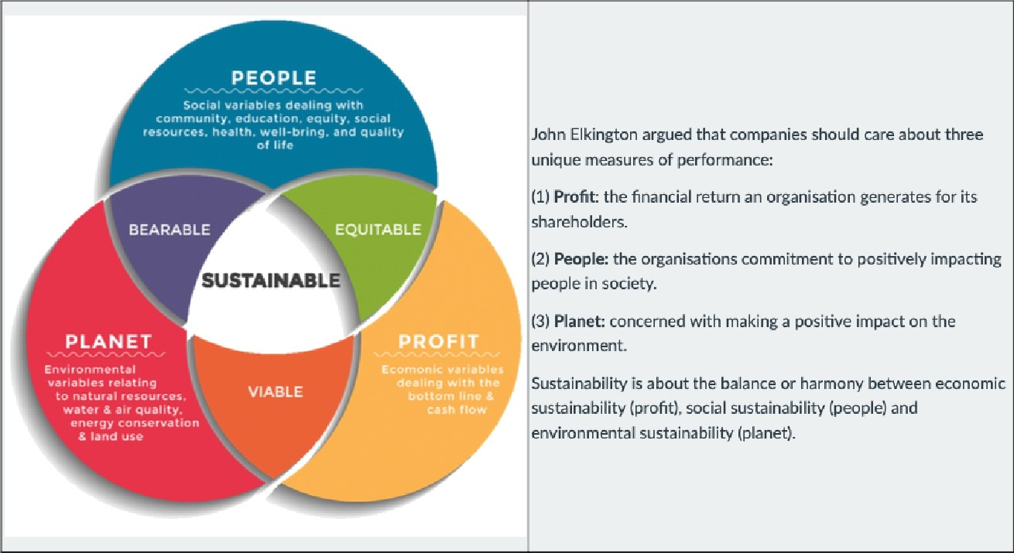



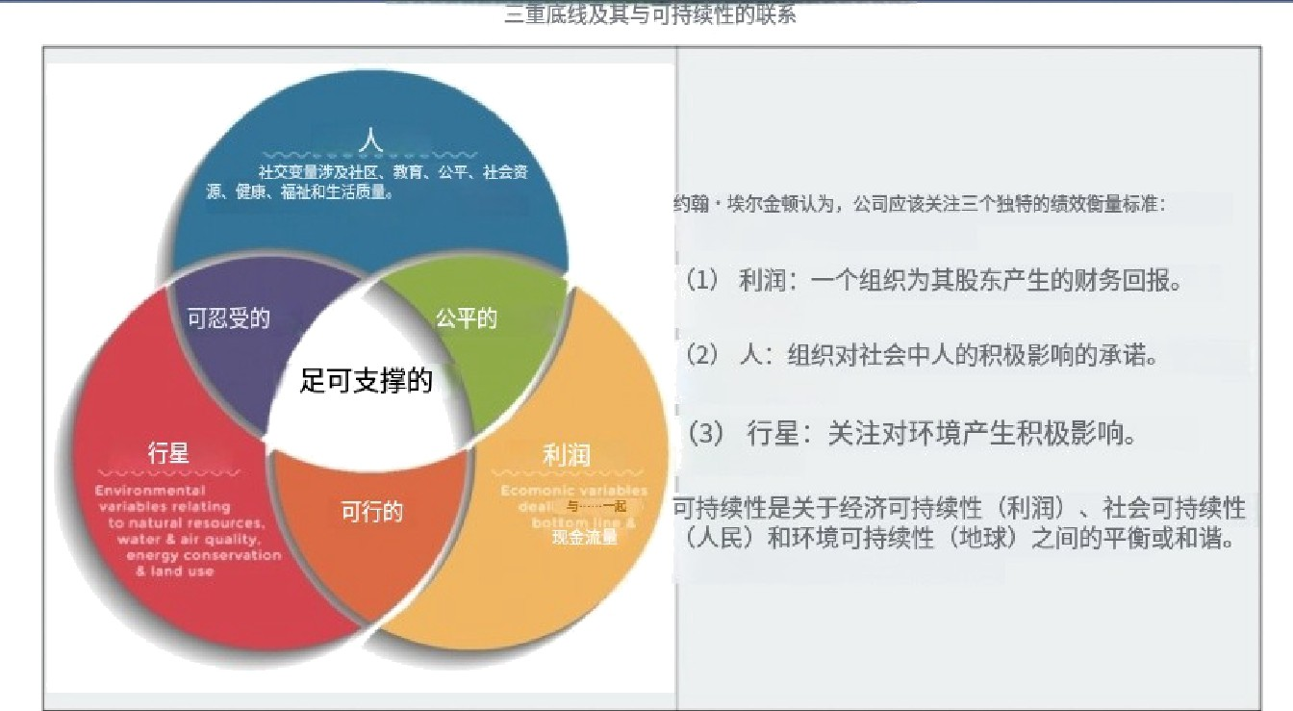

green. It's about connecting the dots between caring for nature. helping each other out, and keeping our wallets happy. And guess what’ This isn’E just for big countries or cities; it's something every group of people can aim for. In Ehe end, it's all abouE building a civilisafion that lasts and thrives for everyone

Making the Right Choices Now





A blueprint for our common future - The Sustainable Development Goals (SDGs)

In 2015. UN Member States translated their vision of sustainable development into a blueprint for achieving it: rhe 2030 Agenda For s i r in hle nevelr.nmeni u.. i t 7 s i°t in r Ie nevelnnment C‹. i° -with ambitious targets to achieve by 2o3o— cover the three dimensions of sustainable development: the economy, social development and the environment





# FUTURE IS

\tP0SSIBLE. 

1i

Anyone can act





While governments set policies to steer sustainable development, and boEh The public and private secFore have to fi n are rhe maim hilt° z it requires, individual decisions add up fast. Your choices to earn a living. move around, make friends Or advocate for justice can all make an

The Sustainable Development Goals (SDGs)



The SDG"s were adopted by the United Nations in 2015 as a universal call to action to end poverty. protect the planet, and ensure that by 2030 all people enjoy peace and prosperity.

In 2015, the 193 countries that make up the United Nations {UN) agreed to adopt the 2030 Agenda for Sustainable Development. The historic agenda lays out 17 Sustainable Development Goals (SDGs} and targets for dignity, peace, and prosperiLy for the planet and humankind, to be completed by the year 2030. The agenda targets multiple areas for action, such as poverty and sanitation, and plans to build up local economies while addressing people's social needs.

The 17 SDGs are integrated—they recognise that action in one area will affect outcomes in others. and that development must balance social. economic and environmental sustainability. Countries have committed to prioritise progress for those who are furthest behind. The SDGs are designed to end poverty, hunger. AIDS. and discrimination against women and girls.

### o's¥, EB¥ BMis#TB¥lNa lC Oo3o9é fAA G%n• B-TBfi€GEMM7 7 o AWNH(DsdrM3 ¥A F. E+Sb¥MHW€fi.B%€b8E2oo BG





Goal2:Zemñvnger Goat3:Goodheatthandwelbeing

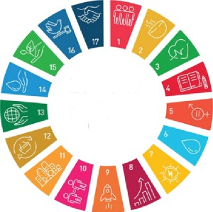

What are the **t7 Sustainab\e Development Goats?**

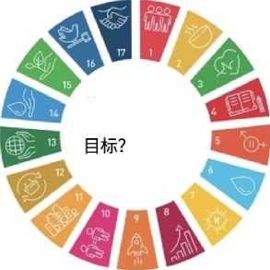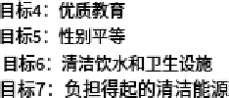



Goat6' Clean water and sanication



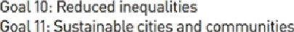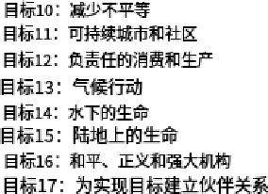Goal 8: Decent work and economic gFowth Goat 9: Industry, innovation. and infrastructure

Goal 12: Responsible consumption and production Goal 1¢. Life below wacer

Goat 16" Place. justice, and strong institutions Goal 17: Partnerships for the goals

##### How falTliliar are YOUWith the 17 SDGs?

Knowing the 17 set goals is the foundation and blueprint to achieve a better and sustainable Mure. Not all T7 of the SDGs are equally relevant to all businesses, but knowing them all is important in order to know and minimise a companies negative impact as a whole. Learn



aboutwhatñegoa aeandwhytheymaterb€o !

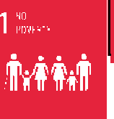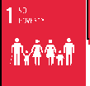

N a P o v a rt y. E n d p a v a r ty in a I I i t s r a rm s e v o r y w h o ra .

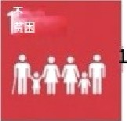



The UN explain s, ‘more thon 700 miTJron people, or 0B o{ the warfd populofion, sfill live in eztreme poverty ond ore strpglirtg to \/fT the most





There are over 821 million who are hungry today and it iS expected to increase by an additional two billion by 2050. We are in need of profound changes of today‘s global food and agriculture systems, as climate change is degrading our soils. freshwater, biodiversity, forests and oceans. This creates Severe risks, such aS droughts and floods. that affect the resources we depend on to sustain life.

The UN explain s” "It is time to retfiin/r how we grow, shore end consume our {ood. T/ done refit. agriculture. {oresfry end #sheries can provide nutrihous (ood {or old ond generate decent incomes, while suqporLing peogle-centeredrural deveTogment end protechng the ernzironment.'

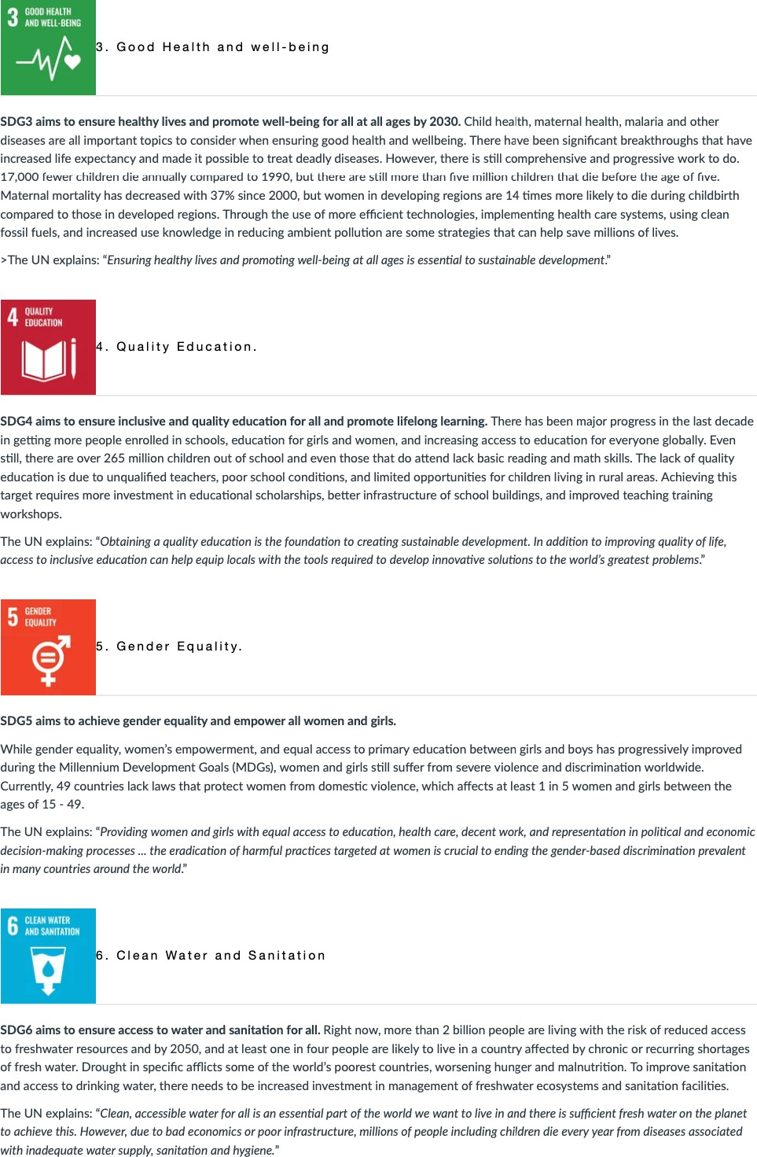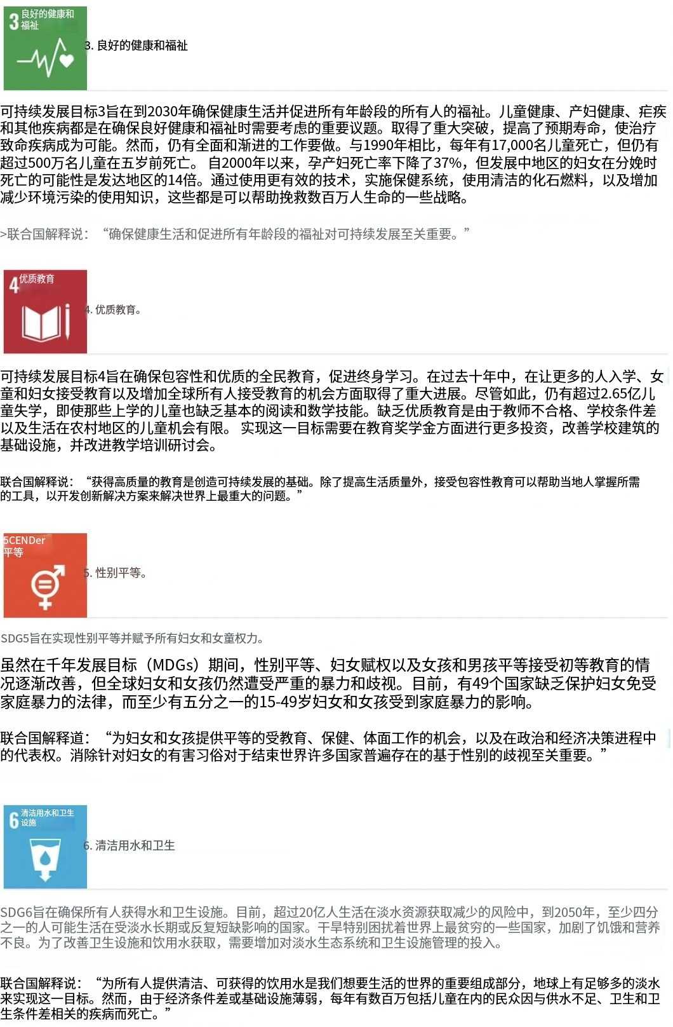

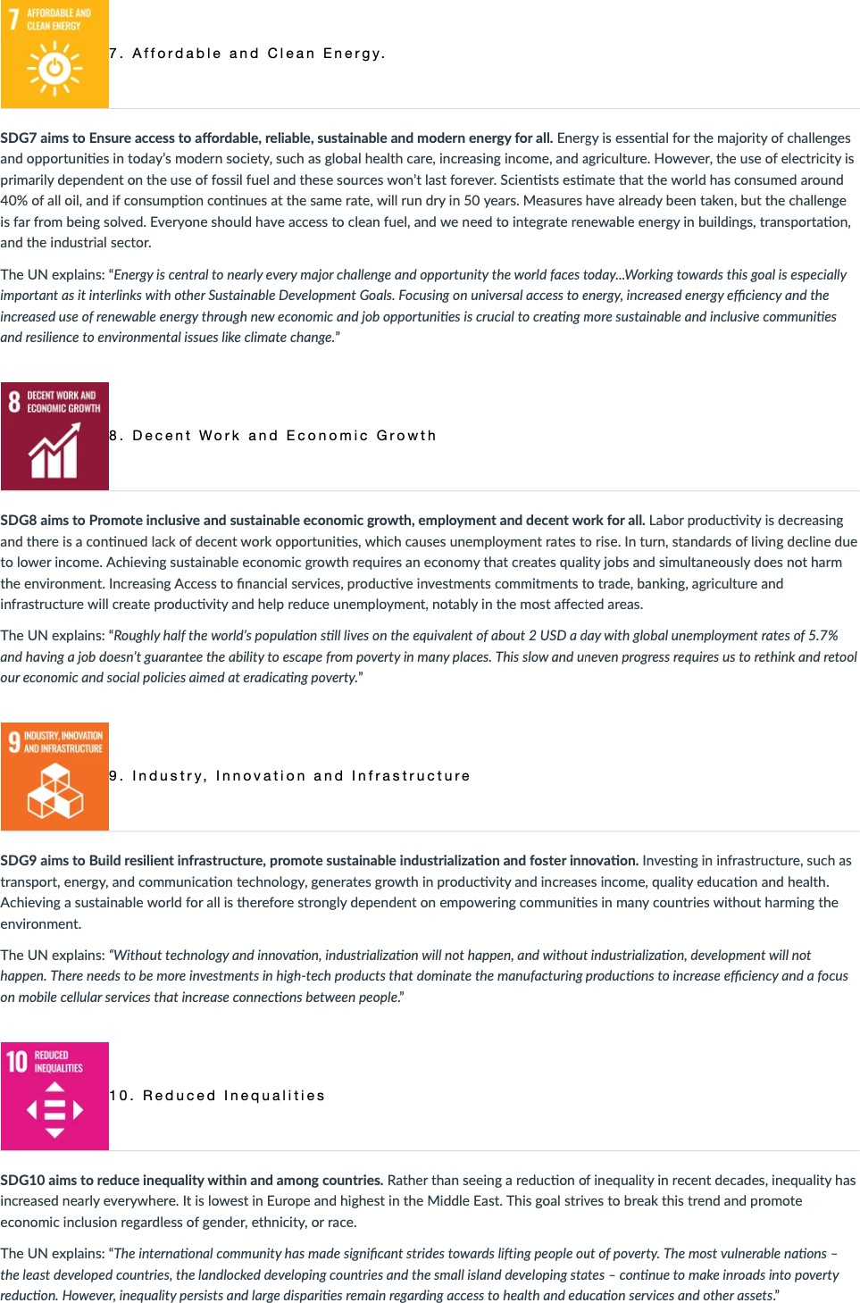 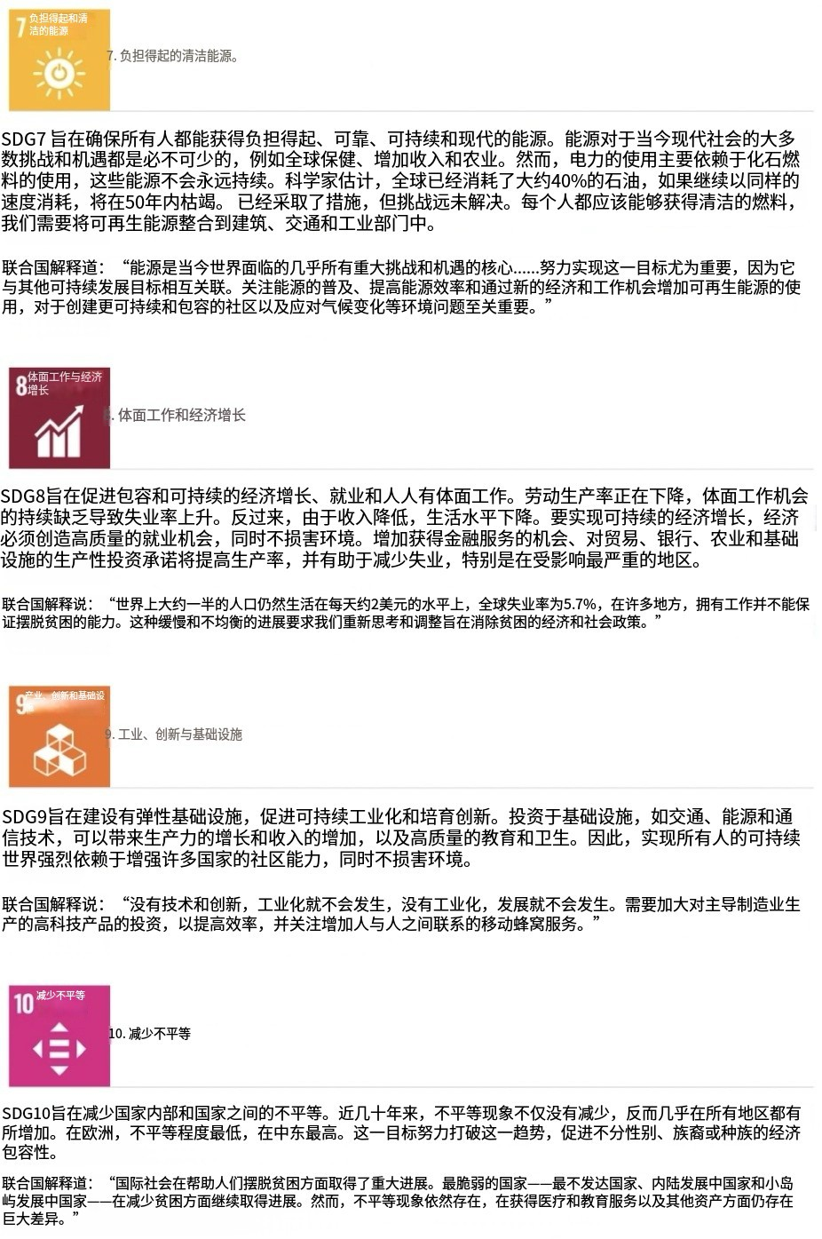

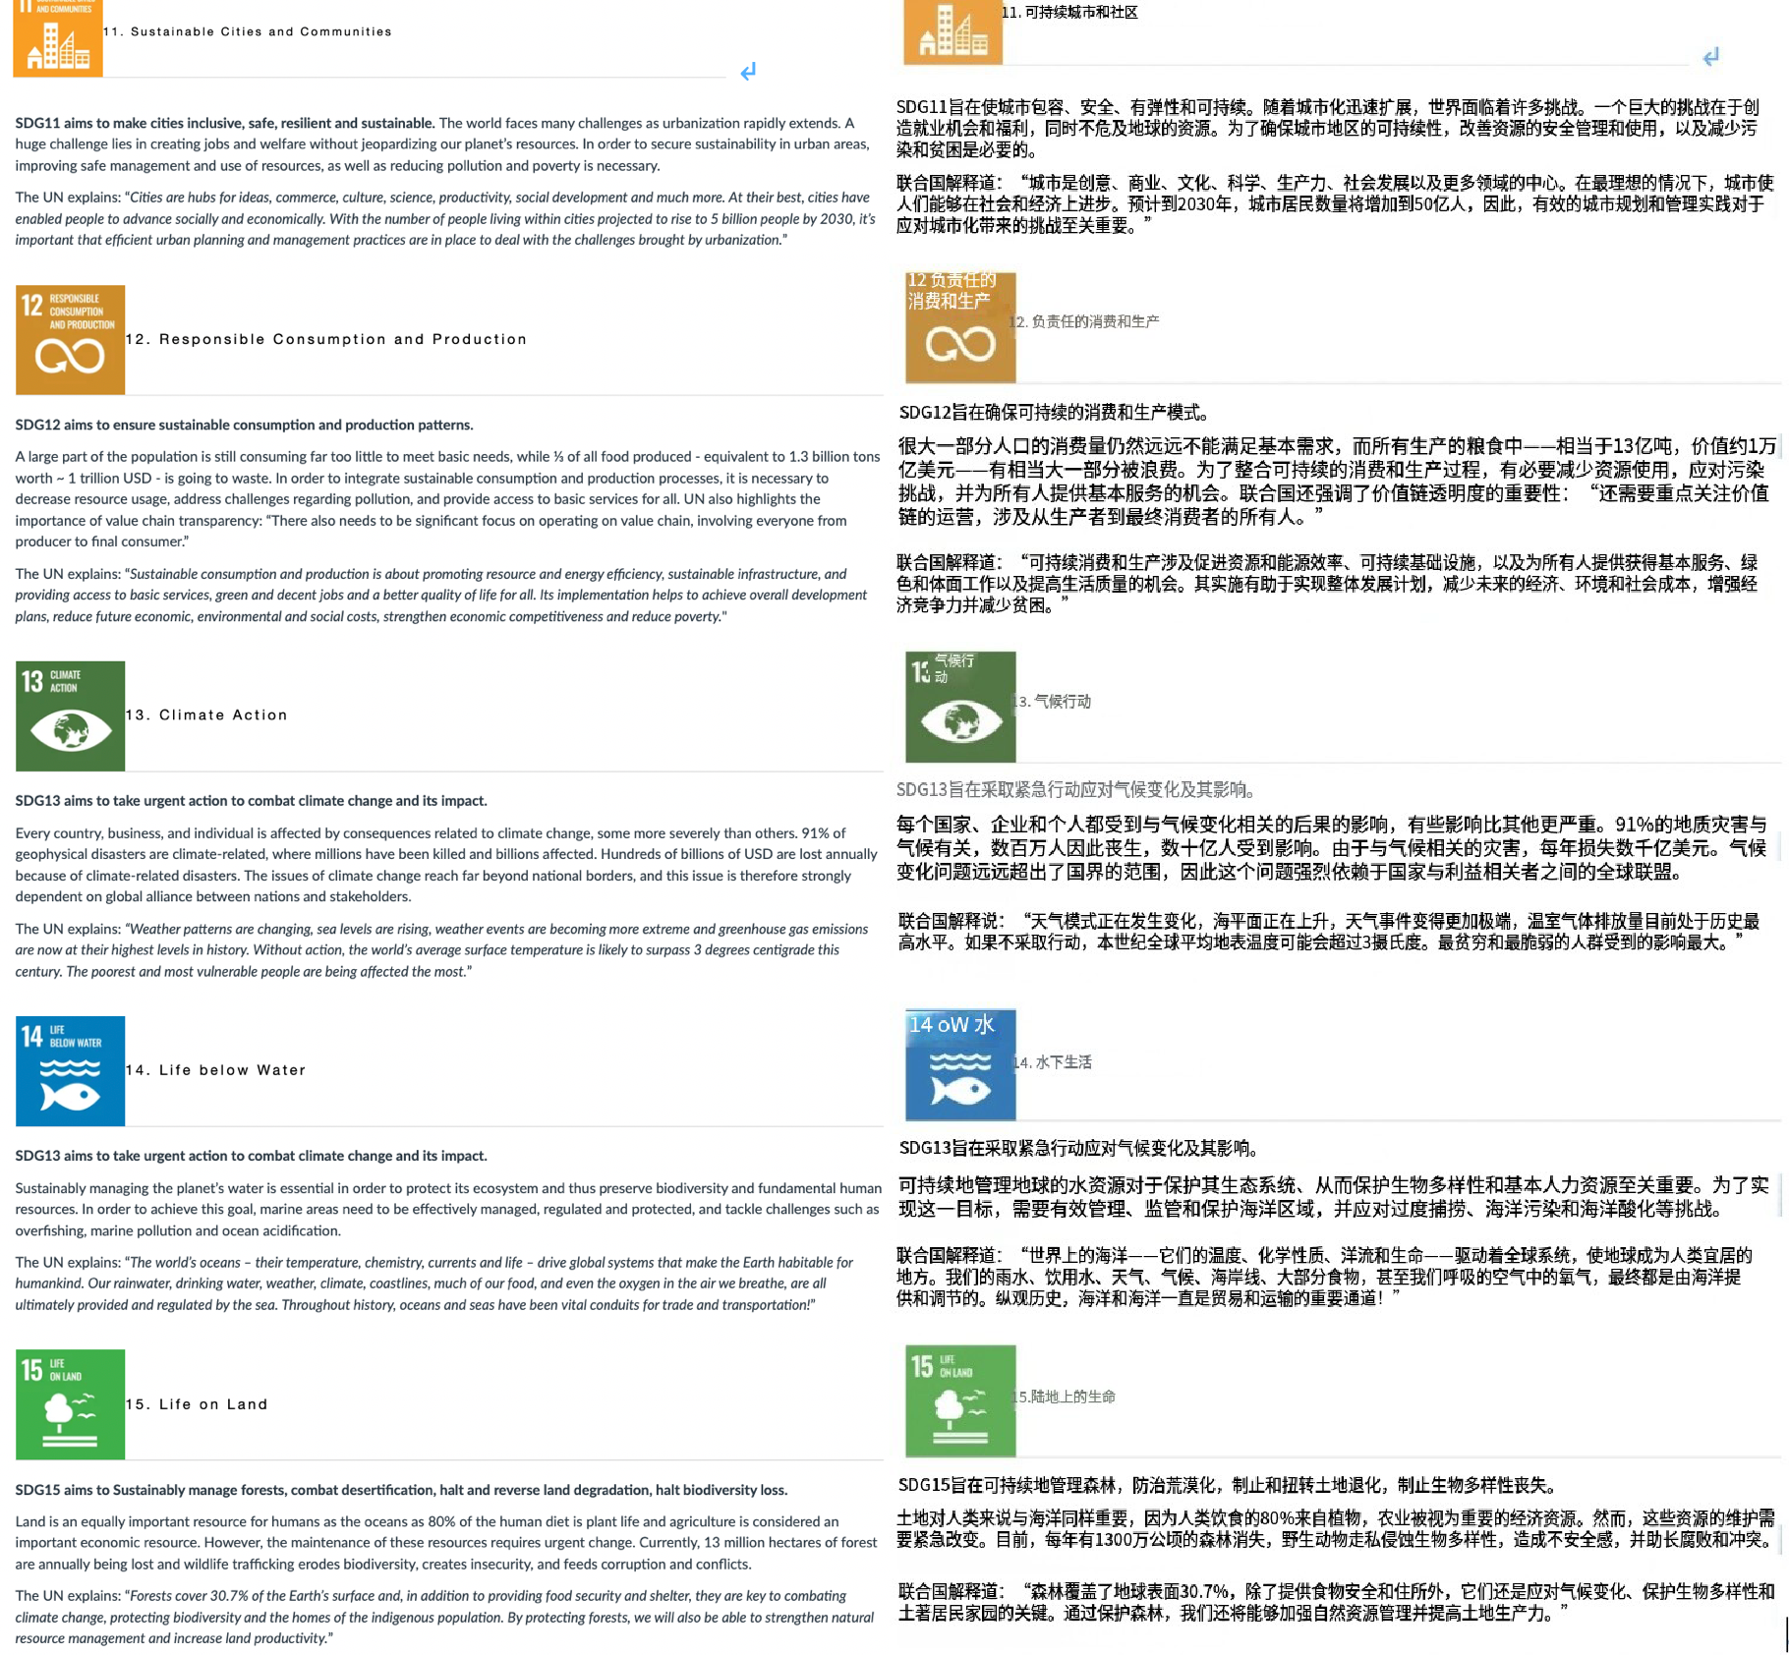

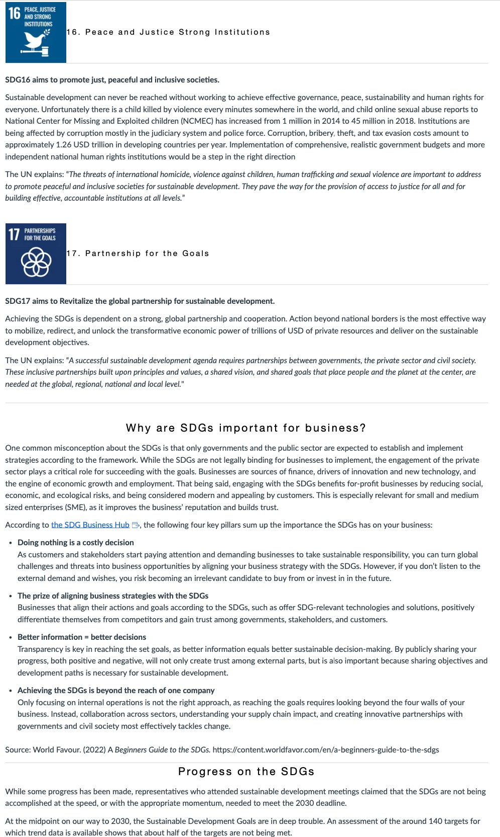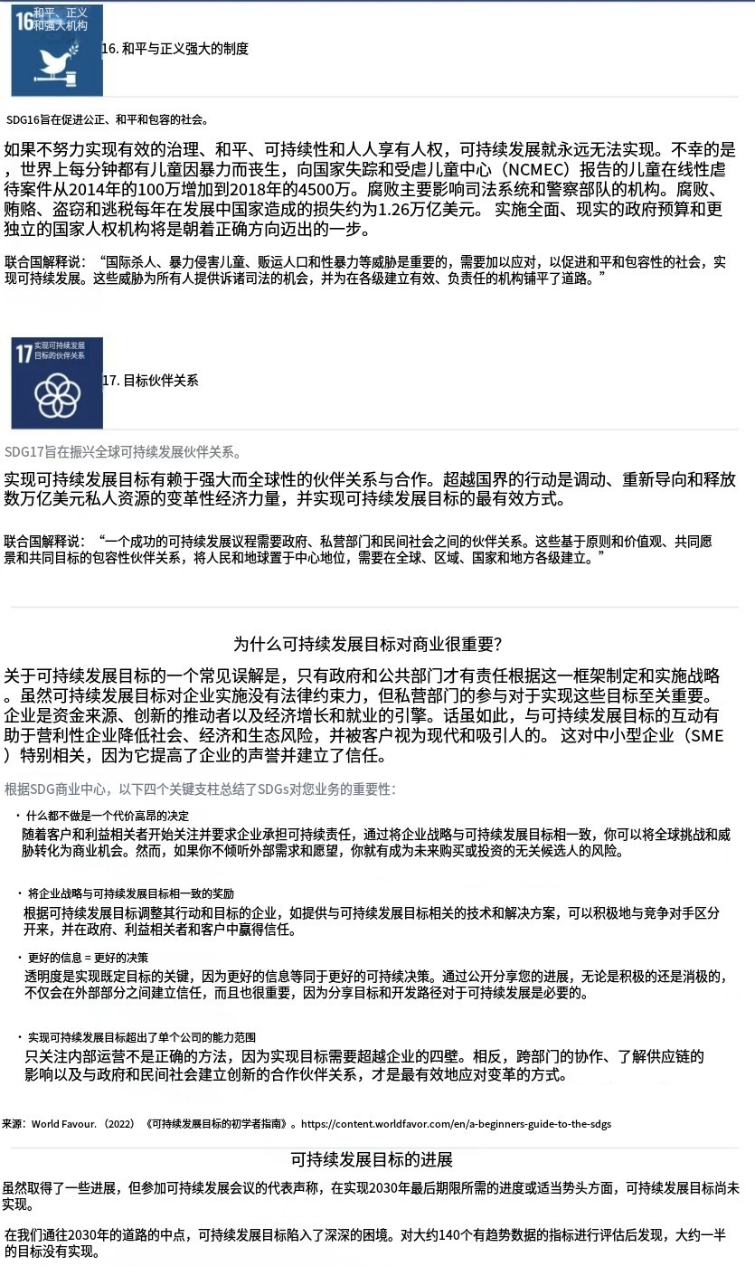

Promise in peril

Leave no one befilnd. Tha I definlng prlnclple of the 2030 Agenda for Sustainable Development 1s a shared promise by every country to work together to secure the rights and well-being of everyone on a healthy, thrivlng planet. But halfway to 2030, that promise iS in peril. A fundamental shift is needed— in commitment, solidarity, financing and action— to put the world Dn a better path. And it is needed now.

Delivering on commitments: wheie do we stand halfway to 2030?

2 3

These targets are moderately or severely off track, and over 30 per cent have seen no movement or regressed below the 2015 baseline. _ _, 20 5 o

Under currenI trends,

* 575 million pea ple will still be lieing in extreme pover ty in 2030, anda nly abDuta ne- third of countries will meet the target to halve

 

* 5h a ckingly, the world is ba ck at hunger levels not seen since 2005, and foad prices remain higher in more countries than in the period

20iS-2019.

The sDc arort yoea. sreciai Edition



We are at war with nature. We neeé to:

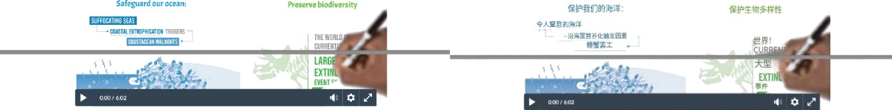

source: UN Seats (2023, July t9 . The SDG Report z023 speciaI Edition. https: /youfu.beenF3b \a0 19a A

* Expana Ai • coi r pse Aii

Transcript: The SDC Report 2023- Special Edition.

Halfway to 2030, the promise is enshrined. and the SDGs are in peril. Where do we stand’ The world has entered a polycrisls era, and SDG progress IS threatened by the climate crisis, conflict, a gloomy global economic outlook, and lingering CQVID- t9 effects. [Music]

WelaeslassessmentoflbeSDGf=ge|spansazonerningpcwe.FiCeenpercentaeon#ak48aemoderatelyorsevenMyod trak d37pexentflavestagnaedorregreseJ[Music





Twenty-five million children missed ouE on routine immunizations in 202't. d million more than in 20't9. And four in five countries studied 202I@ @2500/y @@@@ @20I9 § 600/o E@@@p @@@* @ @ @@@ @ saw learning losses. COVID•z 9 has also triggered the largest increase in between-country inequality in three decades. The world could @@ C{-}VI D-}9@ |@/ 30@@@@@ @@@@/@@o @@ @]2030@ @@@@@ face big misses across the goals by 2030 under current trends. By 2030. gender equality is still 300 years away. At the current rate, it will |@@/ @ @t @]2030@ @gj @$ @ # @ @@ @$gg 2g 6 @ Lake 300 years to end child marriage. 286 years to close gaps in legal protection and remove discriminatory laws, and t40 years to @, @@@ @@, @ }40 @@ ] @@ @@ @@@p @ g

achieve equal representation and leadership in the workplace. [Musicl

The Earth is at a tipping point, and we are standing at the brink of climate calamity. IMusicI





war and convict are inflicting a devasrarng toii on the socs. As or oecember zo22, over toa miiiion peopi woridwide have been @'4'Rfi@VAJK@ T E@e42• BB2022&82@ › & ! G A BU@@› CIO forcibly displaced from thetr homes, 2.5 times the number a decade ago. Developing countries and the world's poorest and most @@@2.5@• @ @@ @ @@@ @@@@@@ @@° @ 2022@II@ * @@ @@@

.uinerabie are bearing the brunf. As of No. mber 2o22, 37 a«t or be or fhe p oorest countries were in debt disfress or at high riska I :f. fi°'7Tb ElIlBkindly'6• tELRBBSS i J6—4T ‹'• P B ZtA•

Eight hundred million people connected to elutricity t›e1ween 2015 and 2021. One hundred forty-sin countries have already met sr are on track to meet the under- five mortality target. Affected HIV treatment has cut global AIDS-related deaths by S2 percent since **2010,** unleashing Innovation and tmhnolsgies powering progress. Medium-high and high technology industries demonstrated robust gror tin. Ninety-five percent of the world has mobile broadband access, and tws in three people use the internet.



WemudmaŁehenmCsnenyeamountAecanandmust1un1hnpaoundbu1hedozks1Wng.[Musi]

To deliver a rescue plan far peopIe and planning, I he 8ecre tary-GeneraI has IdenLif\ed five key areas tar urgent action: one, recommit to transformative SDG action; two, advance inclusive policies for equality; three. strengthen capacity for SDG progress: fDur. recommit hnancing SDGs for all; and five, strengthen the UN system far SDGS. World Ieaders will unIIe at I he SDG Summit to farge a rescue plan ancnorea by tnree transformative breakthrough : equipping governance ana in ntutions ior sustainabi e and incius ve transformafl on, priorit1zing pollcies and irrvestm ents that have multiplier effec(s across the goals, se-curing a surge in SDG financlng, and an enabling global environment far develo ping countries.



For more information, please see t he Susta inable Develop mc nt Goals Repo rt 2028 special editisn.

R e adi ngs



stakeh olders.

Businesses or organisations achieve these goals through conscious and deliberafe efforts or acLivlLies rela ted (o their operaLions and administrations underpinned by global sustainable frameworks such as the t7 SDGS. The SDGs are set out in a way for individuals, businesses: and organ IsaLtons to work together towards making a signif\can( social impact in the world through consolidated processes (UN, zols - foiiow the beiow iink to view aii t7 sDcs.

Please look at SDGs on the United Nafions Web Site below, Scroll down the page once it is open to see the interactive image outlining the gaDls. While reading the goals please answer the below quesLions on your worksheeŁ

**Sustainable Deyełopment Goals** {SDG's) The I7 SDGs of the United Nations act as the foundat!on for social impact **goals** for je United Nations 2022



 

D is c u ss

Reflect in the foiiow:ng questions reiaring to the t7 sDcs. Lees try to get some thoughts together in reiarion to the que lion :n a



t. Why do you think the 17 SDGs are an important guide to incorporating 'social impact’ into a business*

1. What do you consider the most import SDG. and why* (there is no wrong or right answer).



1. How the SDGs drive social change across both society and business’



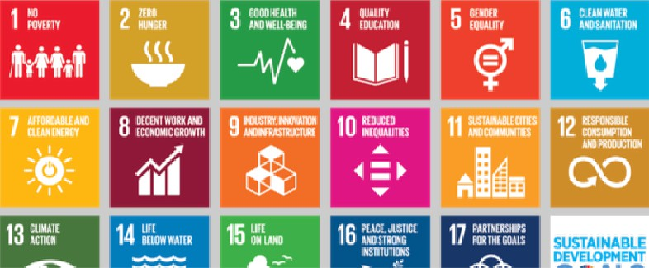'źź"śśś'i'G@ALS

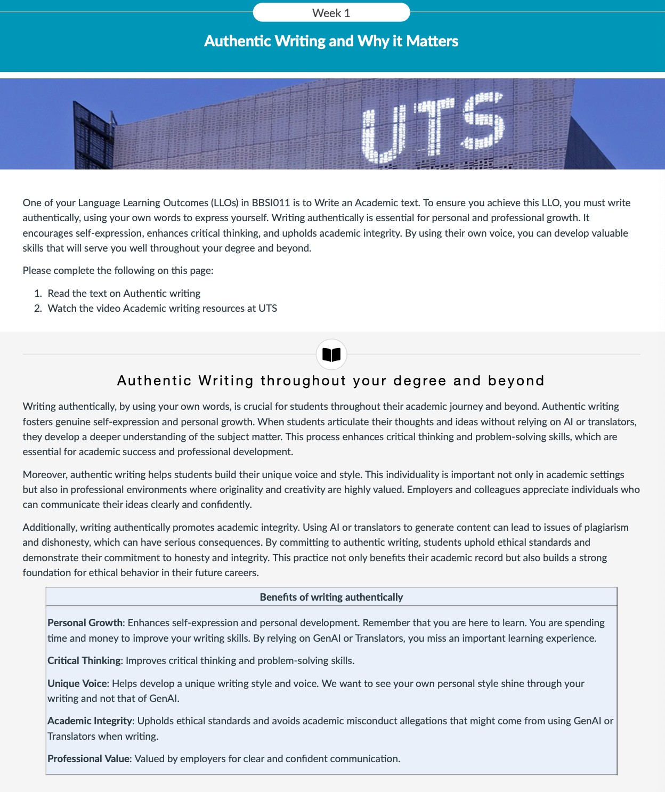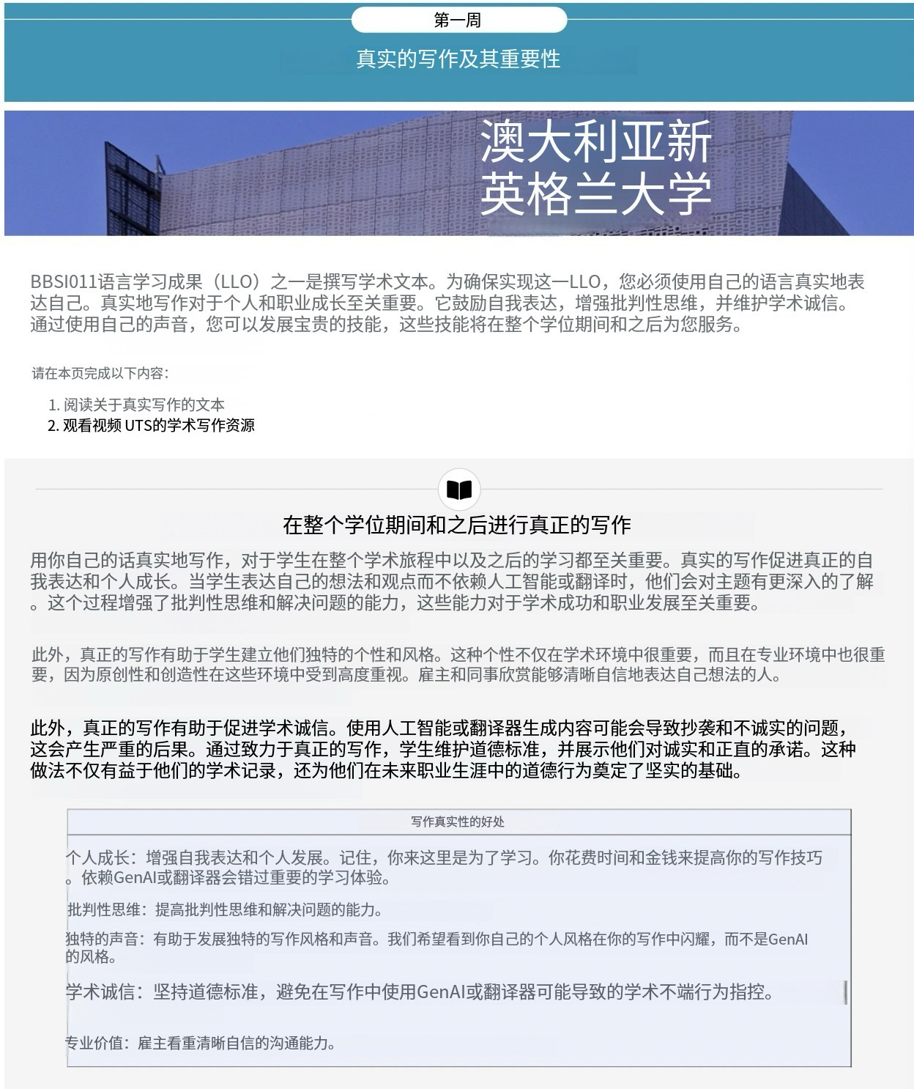

###### C om m on Co ncern s Ab out Wri ti ng Aut h enI icalIy and Respo n ses from t he

B B SI 0 1 1 Teach i ng Team

Many students have shared their concerns about writing authentically for various reasons Below, we outline some common concerns that your tutors have heard along with responses from the BBSI01t Teaching Team. Our goal is to reassure you that we are here to support you. If you have any questions or need assistance wfth your writing. please dont hesitate to reach ouc

Language Proficiency: Students often worry that their English skills are not strong enough to convey their ideas effectively They fear that their writing will be judged harshly or misunderstood.

Tutors response: ’1 understand tfiot «citing in £rglisb con lie cfrnllenging, und its completely nor ul to ferf worried end anxious 4ñout running misted It's important to remember tfrnt everyone, including nntive spenktrs, mot:*s mistakes end deems #um them. Your etterts to write outfientiraffy ore o crucial part ct your lenrning Journey. by pmcticfng andseetdrtg needs you wflf grodvolfy Improve yourIortgu‹tg* Offs and gnln *mnñdence* m tour writing."

FearofMlsb6ss:TfieanxetyMmaWnggamnmfcâorspelngern>mcanleadsudenstomlyonAlortansamrsGeybeGevethesemols wilhépthempmduceermr-0eework.

Tutors response: ‘Maung *mistakes* is o notu/a/ port of lemming. Remembe; eyerymisto/‹e *is* a chance *to* learn ond imqrme. *fifilrifi@* out/ienffco//y helps you dc elog your skills wr Anne.”

Time Constralnts: With busy schedules and multiple assignments, students may feel that using AI or translators saves time and ensures they

meet deadlines.

Tutors response: *’While* usrng AI or tronstotorr might srem lfi a gut #z, it can prevent trem develeprng essenñuf writing bills. Instead, try to plen your time e9cctivrly end mok* us* @ tnc resources evnifofif* to in, such os Studiosity or cfr*ckirtg in with yuur tutor ter teedbocL mese cen heip ynu fmpmve our writing wnih stili mnr9gtrtg yuur woitfond. Pemeii+her, me effort you put fnto writing uutbcnticefly wit puy off in the long mn,

# XTrb rtB%mÄ0ABBs o+ Rrô%Bfü





**Inch of Confidante:** home student lack confidence in their writing abillties and feel that their work **1s not good enough.** They turn to Al or 

H

**translators to boost the** quallty of tbelr **writing.**

Tutors response: ’Mony students have started w/›r/e you are and have made great progwss 6y practicing andseeking help. Yau con do it too!"

Pressure to Perfo'm: The pressure to achieve high grades can driye students to use AI or translators, thinking it will give them an edge In producing polished and sophisticated work

Tutors response: ’Wtttlng outhenttcn#y not one flees you learn but also emurcs that our M truiy rcprcentr your ofiflfties. It's un Important part of mointoinicg *academic* integrity



Hello and welcome to UTS Library’s video on academic writing resources In this video, we will introduce you to some resources that will 

To begin. go to the UTS Library website. From the "Services" menu, select ‘Services for Students' From the left-hand navigation, select "Academic English'' This page links to various resources that will help you improve your academic English.



Scroll down and look under the "Writ•ing" section for a list of relevant resources. "Clarity 8tudy Skills Sucœss" is a great resource to pracdceacademicwribng,gammarvocabuacy, baGcreseacch,audcndcalthnWngskiTs AcademicPhrasebank“bythe Umverfltyof Mancheterisanexcelentresonceforacademicwritemltpovdesexampesofcommonphrasesuedinaodemicwrifng.



under the "Grammar" section. you will see a link to Grammarly Premium. Grammarly is a tool that you can use to check your grammar, spelling, and other writing mistakes. Use your UTS email address to create your free Grammarly Premium account.



At the top of this page, you will see a link to the HELPS online resouxes, which is a page developed by UTS HELPS. It contains some excellent self-help resouroes to assist you in developing your academic language. particularly writing.

Under ”Types of Assignments'' you will f\nd helpful information and tips on structuring your essays, reports. and other assignment types. On the left-hand side of the page, you will see a link to sample written assignments. These are real UTS essays and reports from a range of different disciplines



Explore them to develop and enhance your understanding of academic writing and what is expected of you.

lnthisvideo.weintoducedyoutosomeresourcesth:nwitlhetpyouimpmveyouracademicwññnglfyouhaveanyquesflons.chatwith albarianGatfieUTSwebsiteGoodlucCwithyoursudes



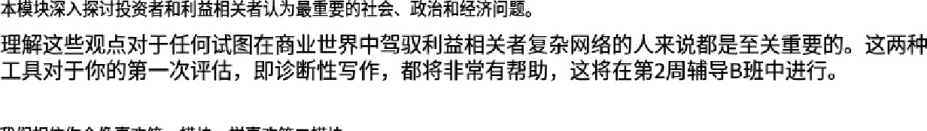



STAKEHOLDER

O ve rv i ew



BBSI011 - Business ß Social Impacts

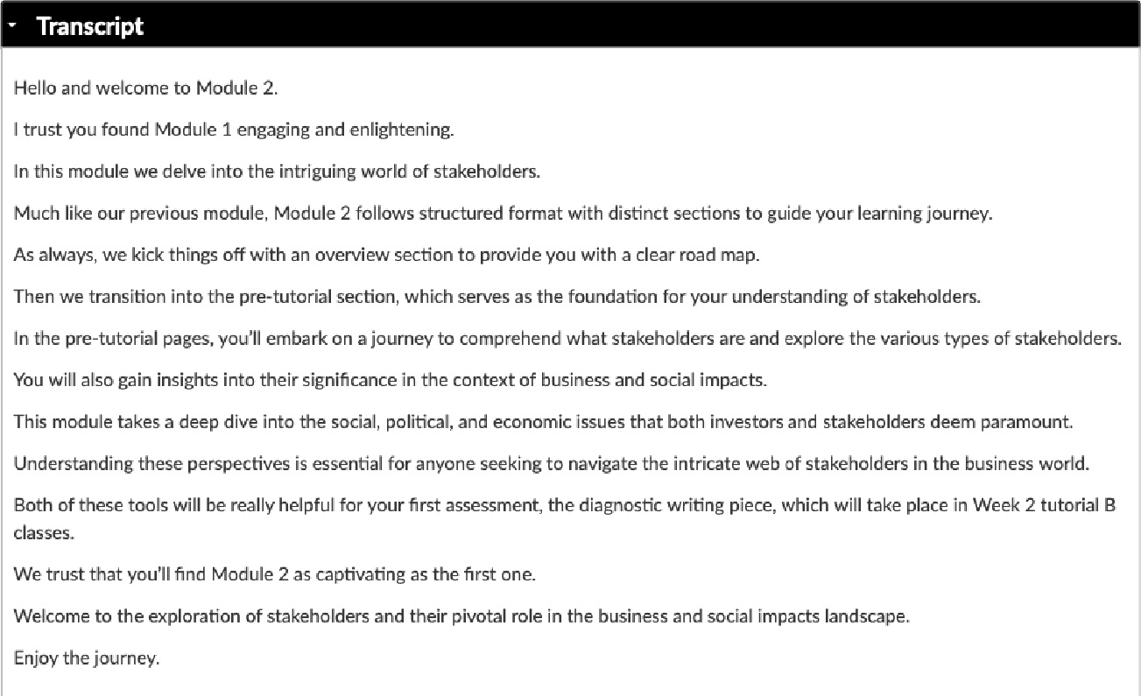Module 2 - Stakeholder

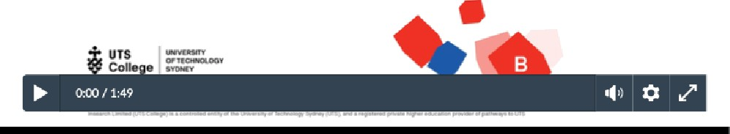

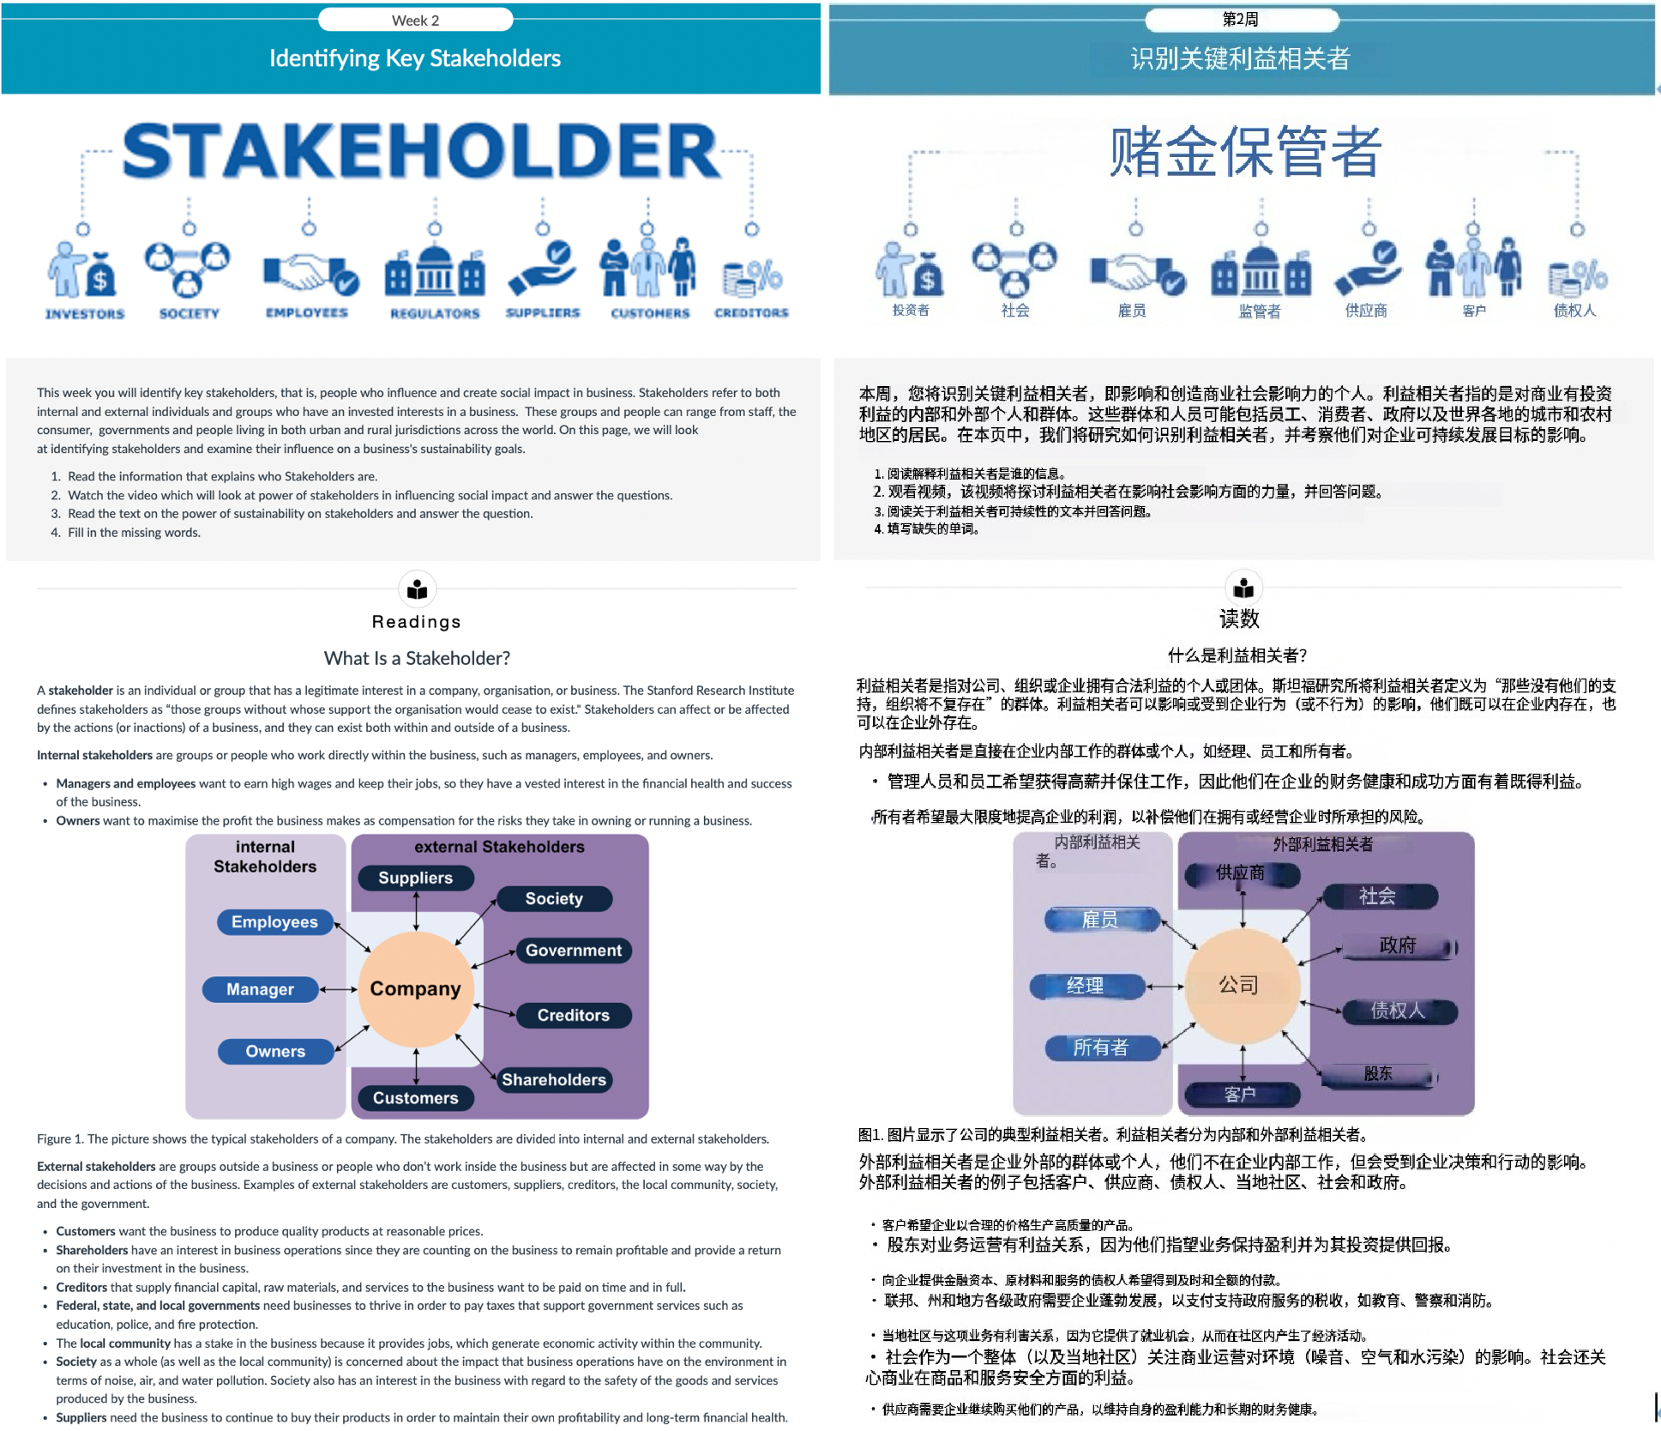

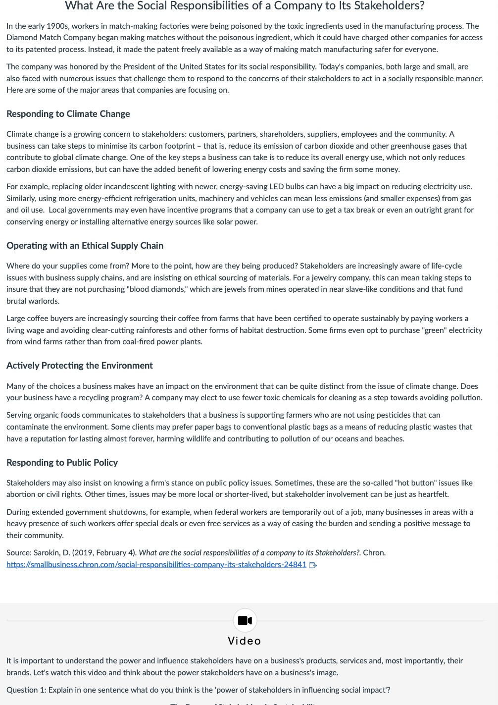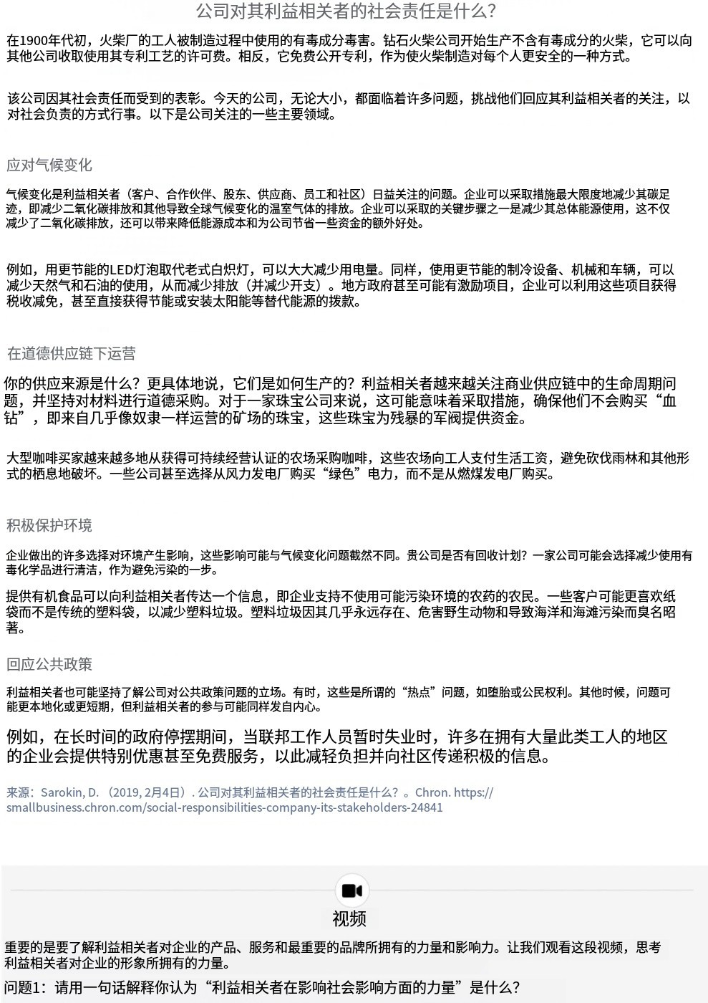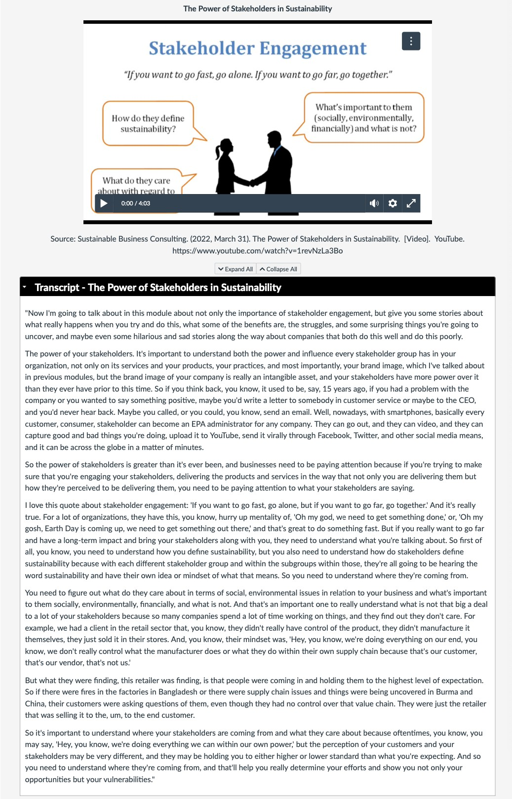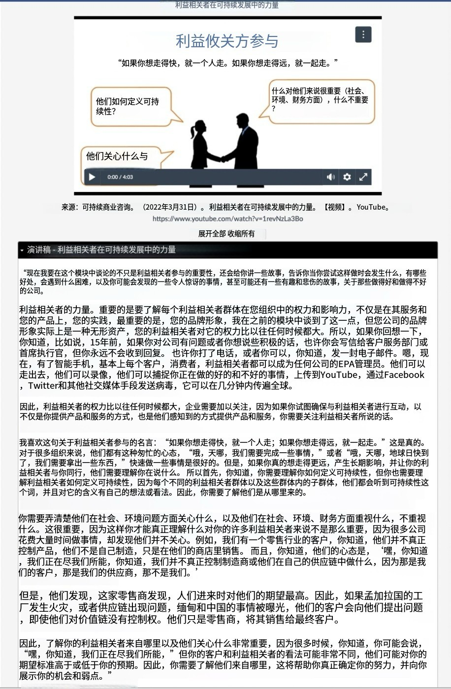

##### Explore

Let's reflect on this quote ‘We 0e/ieye the/e is a strang movement ñsingin socially and enviranmeneI/y'conscio«r products Oecawe the public is demanding a cfionge’ (Clines 2022, n.p.). What 'social and 'environmental' products have you seen recently* Let's read the below text to better understand how stakeholders influence a business's sustainability goals. Make sure to answer the questions on your worksheet!





t. Who are stakeholders?

2, How are environmental and social issues shaping œnsumer öehaviour?

3. List three ways in which businesses benefit from employing social impact

Ot Who are stokeholders?



* • Stokeholders are individuels or groups that have on interest in the octivities, decisions, ond outcomes of o business or orgonizotion. They con be internol or externol to the company.



° o Internal stokeholders include employees, managers, ond owners/shoreholders.

° o External stokeholders include customers, suppliers, communities, investors, regulotors, ond non-governmentol orgonizotions (NGOs). Stokeholders con influence o company's strotegy ond performance, ond businesses must consider their interests in decision-moking.



@t How are environmentol ond social issues shoping consumer behoviour?

° • Environmental ond social issues are becoming increosingly important to consumers, shoping their buying decisions ond preferences. Here's how:

o o Environmental concerne: Consumers are more owore of sustoinobility, climote change, ond pollution, This has led to increosed demond for eco-friendly products, like biodegrodoble packaging, renewoble energy, or sustoinobly sourced moteriols.



° o Social issues: Consumers are concerned with ethicol proctices, like fair lobor standards, humon rights, ond diversité ond inclusion. Bronds that olign with thèse values often gain customer loyolty.



° o Tronsporency: Bronds that openly communicote their envTronmental ond social efforts are more likely to ottroct consumers who prioritize ethicol consumption. Overoll, consumers are more likely to support componies that reflect their values, leoding to shifts in purchosing behovior.



fÏ] List three woys in which businesses benefit from employing social impact.

° • Enhonced brand loyolty: Businesses that focus on social impact ond contribute positively to society often build o stronger emotionol connection with consumers. This con lead to increosed customer loyolty, os consumers prefer bronds that olign with their personol values.



o • Attrocting ond retoining talent: Employees, especiolly younger generotions, are increosingly looking to work for componies with strong social ond environmentol values. A positive social impact con help ottroct top talent ond improve employee retention.



° • Improved reputotion ond trust: Componies known for their social responsibility are viewed more fovorobly by the public. This con leod to o stronger reputation, which can enhonce customer trust ond, ultimotely, long-term profitobility.

C h ec k yo ur un d erstand ing

FiII in the missing words

key g g ,ttttt totlttt . are mada up of people who Inlluance and cteata Bocial Impact in businoes

q g ,tttBtaéah„toIttt. ara conddered both Internal and ecoamal Indlvlduab and groups who have an imzeeled interest in abusineas

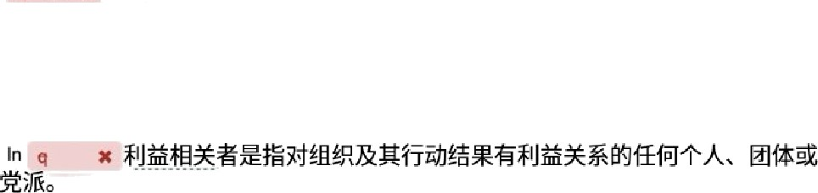

9iatœhuldeæ can range iæm q u ,iinÎÎ„ the oonsurner. çovemments and people HQ In heh uiban and rural junediulinnx across the world

In q x :bueIneaat, a a/a\e/›dder/g any indiudual, group, or pariy thal hag an Interest in an organisation and the oukomes ol its actions



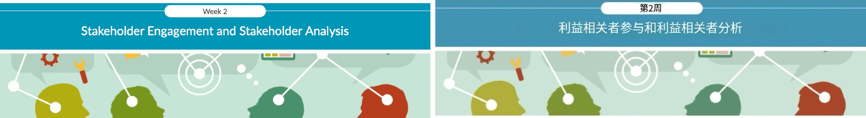

On this page we will examine 'Stakeholder Engagement and Stakeholder Analysis'. We will explore how global sustainability trends drive stakeholder investment decisions and how these investment decisions shape a business’s social impact model. Engaging with stakeholders will enable a business to identify and meet shareholders needs. Meeting these needs through social impact measures will help businesses gain more investors and clients.



t. Watch the video which explains what 'stakeholder engagement' is and answer the questions



1. Read the text on 'Starbucks' which explains how the company adopts social impacts.
2. Check your understanding of 'Stakeholder Engagement and Social Impact' by completing the true/false questions.



R ea d in g s

### What is Stakeholder Engagement?

Stakeholder engagement refers to the process of involving and interacting with stakeholders in decision-making. olanning, and implementation processes related to a business or orojecc The most important part of engaging with stakeholders is to listen to their concerns. It involves actively seeking input, feedback, and collaboration from stakeholders to ensure their perspectives are considered and their interests are addressed.



Why is Stakeholder Engagement important?

Stakeholder engagement helps organisations to proactively consider the needs and desires of anyone who has a stake in their organisation, which can foster connec tions, trust, confidence, and suoport for key social impact initiatives. When done well, stakeholder engagement can mitigate potential risks and conflicts with stakeholder groups, including uncertainty, dissatisfaction, misalignment, disengagement, and resistance to change.



How do you identify key stakeholders for social impacts?

Stakeholder engagement is a crucial aspect of any project. Dut especially for those that aim to create a oositive social impact. Stakeholders are the individuals, groups, or organisations that have an interest or influence in the project's outcomes, such as beneficiaries. donors. partners, scaff, or communities. Engaging them effectively can help you understand their needs, expectations, and perspectives, as well as build trust, collaboration, and support for your project.



#### Video

As a stakeholder yourself, for example, a customer, how do you rate your own buying power* For example, do you ask retailers where the clothes they are selling are made and if they were made in an ethical manner* Do you think about whether the materials to make the clothes are sustainable* Or how the people making the clothes were treated* Dr if the the staff (who are also stakeholders) selling them are paid in accordance with the law* As a stakeholder, are any of these these social impact issues important to you*



The following is a video, 'what is stakeholder engagement' will detail the importance in addressing such social inpact issues for stakeholders. As you are watching please answer the following questions.



1. What is stakeholder engagement*
2. What role do stakeholders play in shaping a business's social impact*
3. If you ignore your stakeholders* concerns, what can be the consequences*

What is stakeholder engagement*

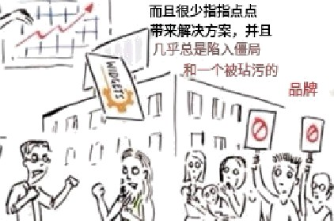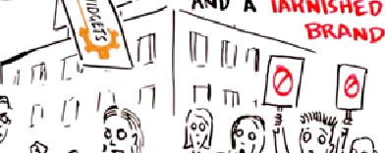

’I

”

Source: Future5O0. (201 , Jan'9}. WhaI is stakeholder engagement* [Video]. YouTube. https:/www.youtube“com/watch*v=VHGTsEwbOJY

* + Expand Aii ^ co iia the Ai i



Say your company makes widgets and buslnes s is booming NaturalIy, people start to notice you. One day, you drive to work to find



man y great things your company does and how ridiculous those crazy hippies are. arabIem sol ve d, right’ Na I so fast.

In the end, it doesn't matter who's right and who's wrong. The cycle of demonizatlon and finger•pointing rarely leads to solutions and almost always to gridlock and a tarnished brand To overcome this cycle, we at Future 500 advocate for stakeholder engagement.

Technical Iy, it's the systematic and proactive integralon of feedback from those impacted by your organize Lion's operations. In pracice, it's all abouI humanizaLion When we acknowledge our shared humaniLy and admit that none of us is perfect, we can begin removing our masks and working together No find common ground.



Stakeholder engagement means bu:Id:ng trust, even between thone with very d Iferent view s, from right to Ieft, corporate to NGO. It



humility, rather than boasting And it means engaging over and over again to continue raising the bar in a way that's better for your

Now, it doesn'I always have to be formal. After all, most triendships aren't built in the room, and having a little fun never hurt either.





So, the next time you and protesters at your gate, consider this: maybe you shouldn't ha.e a gate in the r rsf place Fu ure 500 is a San crifical stakeholders to address imminent environmental and social isSues. Learn more at future500.org."



A c t i v i t y





organisahon it is essential that all relevant stakeholders are involved. Such stakeholders can be:

* Internal stakeholders are the company's staff, including general staff and project management staff.



* + Maternal stakeholders include investors, policymakers, representatives of public administrations, other organisations, persons indirec tly affected by the project, citizens' initiatives, interest•group representatives, and associations of affected groups or individuals

n umber of ini‹ia five s aimed aI reduc:nz its environmental faotprint suppor‹ing farmers and communiries, and promoting ethieal sourc:nz

SarbuñshsrecogniedheimpoflanceoCenga@ngl'businessandsociaMmpacs'OneCthere onsCorStabuckstoempoysoGa impact iniñatives is due to stakeholder consul tahon in the communi Lies in which the company operates Starbuc ks offers an exciting example of how or$anisaRons respond to stakeholder demand for posifive changes in society through bushes s and social impac ts.



Starbucks understands thaE their social impacts could only succeed if internal and external stakeholders were involved in the projects.

Please read the instruchons carefuIly and complete the acfivity to bring to Tutorial A.

Please do the followings

OpentheYVebsReandfeadtheatctebeow: Statbucksunveitsnevvplonstoe!minote sngle usecups encourogereusoble mugs

As you read the amcle, identify the internal and external shareholders who would have been involved and/or influenced by the

removal of single-use cups.

3. Think critically about stakeholder involvemend and influence in these social impact infLiatives and complete the stakeholder analysis table below.

Stakeholder analysis



1. @P

|  |  |  |
| --- | --- | --- |
| 1. How would this stakeholder be involved in  Stakeholders the oroject* |High, Moderate or Low Invol ve ment] | 2. What positive influence 3. What negative influence could this stakeholder have can they have on the  on the project* success of the project’ | 4. What might be this stakeholder's key concerns* |
| Internal stakeholders:  1. Em Dlo ye e’s |  |  |
| 2. Owners of Starbucks stores |  |  |
| External stakeholders |  |  |
| 2. Suppliers |  |  |

Stakeholder engagement is irrelevant to achieving 'Business and Social Impact'



o True



a False



Social impacl has became a trend, and many multinational corporations understand that stakeholders are concerned about the environment and wasteful business practices.

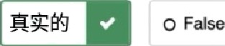O T e o False

The only stakeholders a business has to be concerned with are the 'consumers' True



False

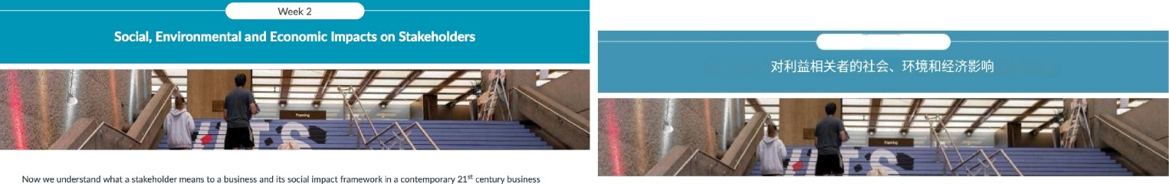

environment, we will now look at what social, environmental and economic impacts are driving stakeholders to invest in certain businesses and initiatives. On this page we will come to understand what social, environmental and economic impacts drives stakeholder to sustainable iniLiativec

Please complete the fôllowing on this page:



##### So c i a I, E nv iro n mentaI and Ec onomi c im pact s

When the business environment changes. strategles must adapt. Soclal impacts and sustainability have become extraordlnarily disruplfve phenomena Impacting buslnesses In a number of different way From globally risfng Inequallty and soElal fragfIfty to the lack of access to clean water, sanltation, health care and education, or the Increaslng speed at which bIodh'ersIty Is befng last—the toplcs are as dlverse as they are crucial.



Social, Environmental and Economic Impacts are Important factors that Influence the Stakeholders oF soclal Impact and buslnw Social impact is the effect of an organisation*s actions on the well-belng of the communify and socfefy at large. Business is the activlty of maMng. buying, or selling goods or services for money. Hence, organisations must fomulate a systematic perspective on business and soclal Impacts. This perspective has to reflect all critical challenges faced by Stakeholders. which range from the economic, soclal and environmental impacts noted below.



|  |  |
| --- | --- |
| Soc1aI impa‹-ts4 |  |
| Soclal Impacts: These are the changes In the culture, noms. values, beliefs, and behaviours of the society. Some of the social issues that influence business and society are:   * Access to education for all people, whldi is a key drlver for soEIaI development * Dlverslty and fncJuslon, whlch can enhance the creativlty, innovation. and performance of organisations and teams * Ervfronmental awareness and acffvism, which can   motivate Indivlduals and organisations to adopt sustainable practices and reduce their carbon footprint. | The followlng SDG's aæ also important to Stakeholden when conslderlng socfal impacts:  SDG 4: Quality edM<ation. Thfs goal alms to ensure induslve and equitable qMaIIty education and promote IIfeIong learnlng opportMnlties for all.  SDG 5: Gender equally. Thls gaal aims to achieve gender equality and empower all women and girlc  SDG 10: Reduced lnequallhes. This goal alms to reduœ fneguality wlthln and among countrles.  SDG 11: SMstafnable cities and communlfies. Thls goal alms to make cfties and human seolements InclMslve, safe, resilient and sustainable    SDG 17: 9artnershlps for the goals. This goal aims to strengthen the means of Implementation and revitalize the global pannership for sustainable development |



, ”°

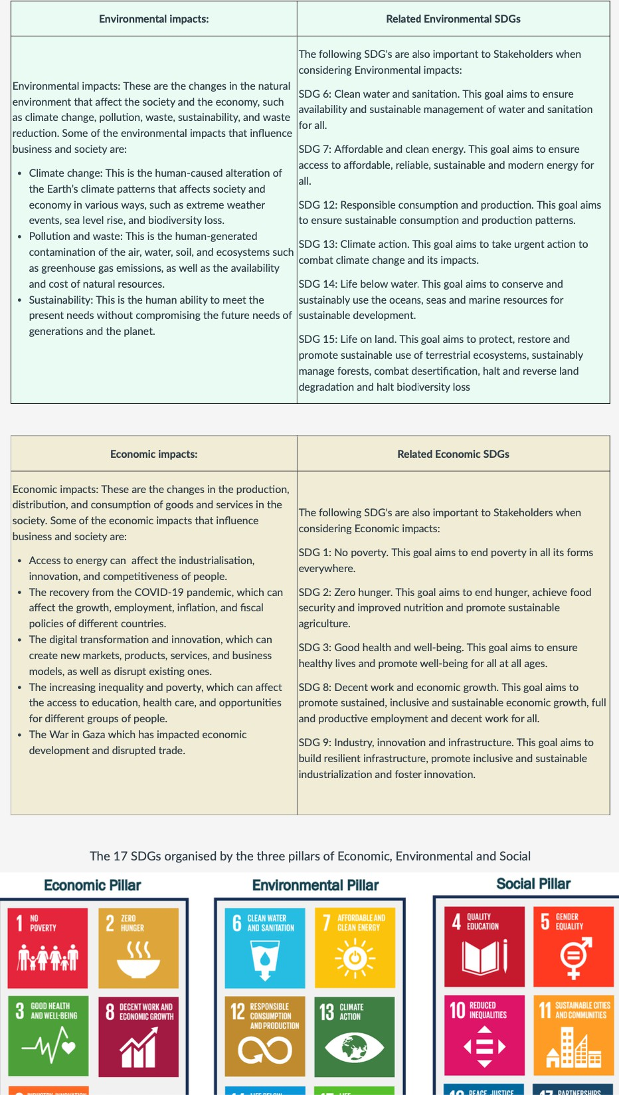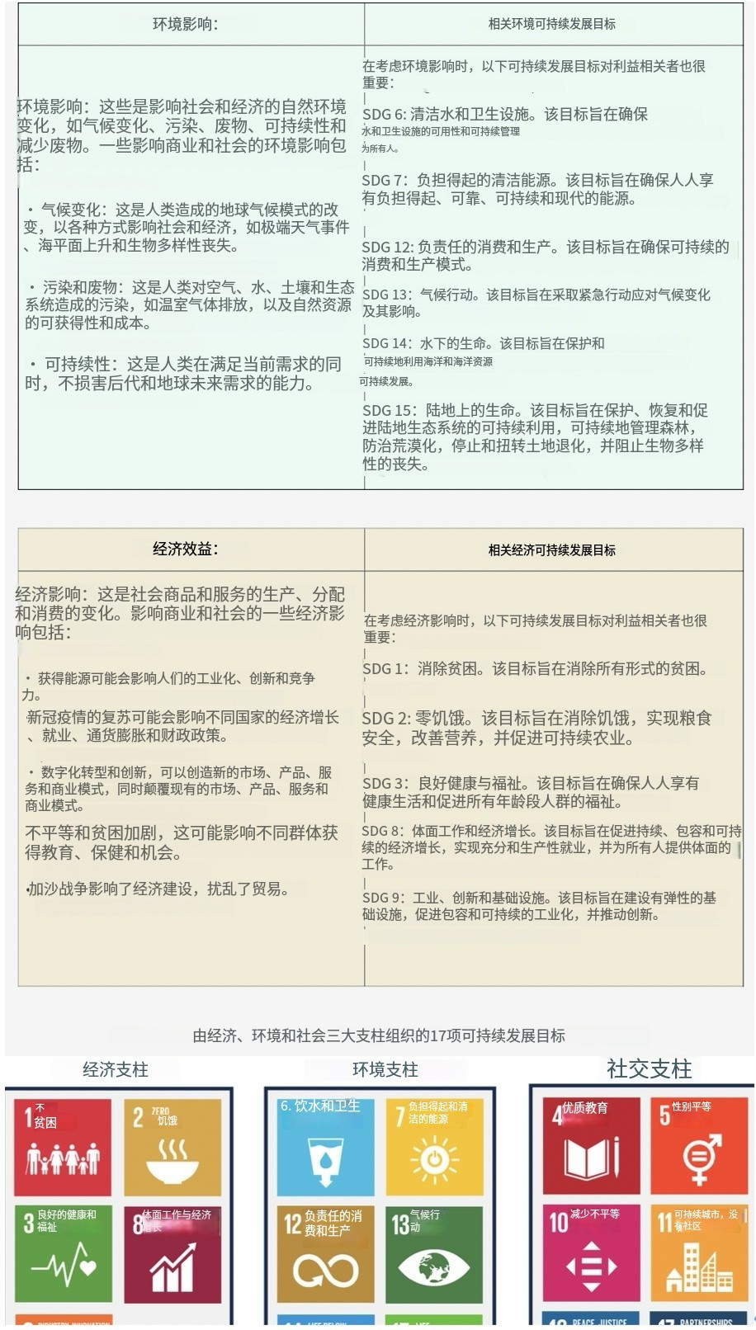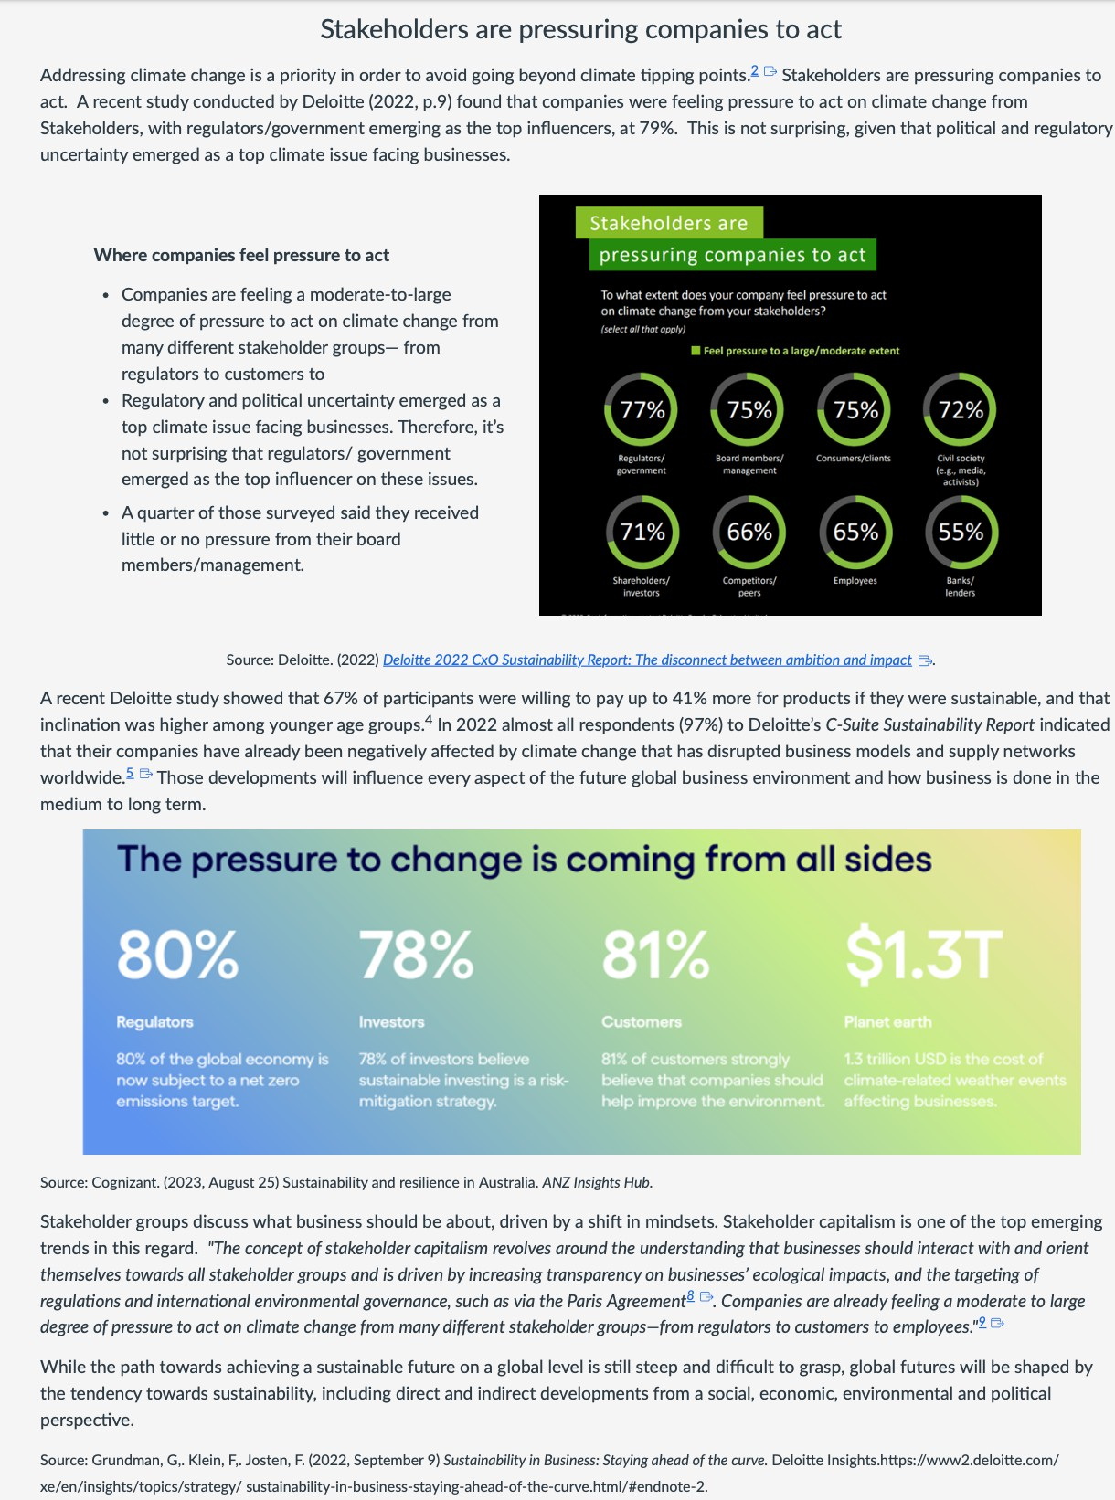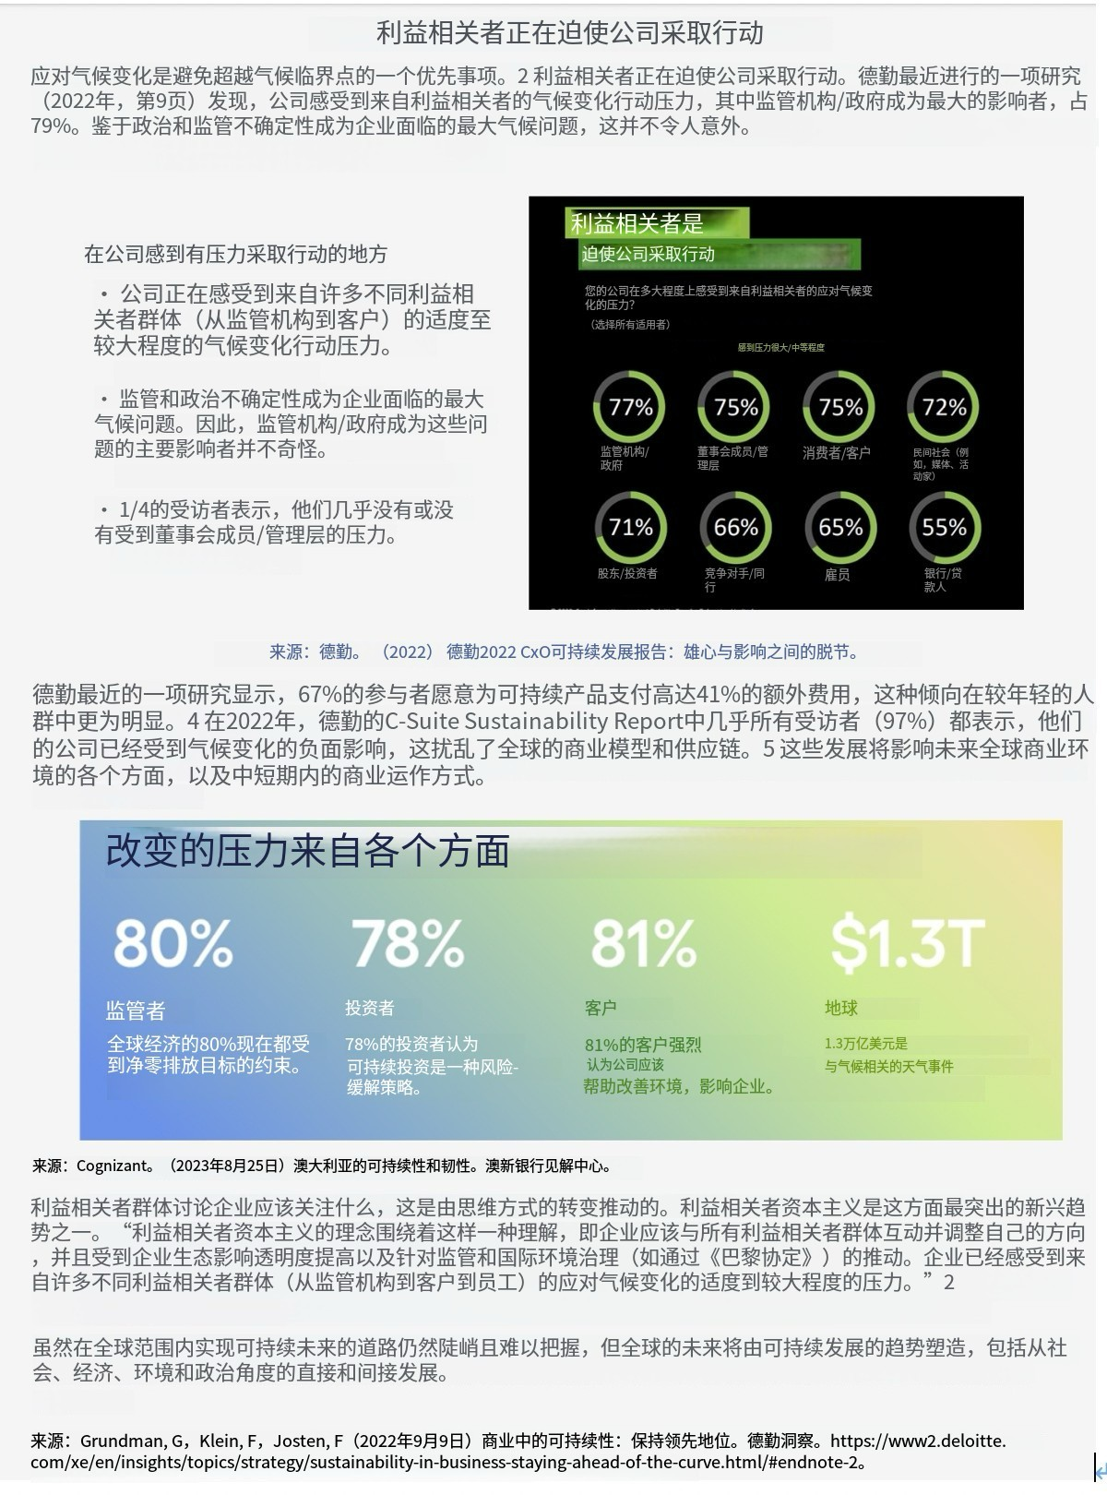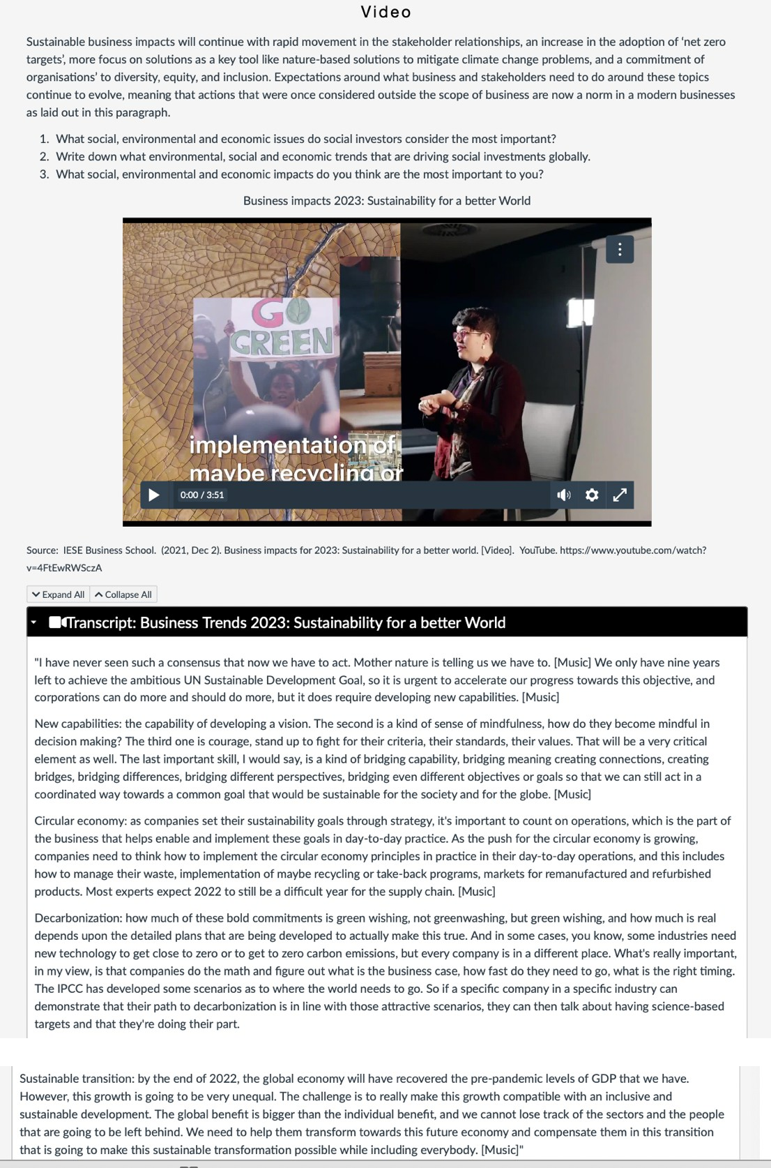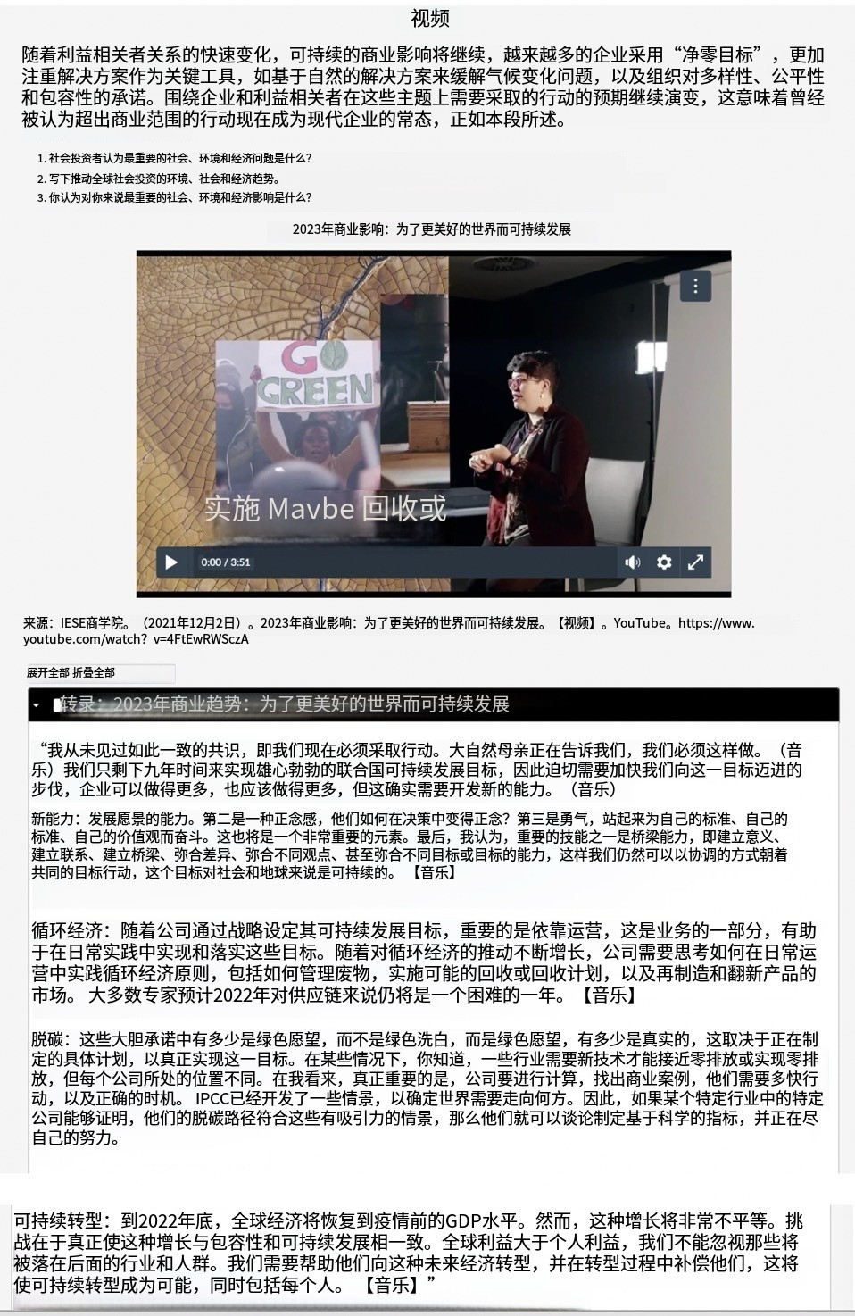

Leadership in Business and Social Impact

During this week three, we will ïnvesfigate the role of leadership in Incorporating successful social impa¢t inŁo business models. We will look at thę charąctęristacs oI lęadęrship required to ąttaÎn susŁainąbility inihąłiv+•ș; ąnd why leadership leąds us to a stronger ąnd fafręr soci °ty through Sociąlly awarę busfnes prac0ces!Leaderships İn the sc+cial impact space reflects the crïùcal rolę OI organisafions ąnd the



2 WachashorUhefiodvdeoolthe?asteoCoöaimpart:leadenW}andansvebeguzsfons

3. Read the text on responsible leadership, people and profits and address the focus questions.

###### What is Leadership?

toge Łher to accomplish whąt Łhey couldn‘Ł da working indİviduall y.

Leadersrip theories have evolved signífìcantly since the early żßth century when ‹he tr it theory was I+rs ›n roduced. Let's take a look a‹ some of these @ 20 tIJ-/ŞȚ @|f}rtjt|șțÿ@ z|| yÿ@, @@lțț!țÿ{—ț/@ -¡•@@ |}tj@ @ t]-@(tȘ@@@@r:|zi— *jI| țÇ ;

* The Trait theory: Suggests thai leaders were born with certain innate characteristics that made fhem effecLive leaders. This theory was criLicised lor
* The BehaUoural Tfieory: Emerged as a response to the IimïtatÎons of the trait theory. This theory focused on the behaviours of leaders rather than their innate characteristics. it suggested that leadership was a Set or learned behaviours that could be developed over t1me.
* The Contingency Theory: Suggested that there was no one-size-fits-all approach to leadership. This theory emphasised the importance oF situational far tors in determining effecŁve leadership. It suggested that different situations reoulred different leadership styles and that effective
* The Transformational Tneoş: Emphasised the importance of inspiring and moøvafing followers to achieve a shared vision. This theoi“y suggested that effective leaders were those who could create a sense of purpose and direction that mofivaŁed people to work together to achieve a shared object'Íve.

Year & Name Oefinłtion 6 Exampks

## TRAIT THEgRY OF LE ROERSHIP

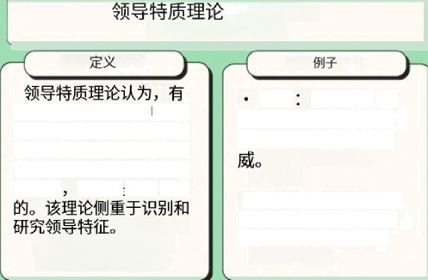

„,t \tt

###### DEFšfiITION ’ ”

The Trait Theory of Leadership | - Charisma: Possessing a suggests that elective leaders presence and communication possess inherent personality traÏü style that captivates others, that distinguish them from otners. exuding confidence and These traits, such as adaptabitLyy ł äuthority.

assertiveness, and self-conhdence, !

##### are beheved to be innate rather I * Inspiration: The ability to than learned. The theory focuses I inspire others through uplifting

on identifyfng and studying Speeches and captivating

leadership characteristics. communication.

BEHRUtORAL THEOR y 0F LEADERSHIP

ADURNT AGE

The behavioral theory of leadership posits that effective leaders engage in specific types of behavior which result in improved team performance, which can be taught to others. The focUs of behavioral theories is on identTfyfng the specific actions that effective leaders dfsolay and teaching those traits to others. This often involves constructing a clear and explicit taxonomy of whal effective leaders do.

The key premise of this theory is that

che ehthe nreat 11 Th ry “

which sees leaders as born, not o

made. The idea that leaders can be trained is appealing to business, opening the door to tke oossibility that any and all employees can artend some and walk out the door being an effective leader.

C ONTINGENC ¥' TH£0RV OF

£ERDERSHIP

The Contingency Theory of task St UFg• If a task is clear, a Leadenhip posits that there is no directive leadership slyLe might be

single best leadership style, and the More effective; conversely,

* + effectiveness of a partic gt Unstructured td5ks may require a ” leadership styte is contingent upon more participative approach.

various situational factors. Instead of , yearn Relations: A leader with advocating for one consistent strong rapport within lhe team [eadership approach, the theory might succeed with a more

suggests that leaders should adapt democratic style, while distrust

their style based on the might necessitate a more circumstances. authoritative approach.



TRRNSF ORPTATIONRL LEADERSHIP

Transformational leadership iE a leadership style that insoires and motivates followers to

achieve exceptional performance ar›d personal growth.

E €APtPLE

OVERUIEN

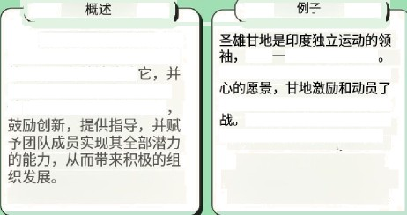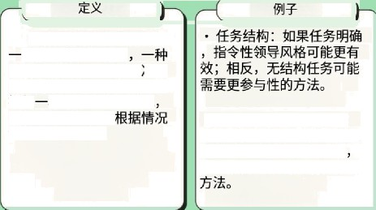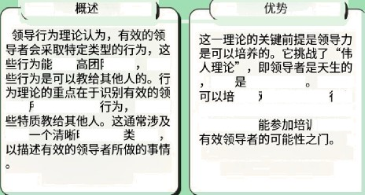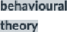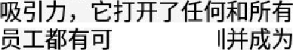

ts m

’“’° ""

Leaders who adopt the transformational approach create a compelling vision, communicate it effectively, and engage their teams on an emotional level. They exhibit charismatic qualities, encourage innovation, provide mentorship, and empower their team members to reach their kll ootentTal, resulting in positive organizational development.

Mahatma Gandhi, the leader of the Indian independence movement, was a transformational leader. Through his Inspirational vision of nonviotent resistance, Candhi motivated and mobilized millions of oeople to tght for freedom and social ustice. his transformative leadership style empowered individuals to believe Tn their *own* ability to effect change.

198@@(¿'

@'@' @

'@ @ yyW@ @

yyñ@@ @l — @{@/

@ , @ tt[l

f{zj — // q

1@(|§@Il^ /@@ @n”n

###### The Future of Leadership: Responsible Leadership

The scope and complexity of social and environmental challenges we face today require a new kind of leadership that is more responsible, accountable, and sustainable. Responsible leadership is about creating long-term mutual benefits for society, partners, the economy, the environment, and local



Responsible leaders are those who recognise the importance of addressing social and environmental challenges and take proactive steps to address them. They understand thaf their actions have a significant impact on society and the environment and are committed to creating pos"t1ve change. ”hey also recognise that they have a responsibility to their stakeholders, "nclud"ng employees, customers, shareholders, and the wider community.

Responsible leadership is important for businesses because it helps them creafe long-tern value for all stakeholders while also achieving their business objectives. By adopting responsible leadership practices. businesses can "mprove their reputation, build trust with stakeholders. reduce risk, increase



.



ineguaiy,cimatechange, or oandemics BywormngcoIlaboranvelywithtaeh‹wdensuchasgovernmenu, MGOz,‹ommunfes, or‹utomen, responsbIeleadersan<maeposifivesoGaimpcswhileaboacWevng0:eirbusinessobe%ves

Link to stakeholder theory and strategic planning

It would be easy to consider responsible leadership as an extension of stakeholder theory. In its Simplest form, stakeholder theory refers to the need for an organisation to consider multiple stakeholders, not just the shareholders, when determining strategies and behaviours. However, responsible leadership is so much more. there are several considerations when determining responsible actions. Whilst there is no single defin"t1on of what these are, a good starting point would be to adhere to the following three behaviours:



:t. Focus on the broader needs of others rather than on personal interests



1. Consider the societal and moral implications ol decisions
2. Ensure that decision making is based on the long-term rather than satisfying immediate prior"t1es at the potential expense of future success.

We can see thaf there "s a clear link w"fh strategic planning, which should take all these factors into consideration whilst ensuring the organisational objectives are met. The planning process may take longer as a result. but the benefits are more likely to be realised and long-term success assured. The reputation of the organisation can increase dramatically il if is known to always behave in a responsible way; nof merely to choose areas of respons"b"Iity and to use these for marketing purposes.



Organisational behaviour and Responsible leadership

Consider the slfuation whereby a car manufacturer takes care of its sfaff, Through good reward packages, as well as exceptional manufacturing planf safety. It meets the needs of end-customers by prov"d"ng value for money whilst using quality materials. It worM with local author"t1es to ensure fhat chosen sites for manufacturing plants meet all planning requirements and don't have a negative impact on the local population by choosing appropriate sites and enhancing traGc management in those areas. The company also shows its environmental and sustainability actions through the manufacture of hybrid and electric vehicles. Through these actions, the manufacturer can operate effectively and comoete in its chosen market, thus prov"d"ng profit for shareholders. On the face of if. the company is acting in the "nterests of stakeholders. wh"ISf ma"nta"n"ng a healthy profit, a good example of



However, whist ie or4aniwnon may believe it is behavlng nmponsiby thems much mom to consider, not leasf the tkehoder wNch cannot soeak, such as the environment and the nature resources w"tMn it The same manufauurer coud be considered much mone responsive "I it took the folowing

* Involving stakeholders in the decisions mode. For example, giving the workforce a choice about overtime, and ensuring that the overtime worked is nof excessive. even if the rewards to the workforce are good. Showing an openness to new ideas from the workforce, rather than assuming the business has everything right. This will benefit both the organisation and its customers, as well as motJvatJng staff. Ensuring that fhe workforce has



sustainable business in the lang-term.

* Considering fiumon and environmerifo/ impacts when making supply cfioin decisions. For example. minimising the use of materials such as rubber or leather where possible, as these can have significant negative effects on biod"vers"fy. Or purchasing only from suppliers with positive approaches to human rights. Designing vehicles using advanced computer aided design systems can ensure the repeated use of components in new vehicle models. reducing the need lor costly and energy IneGcienf component design processes, and fhe build-up of obsolete components.



* Implementing end of Tile vehicle IEEE processes. These processes can be implemented to avoid unnecessary Stockpiles of obsolete vehicles or component parts. This could include recycling and remanufacturing of old parts and supporting facilities for the dismantling and depolluLion of ELVs.



* Behaving Ina socially resqonsidle manner. This could include such diverse factors as implementing environmental management schemes or even providing protective clothing for workers which has been purchased from ethical and sustainable sources.
* Providing pu6fic value and addressing societal problems. For example, sponsoring university research programs into fhe development of safer or more energy eGcient vehicles. Some car manufacturers work w"fh not-for proflf organisations to provide vehicles for charitable use, or to support spec"fTc charities through events and fund-raising activities organised by fhe manufacturers.
* Developinga socially resqonsidle culture Throughout the orgonfsot4on. Company staff are encouraged to share the same values of equity, sustainability. quality and acting in fhe best interests of society. Leaders can show their commitment to this culture by introducing volunteering programs, managing and encouraging diversify and reporting on issues such as gender pay gaps wlfhin the organisation and the industry as a whole. Leaders can enhance fhe culture by rewarding appropriate behaviour, such as recognition for staff who make innovative suggestions to enhance future energy eGciency "n operations, or through reinforcement of values "n company meetings and literature.



* Always 6efiov/ng etfiJcoJfy. For example reporting vehicle emissions truthfully and accepting reSponsibil"ty for any vehicle faults and dealing with recalls ina responsible and timely manner, as well as standard business ethics such as paying fair taxes. which benefit society as a whole.



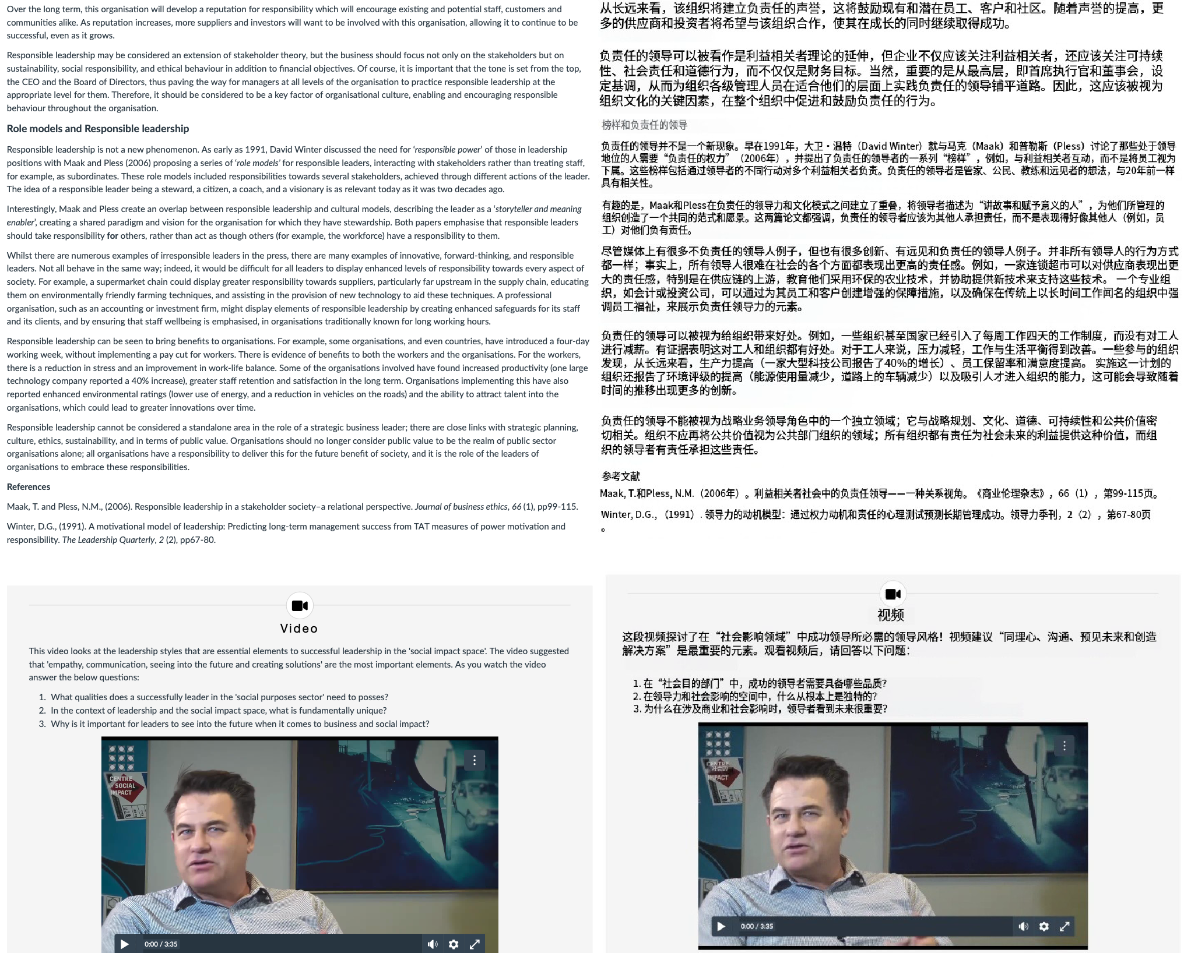

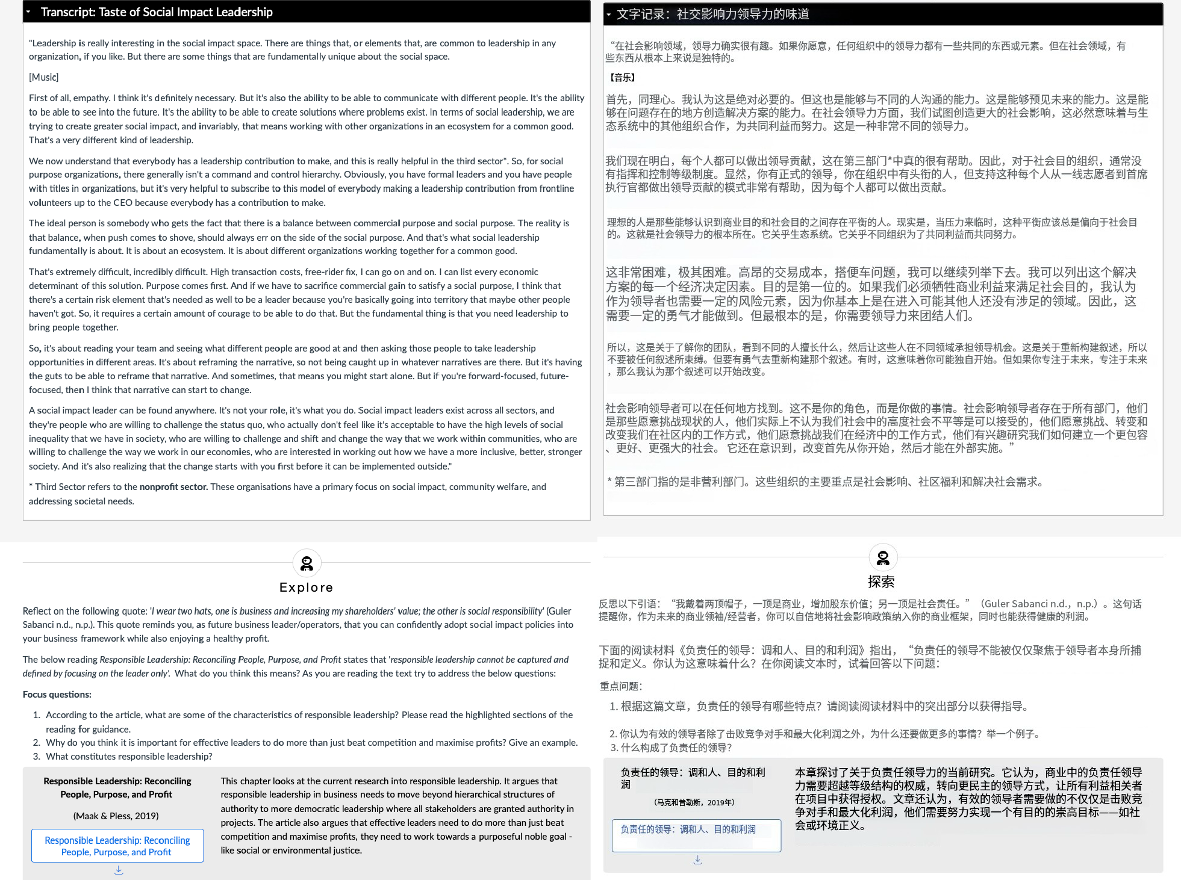

#### Characteristics of Responsible Leadership

According to the article, response ale leadersnip is characterized by the following key features: Relational and Ethical Nature

+ Responsible leadership is defined as a relational and ethico I phenomenon, occurring in social intero ctions with stakeholders who are offec ted by leadership (Maok & Pless, 2006a).

* + It emohosizes building ethically sound relationships with diverse stakeholders, not just subordinate s (Maok & Pless, 2006b).

Multilevel Approach

* + Responsible leadership operates ot individual, team, organizational, and societal levels, oddressing

##### responsibilities across these dimensions.

It requires relational intelligence, comb ining emotional, social, and ethical intelligence (Pless & Maok, 2005).

Purpose-Driven Leadership

* + Leaders must focus an a compelling and credible purpose thot enpopes stakeholders and olipns witn legitimate societal goals (Dona Idson & Welsh, 2015).
  + Examples inc lude visions lake ””"Advancing humanity through so+two re ' (Atlassian) *” or ”'" Making poverty

history™ (The Worl d Bank)””.

Four Key Roles of Responsible Leaders

1. Visionary — Providing a meaningful direction beyond profit (e.g., sustoinability, social impact).
2. Servant — Prioritizing the growth and well-being of others (Greenleaf, 1977/20 02).
3. Citizen — Acting as an engaged, ethical member of society, contributing to justice and human rights.
4. Steward - Ensurin g long-term sustoinabJlity for future generations (e.g„ environmental responsibility). Accountability and Trustworthiness

+ Responsible leaders must oct with accountability, aligning decisions with moral and societal expectations.

* + they must build trust with sto keholders, given the current crisis of legitimacy in business leadership (Edelmon Trust Barometer).



##### Importance of Leaders Doing More Than Just Maximizing Profits

Why It Matters

* + Societal Expectations — Stakeholders increasingl y demand thaI businesses address human rights, climate change, and social justice (young, 2011j.
  + Legitimacy & Trust - Leooers who foe us solely on profits risk losing puolic trust, as seen in scondols like Enron ond the 20 08 financial crisis.

Sustainable 5uccess - Componies with a noble purpose (e.g., Potogonio's environmental mission) often

achieve long-term loyalty and resilience.

Example

* + Potogonio (" We exist as a busine ss to nelp solve the environmental crisis") demonstrates thot profit and purpose co n coexist. By p rioritizing sustainability, it has built a loyal customer base while maintaining prof itabilitv

1. **What Constitutes Responsible Leadership?**

Re sponsible leadership is defined by:

1. Ethical and Relational Foundations
   * Leaders must oct with moral integrity, considering the impact of decisions on all stakeholders.
   * It is not just about influence but about ethical relotionships with employees, customers, ond society.
2. Stakeholder Orientation

+ Moves beyond the leader-follower dyod to include multiple stokehol ders (employees, communities, regulators).

* + Requires relotionol intelligence to manage diverse interests fairly.

1. MultidimensionoI Responsibility
   * Individual level — Values, virtues, and ethical decision-making.







?o





(Pless & Maak, 2005) »





* + Organizational leve—l Linking CSR, stakeholder theory, on d leadership.



H

H

* + Societal leve—l Addre ssin g cultural and systemic ch olleng es (e.g., climate c honge, inequality).

1. Development of Respensible Leaders
   * Leaders ore mode, not born - they must be nurtured throug h education, service-learning programs, and ethical troining.

Requires cognitive, emotional, and beh oviorol development to integrate responsibility at all levels.



1. Alignment with a Noble Purpose
   * Leaders must define and pursue a meaningful vision beyond financial success.
   * Example: The World Bonk's mission (“ Making poverty history“) aligns business success with gloool welfares

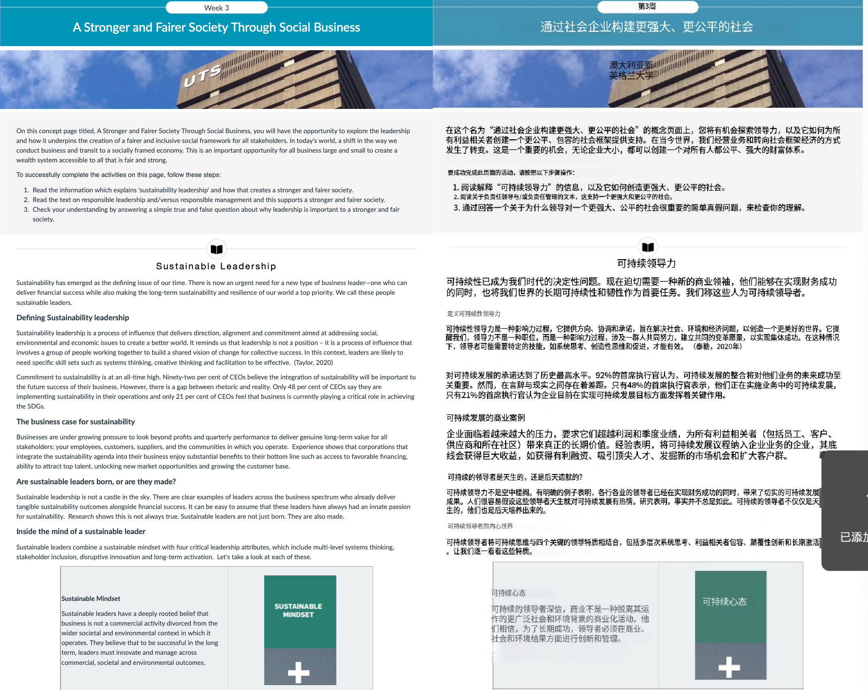

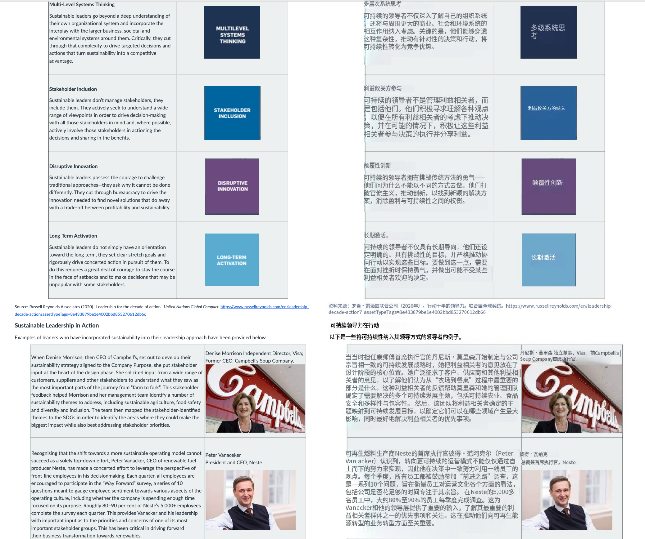

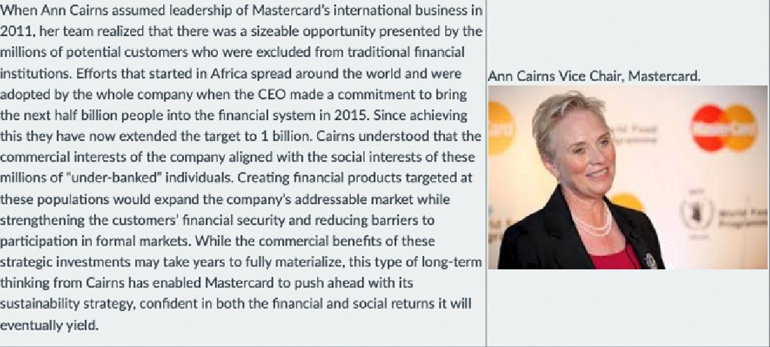

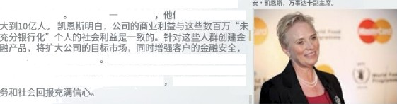

Exp lore

Aesponsible leadership has now beœme a laadlng tienne in the research that undeccores 21"œntury social ImpactsfrcmmvorI‹s. Responsible leadership, as suggesied inII+e /ôIIowing article, undergins an etfilcal <orgo«cæ culture. Respo«clble lezderchip is crucial in adaressing stich thir\gs as tnnsparency. climats change mitigcrion and gender eouality through cheir operatior›s.

* + 1. Reer to tne n@hgmed secôocs the te›‹t and answer: what skiiis to leaders need to possède to oct responsibiy in giobai business



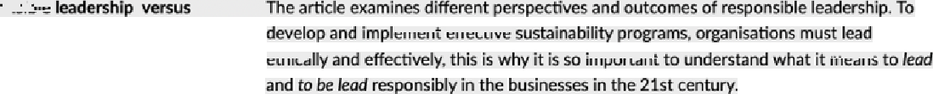

1. Skills for Responsible Leadership in Global Bueineas Leaders need:
   * Cultural emarta: Understand and respect different cultures.
   * People skills: Build trust with employees, customers, and communities. Adaptability: Adjust strategies to fit local needs while keeping global ethics.

a Ethics: Make fair decisions that help society, not just profits.

1. Three Levels of Responsible Leademhip

a Micro (Employees): Happy, motivated workers who follow ethical examples.

* + Meso (Company): Good policies (like fair wages) and a positive work culture.
  + Macro (Society): Trust 1'rom the publlc, better reputation, and solving blg problems (Ilke pollution).

1. How to Lead Ethicelly for Sustainebility
   * Walk the talk: Leaders muH act responslbly first.
   * Good rulee: Clear policier on ethics, environment, and fair treatment.
   * Listen to everyone: Balance pro5ts with what‘s best for workers, customers, and the planet.

a Train leaders: beach them to care about people and long—term sucoess, not just short—term money. Simple takeaway- Be fair, think long-term, and care about people and the planet.







2.6 (vo•atiin •t ai., 2o12J bilan. ztaBfiitssîiñi naina* • “6IaIaB" zî “eBsB' 08Jæ+I-'a?







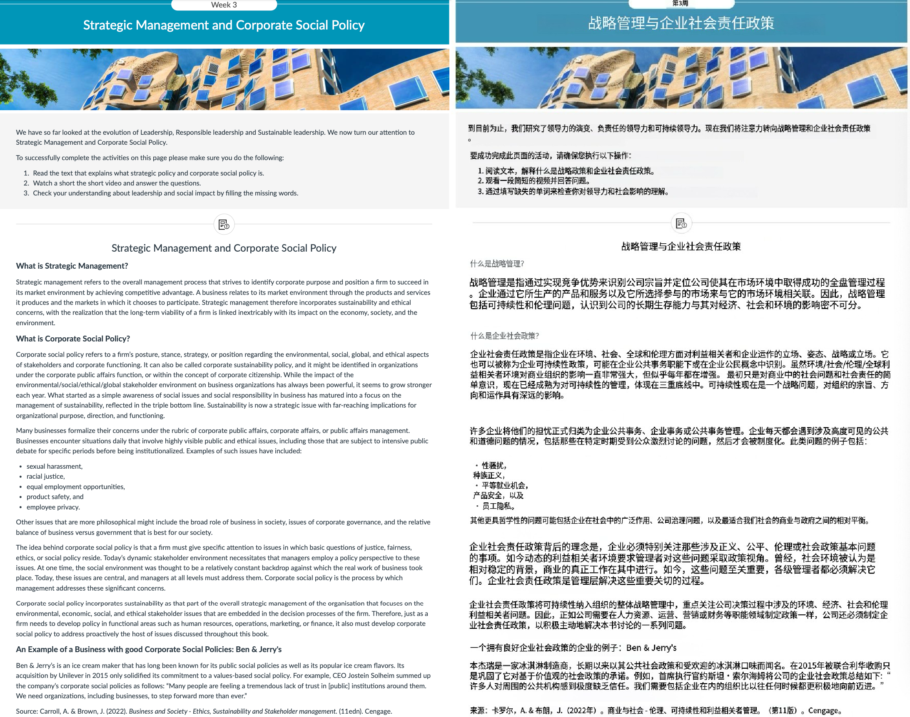

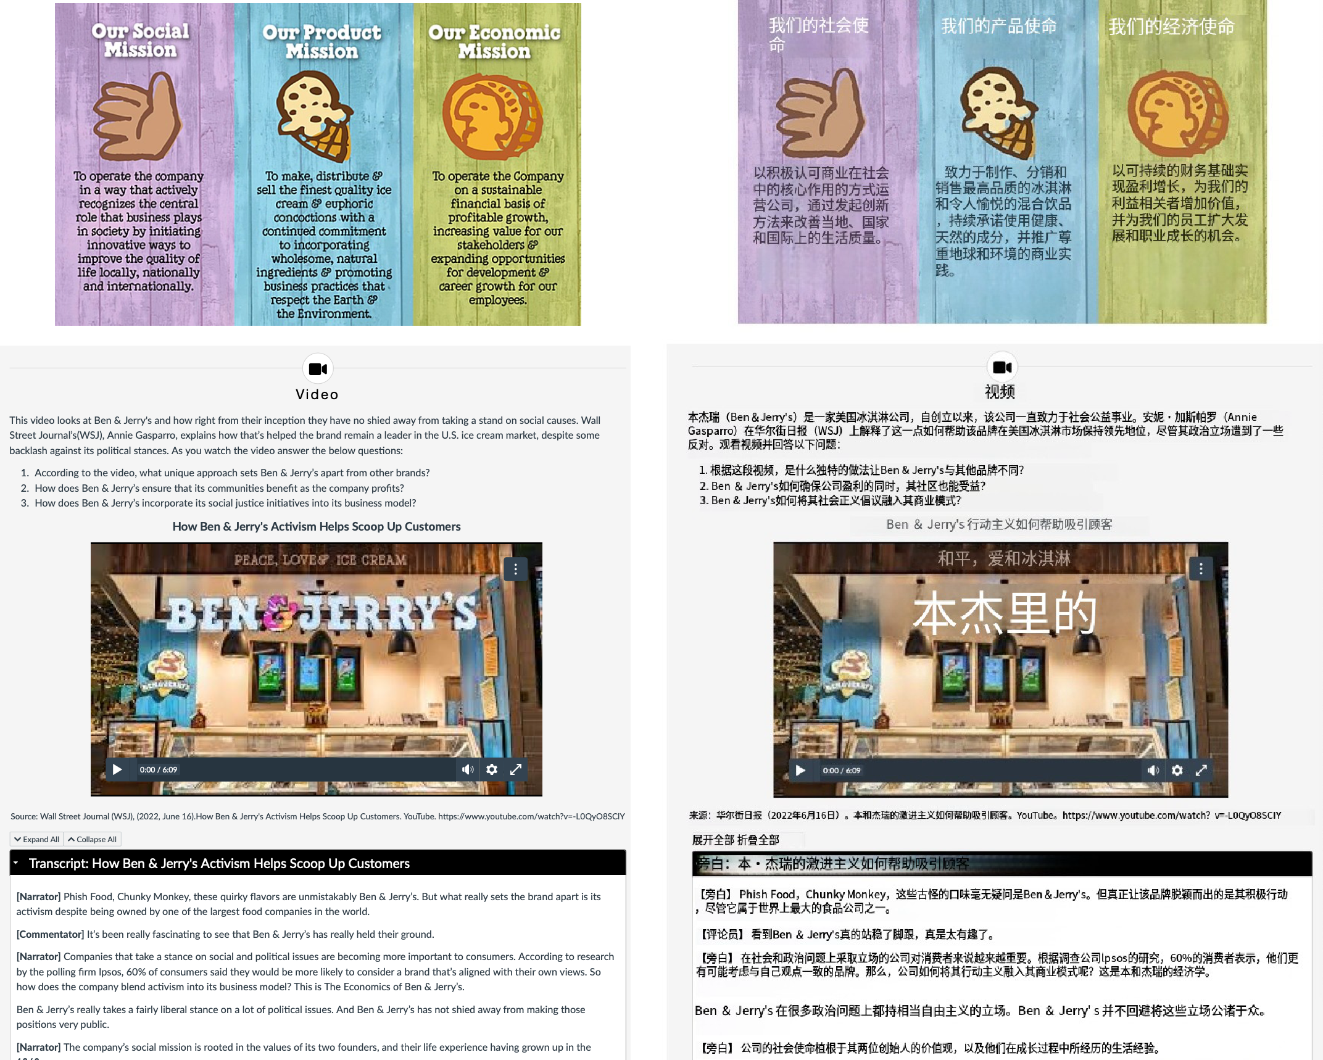

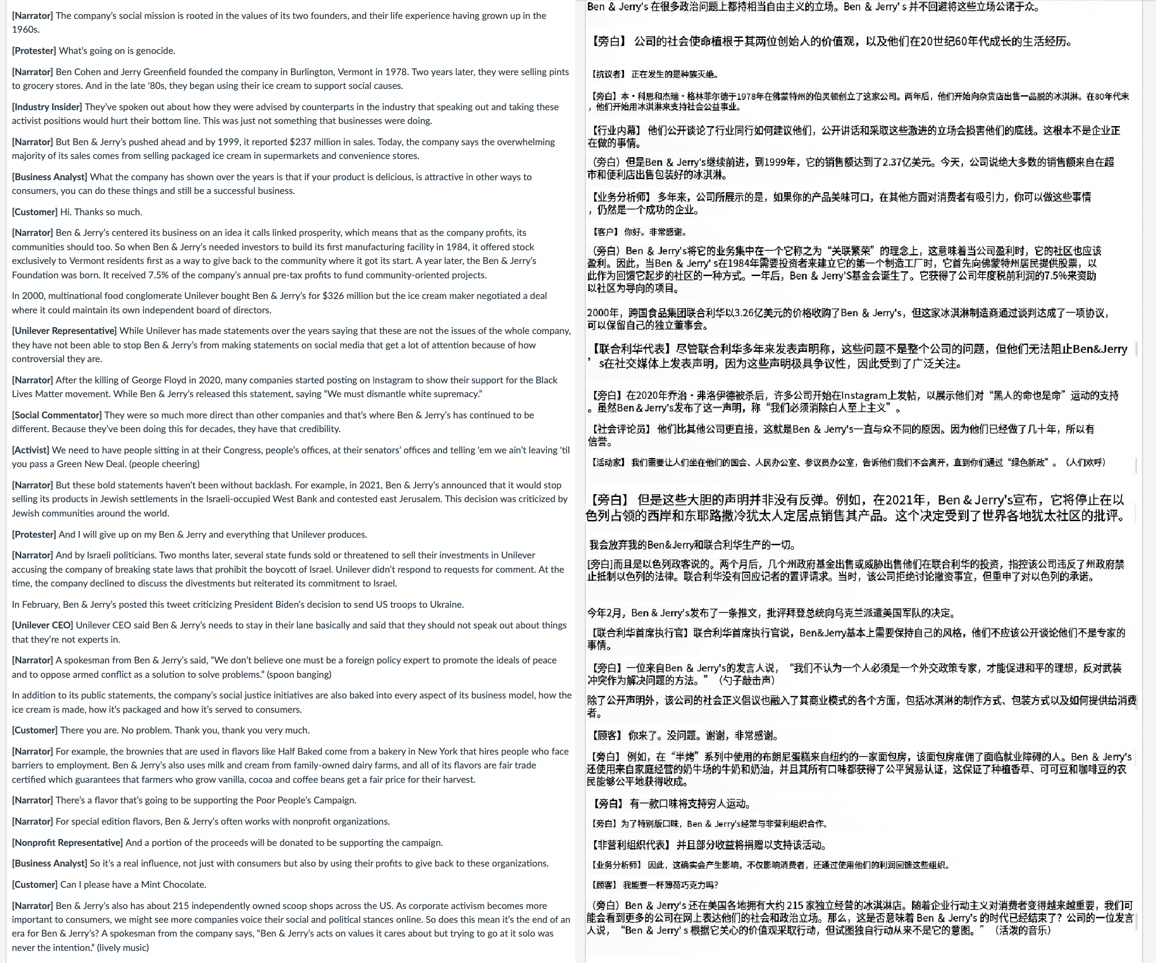

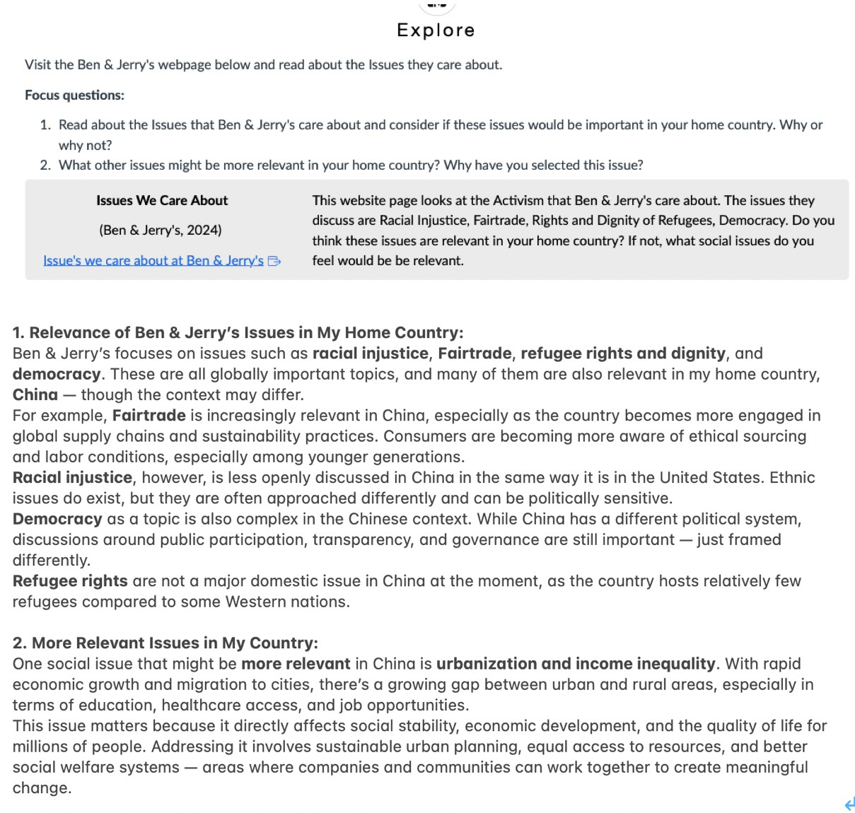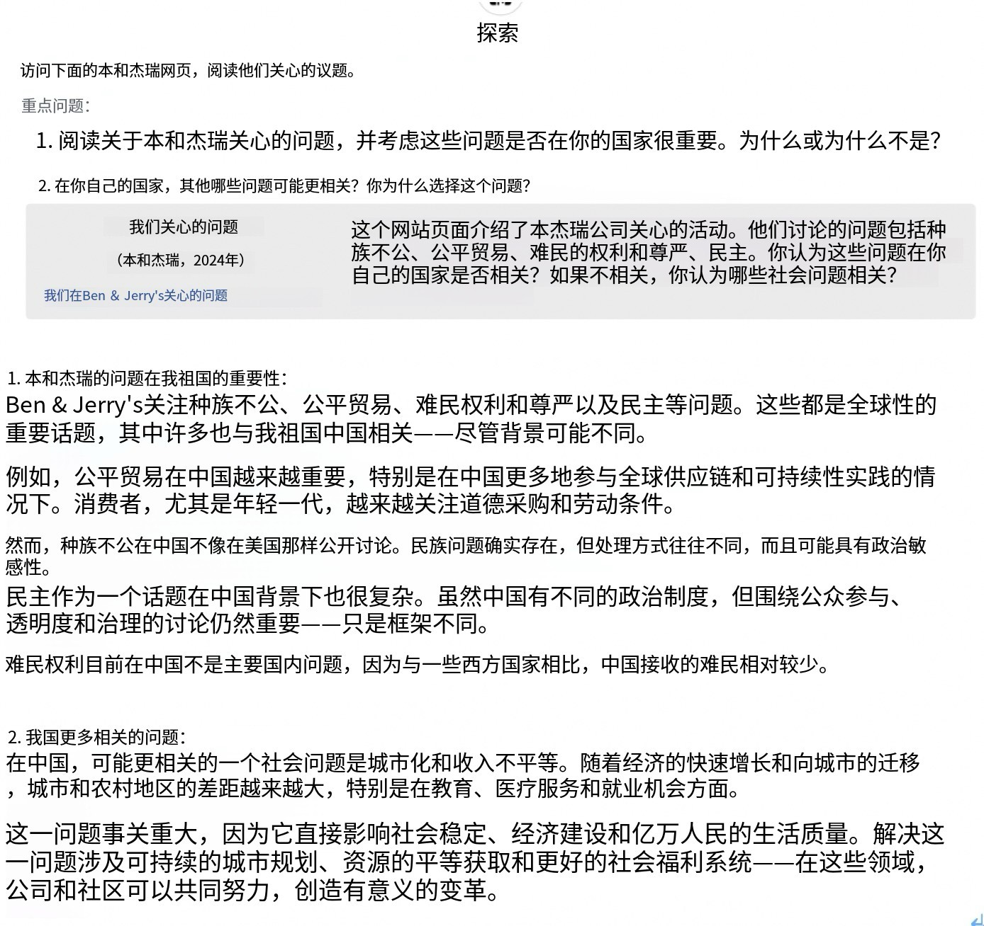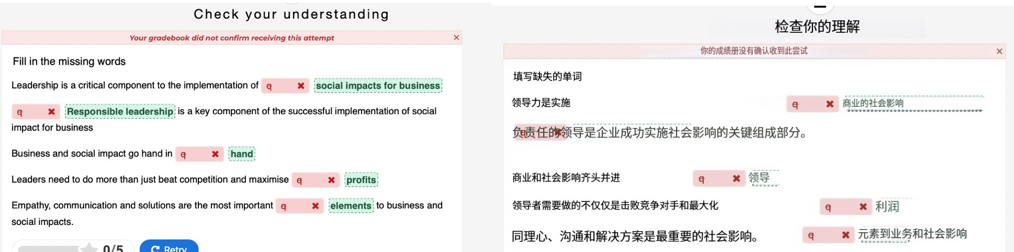

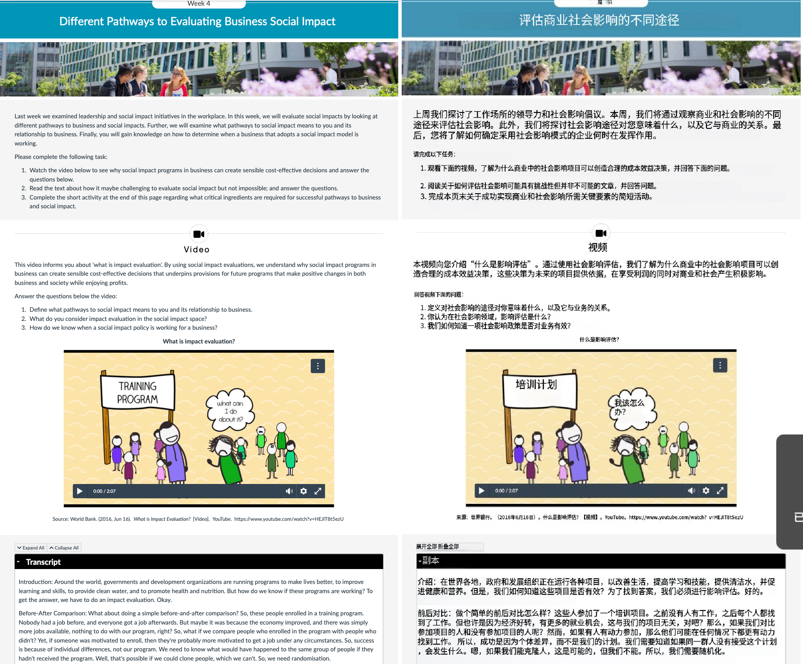

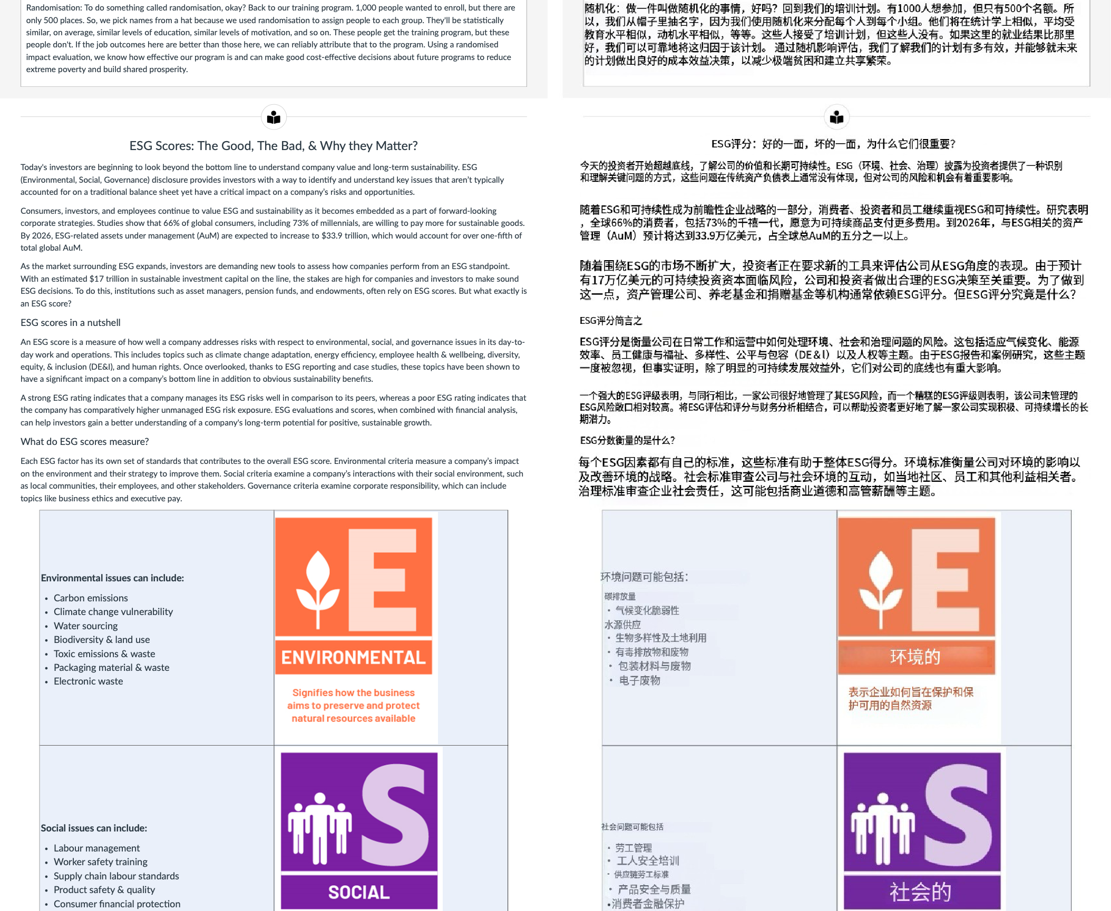

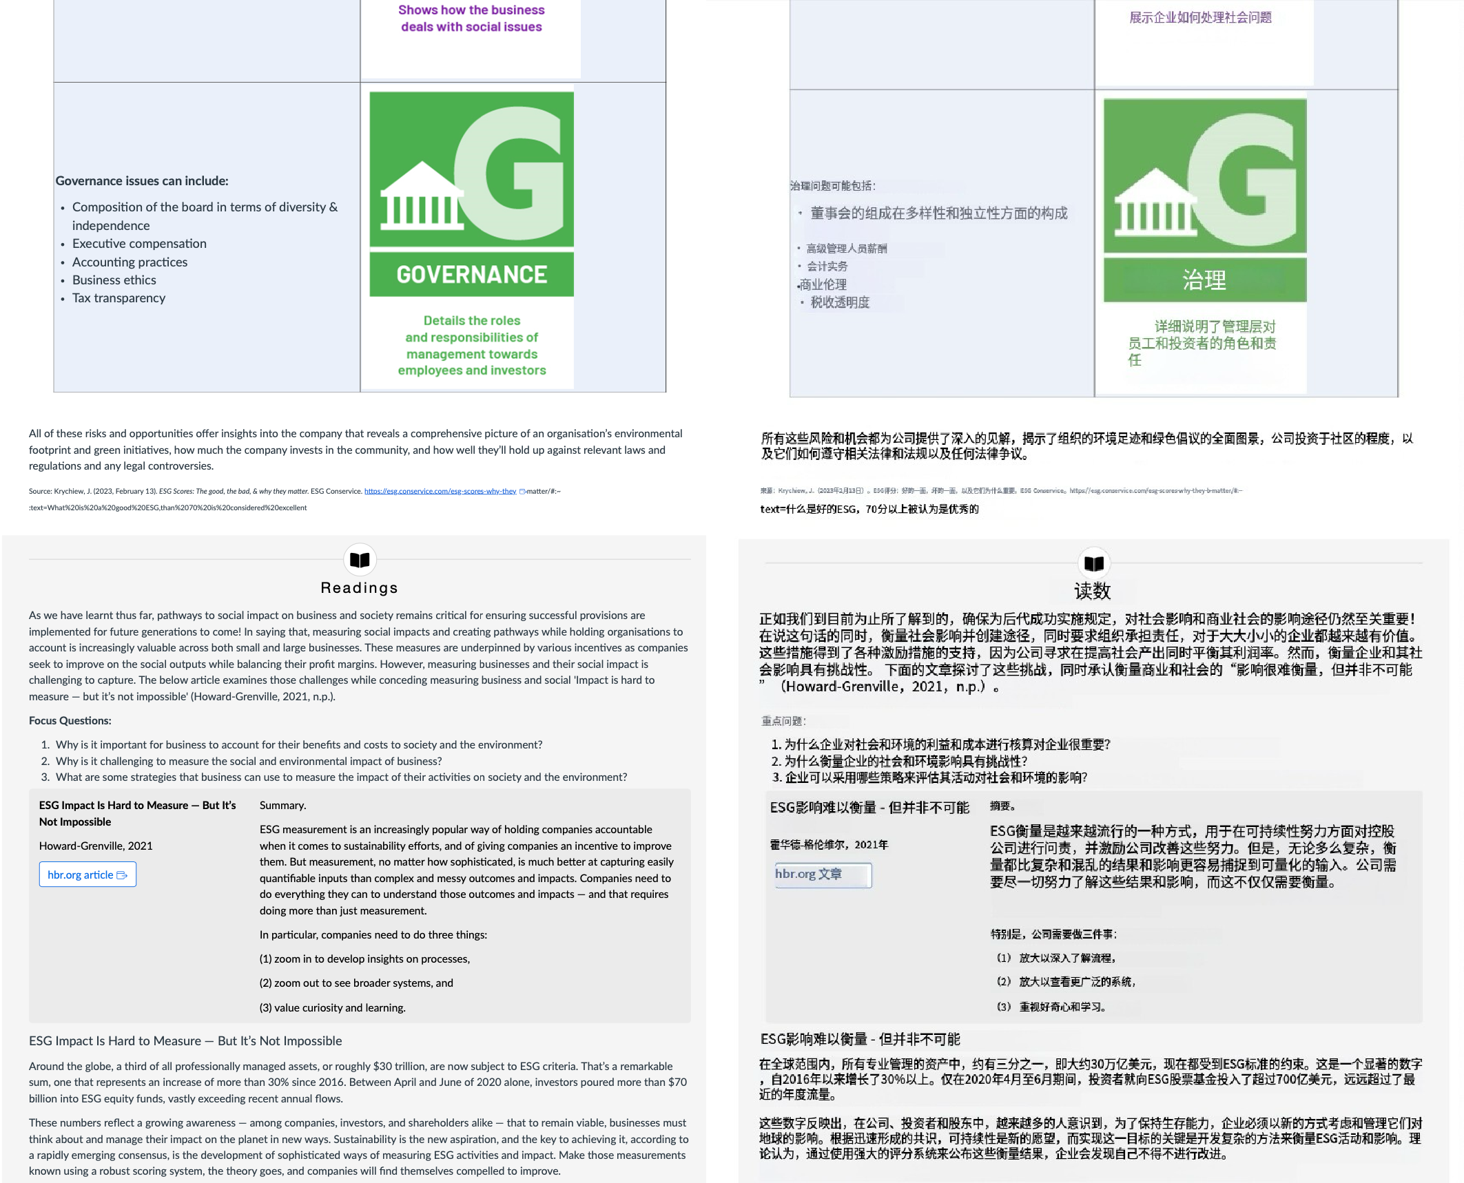

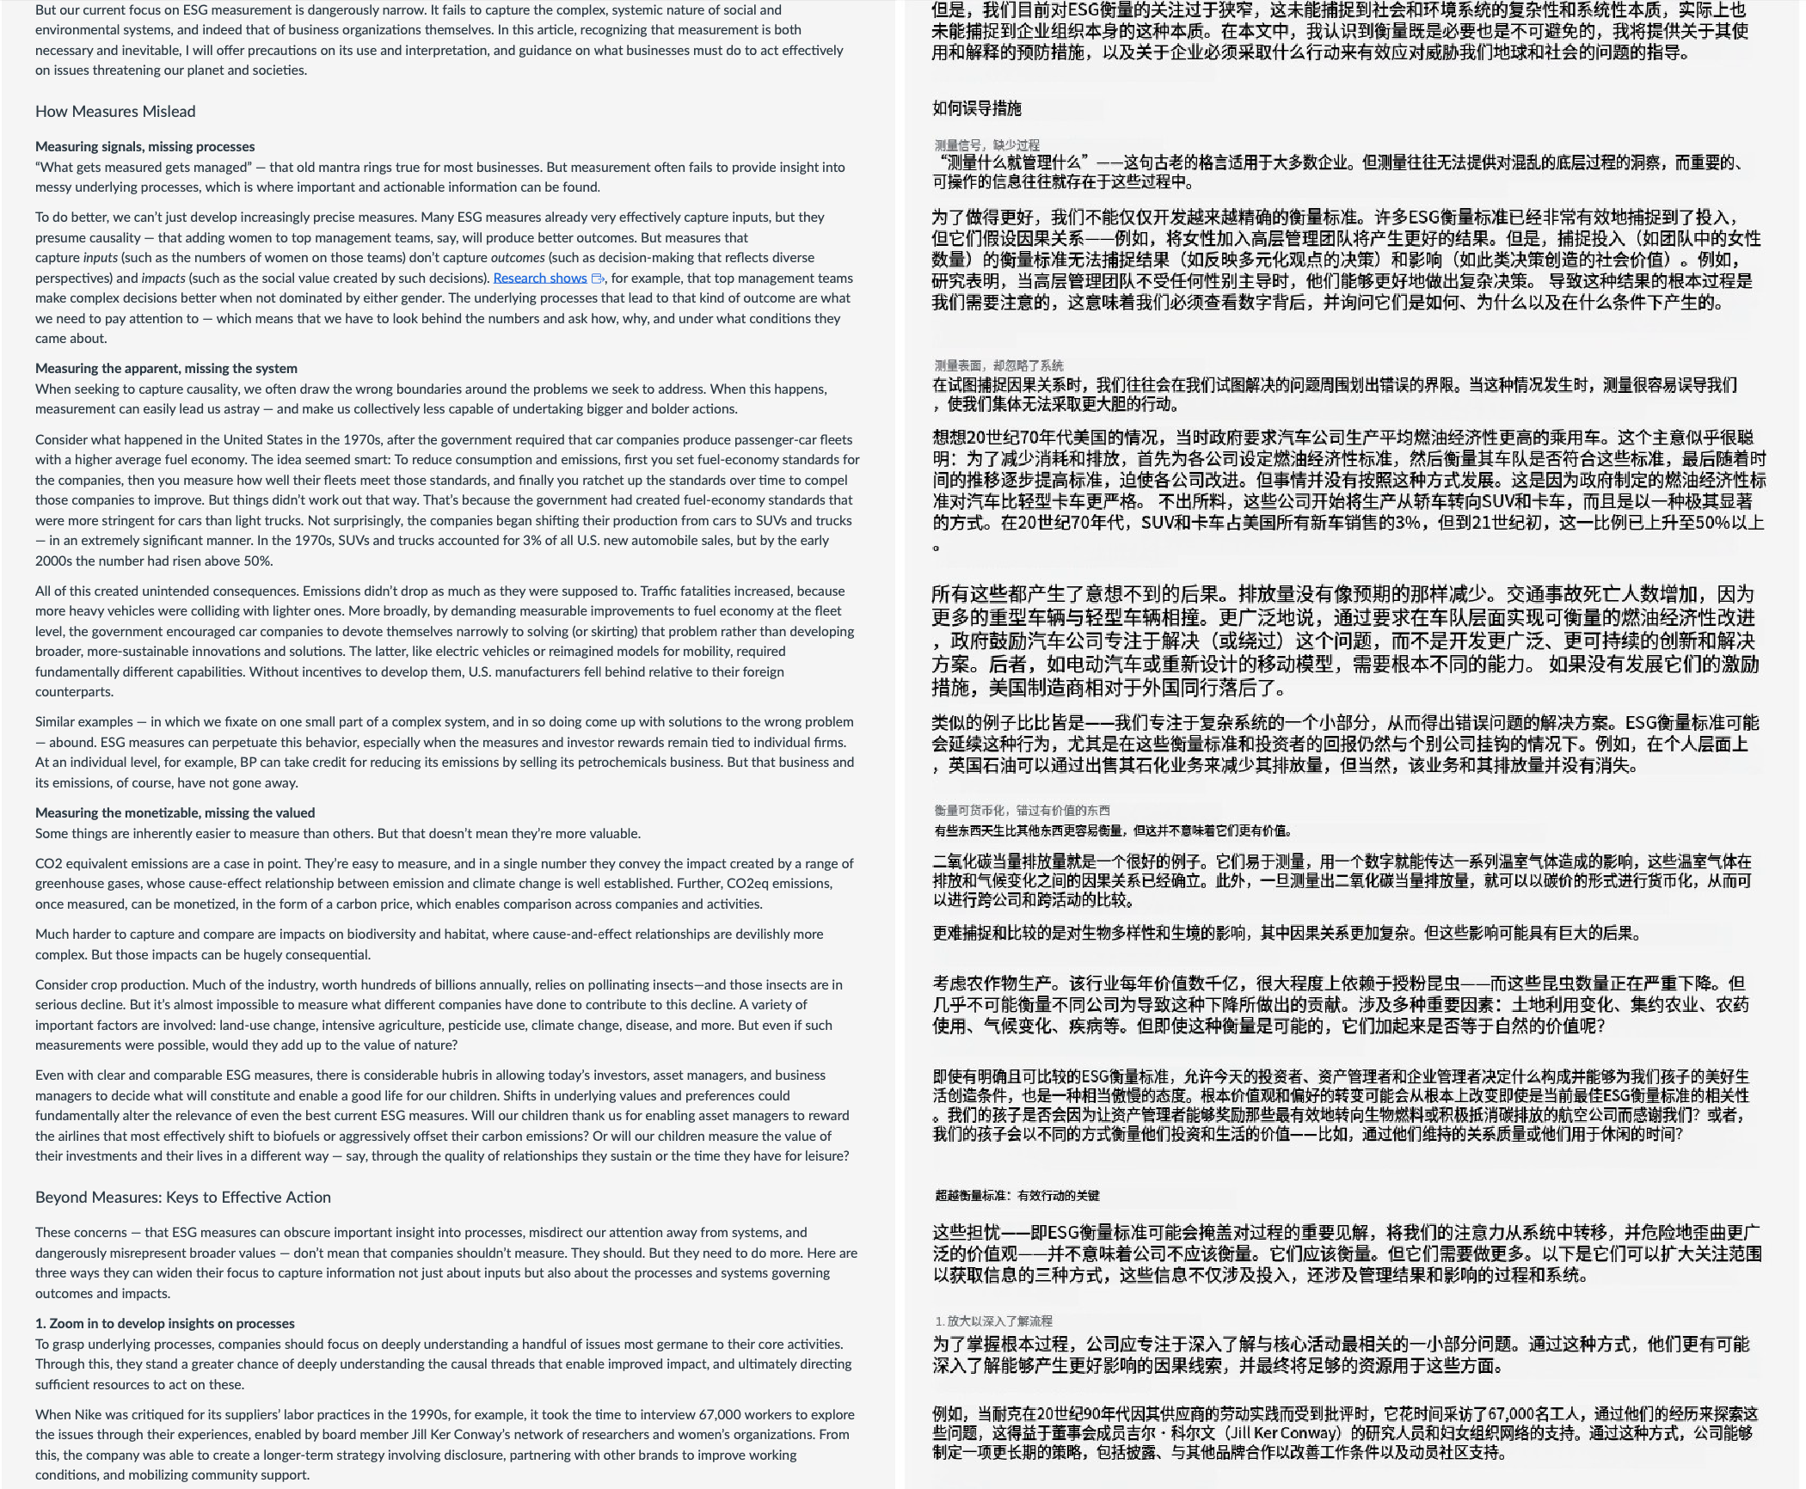

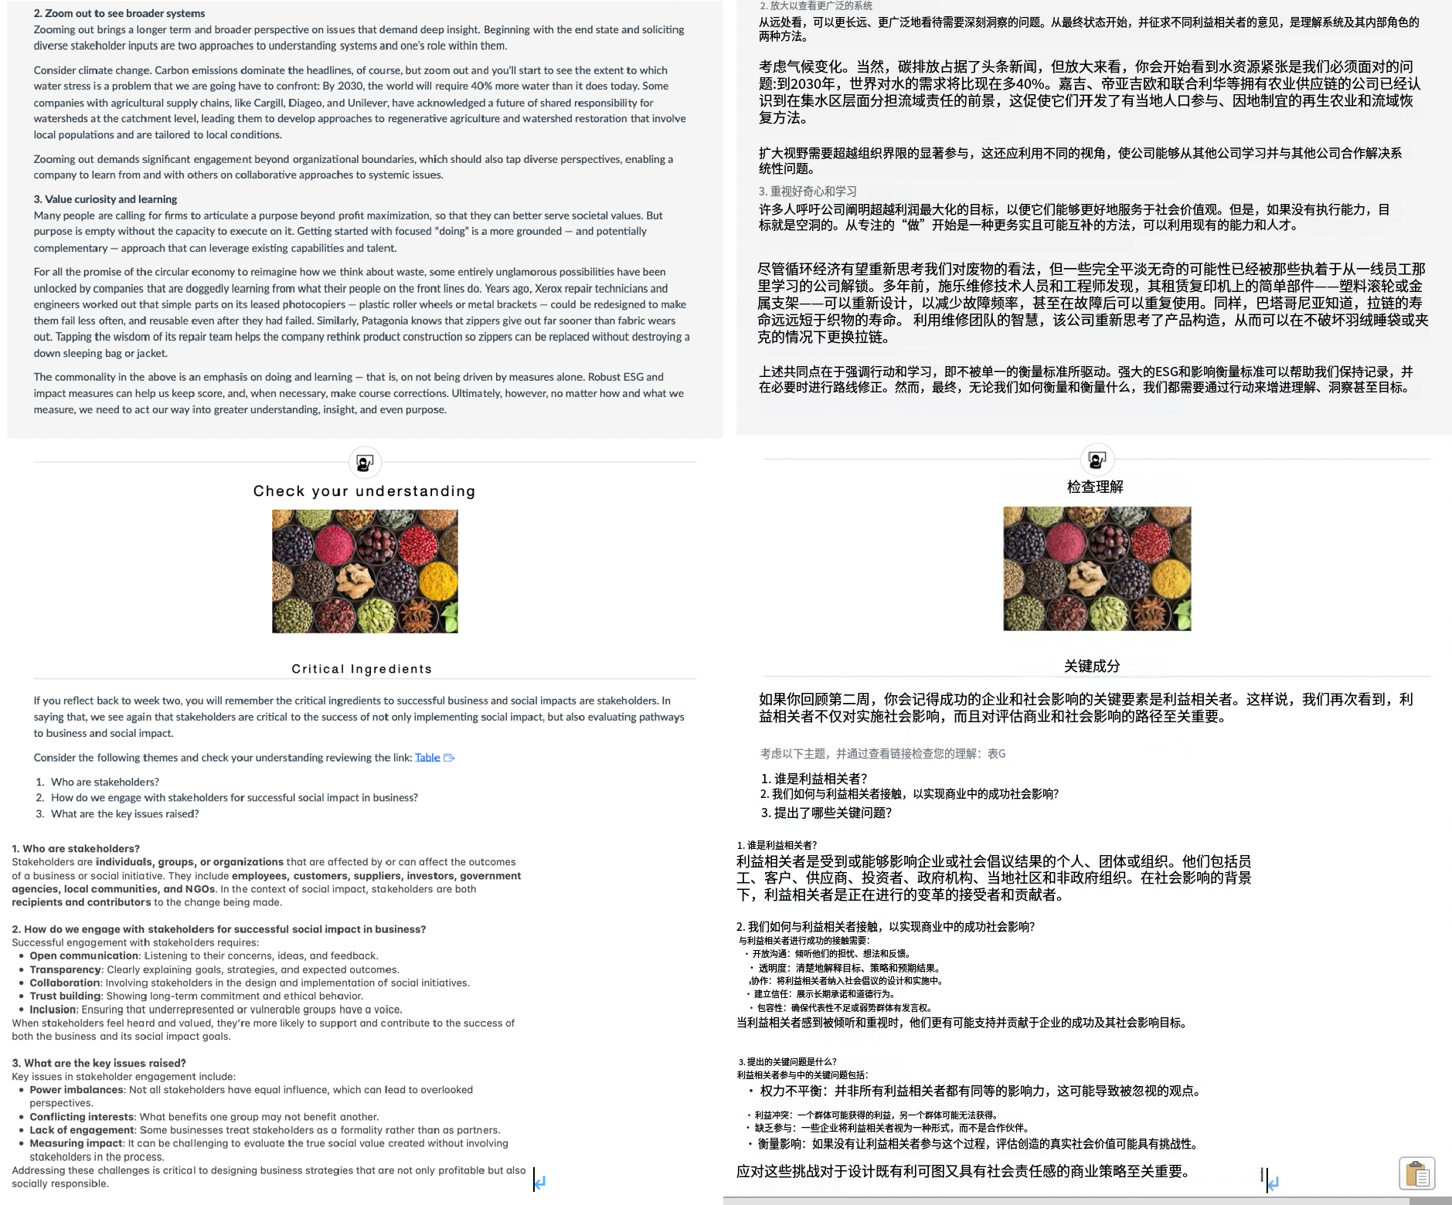

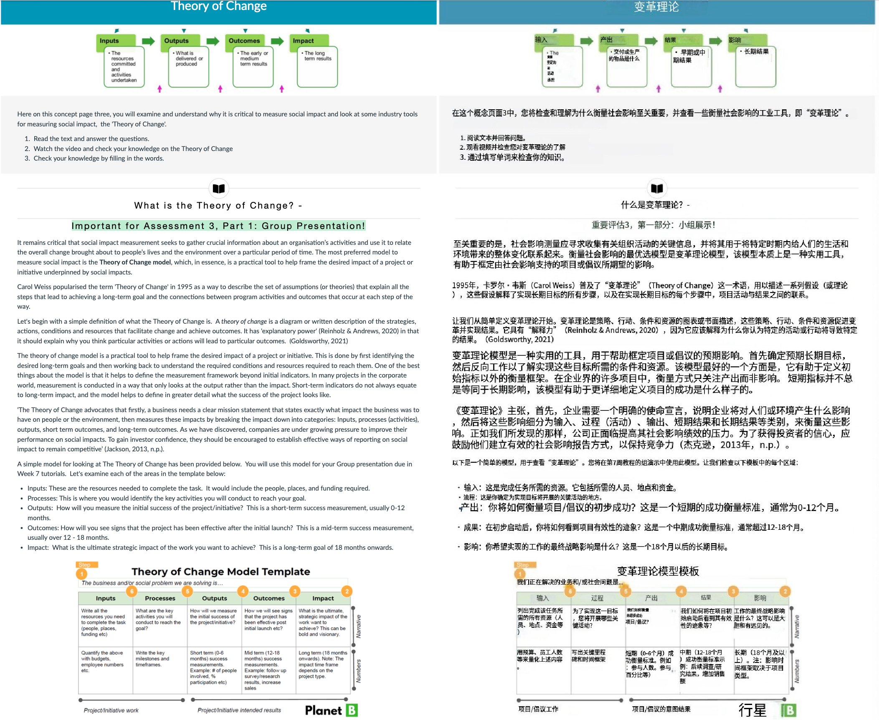

An example on how @ apply the Theory of change model to yaur Group Presentation is available in the video below. Please watch the short video below and use the information to assist your group when you work on the Theory of Change in class this need

## How to complete the Theory of Change

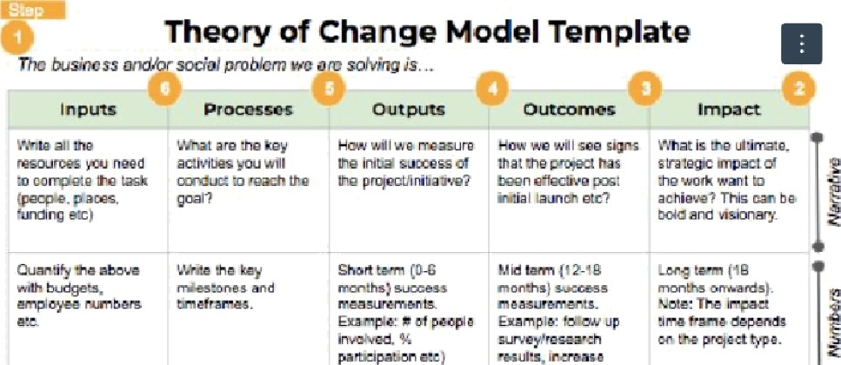

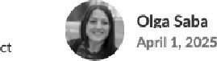

How to complete the Theory of Change

###### Video

An example on how fo apply the Theory of change model is available in the video below. Please watuh the short vfdeo below and pay attention to the manner in which the impacts from the activities on the ‘Rooftop Garden Project’ are measured. Mile watching the video

I. In the context of the ‘theory of change’ how are the activities in the video on the ‘Rooftop Garden Project’ being measured*

1. How does ‘organisation. ac fivity, output and outcome’ relate to ‘social Impact’ and business*
2. How do you actually use the theory of change to measure your social impact’



›arzxa»xizit











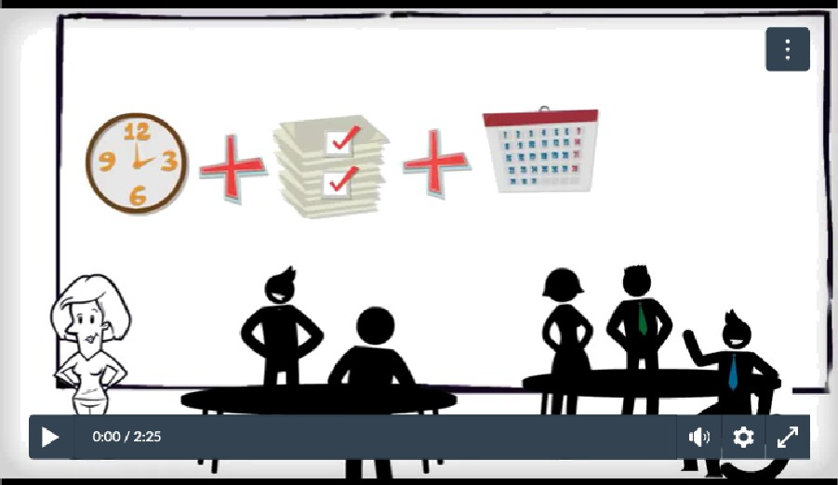 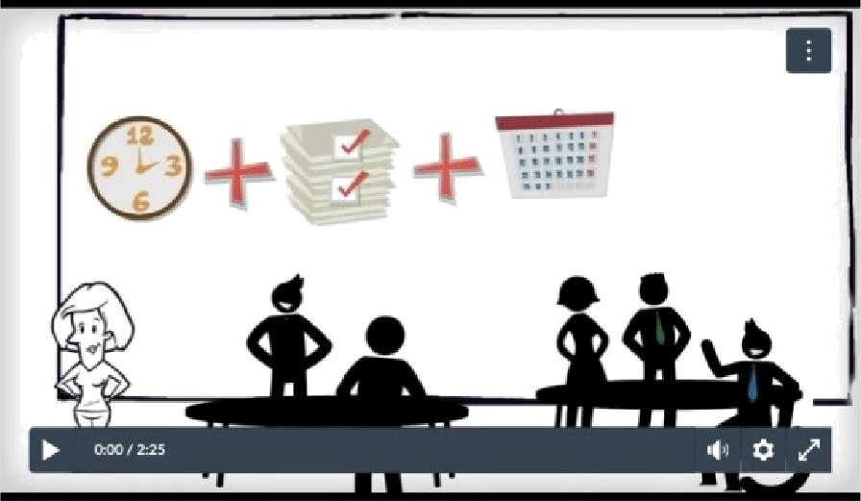

Source: Social Investment Business. (2014. Feb 4). Measuring your social impact: Theory of Change. {Video]. YouTube. https:/youto.be/dpb4AcTsa4u

@@J t @Jg'@kk . (20I4@2,I§4EI) . tb&|/|T$\|ttp @: @ @. [Ql@3 . YouTube. https://youtu.

**be/dpb4AGT684U**

v w»a <i • aiaea a

##### Transcript: Measuring your social impact: Theory' of Change.

“So. what exactly is the theory of change or impact chain’ Well, the theory of change forms the backbone of arTy social imput measurement system and is massively useful. It's basically a visualization of how tI‘ie day-to-day xtivities of an organization relate a tI‘ieiroveraII mission or long-term goals in tems of outcomes for the areas they work in. And it is key in deciding on what exactly should be measured in an



Well, that's tI‘ie theory of it, but how do you actually use it? Let*s use our favorite rooftop garden project to get started. IF you remember, the rooftop garden project worI‹s with people with learning disabilities. providing a space where they learn to garden in groups, giving them a



So, how should Theresa, the CEO, go about putting her theory of change down’ Well, in practice, it's best to do this activity in a group worI‹shoq because you need mukiple perspectives to get a complete picture. Get some staff. some trustees, some primary, and even some secondary beneficiaries involved if possible. For Theresa, that means getting group facilitators, gardeners, clients, carer, and parents to come to her workshop.

The first thing to do is to get down what the n›oftop garden project does on a daily, weekly, and monthly basis that contributes directly to their mission. Fdr the rooftop garden project, these activities are group gardening and training with Jients. and social events with died



The next part is to brainstorm on what exacdy these activities 6ring about in the beneficiaries. Theresa has seen that many clients have lose weight after coming on the program because of the physical worlc, so she mentions improved health a an outcome and weight loss as a medium-term output. A parent mentions that their child's sleep paMems are much beMer and they don't get woken up as much. A facilitator mentions that their clients have improved their Mness levels. So, why did these come about’ Because of the physical activity, which is due to the rooftop garden project running group gardening and training.



Another theory of change is that the program allows better relationships with Fiends and family. Why* Because tI‘ie client is less likely to throw tantrums and perform other types of antisocial behavior. Why is that? Because their so¢ial skills have improved due to the social nature oFgroup gardening and social even Also, the clients are more tired after a day's gardening and are less bored.



So, they have two examples of theories of change or impact chainc These both relate to the mission statement because they are providing a more full life for the persons with disabilities. which is part of the mission statement'



#### Chec k your u nderstand ing



Fill in 1he mi99ing word9



Measuring and g x /reponIng, on a budness's soci•I Impact 1s important for securlng investors There are proven q * "•. .!••., *’•=’ n epply broadly to analyse and improve many types of

A budness needs a clear q x ,mlaalon ststemant, that states exactly what impact the buslness was to hgve on peogle or the envlronment



 





#### 0/4

  



Important for Assessment 3, Part 2: Group Report - Evaluating Business &

Social Impact from Multiple Business Perspectives

@@t t@g,

; /j \é@}§@-}\

@ @

’/@@ $g/\@

As a future business leader, you should understand why pathways to social impacts is critical co evaluating business social impact from

1. Click on the link which will cake you to the Assignments page and read through the requiremeno for Assessment 3 Part 2 - Grouo

Renort Due Week B I gLA006

1. Read the information below on the Perspectives in relation to Business functions. This is relevant to Che body of your Group repon.
2. Review the slides which contain information on Che RerspecLives in relation to the Business functions. This information is relevant to Assessment 3 - Part 2: Group Report, due in Weel‹ 8.

Pe rs pe ct i ve s i n Re latai

n to Bus i ness Func tions - Important fa r Asse ss ment 3, \[|/ @ /@X@7g„.. - i¿‘(g3@E §Nj @@- zj *ft@@!

Part 2 - Group Repo rt!

|  |  |  |  |  |  |  |
| --- | --- | --- | --- | --- | --- | --- |
| Let's tdke a lOOk at tile Business areal and theiF rel8tionshig IO 5oCial img8CtS.  this iniormanon Is important farxs••••nmn a I•art a• spun aeoort oue week a | @// @@ gg @ //-/ @@@ @o  B .é Ti9fg3-@E@fi : ›J\@@ o-¥f1T-18/$|4kQB@ | | |  | | |
| When completing your Group report and answertng the Perspectives in relation to Business and Social Impacts, you will need to understand the | @7] \*@@p @@ p @/@ @/:zs;%8|9@j$,t,*1„,'@, }@@@ @ {\ | | | @ @ | @@@p @@@ | @ |
| bustness functions of Accounting, Economics, Finance, Management and MarI‹eLing and its relation to soctaI impact. Detailed tnformation on | §@@ | -|-@ 8|fj{]t}/ | @ j§j @@{}tj @ s @/, [ : /yjs!@tBp |}t|s @ ‘/@@@ @ | | | |
| each business area can be found below. [Rease note: You are encouraged to use the Information below when defining and exglalning key | @ g , | @ @ @@j j ¿// | @] | | | |
| concepts throughout your section of the Group reports |  |  |  | | | |
| The Five Business Perspectives for your Group Report |  |  |  | | | |

g Persoective

’Accounting is o technical, sociol and rriornl prnctice concerned with the sustsinoble *utilisoñon* ed*resource a*n*d proper* accountability fastakeholders to enable the gou/ir/ling oforgonirations,leap/e and nature." (cited in BACCOII Canvas page from Carnegie, Parker and Tsahuridu 2021)

Accounting can have social impacts by reporting on sustainability which can influence the decisions and behaviours of both internal and external zxj/@ J@ @ o @ @ @ zr@8@, @@ @*@@@@§ @@]@@/@@@ /o stakeholders.

Numerous sustainability reporting terms have developed over Time such as; corporate social responsibility{CSRI reporting. triple bottom line BBf4f•fl&Jg@ tdBltT T?&@ NE fi@. {§J8I: -'Ikttp dt -£ (CSR) {| “o § (TBL) @ @

{TBLI reporting, corporate sustainability and so¢ial responsibility{CSSRI reporting and environment. social and governance (ESG) reporting. 1J @ @ zs;@{- (CSSR) @“o L4/tf{'J§. {I IB (ESG) ]E o . (White et at, 2022, p.253

(White et al, 2022, p.2s3). The homework that will be used to look at the relationship between Accounting and social impacts will focus on ESG ), jg y@@ ¿-|-@tj- @yp/[ag/@@j g/ I}jy]@/ESG@“p. reporting.

The three frameworks that you need to consider when looking at the relationship between accounting and social impacts are SASB. GRI and ** * SA*Bs GRI TCFD. "* ° TCFD. Further information is available on each below.

* SASB (sustainability Accounting stanaards aoard): sASB standard.s e- enable organisations to provide indusoy-based disclosures about * SASB (é A =*† 1’* s : SASBT3 @@•'% ‹ TI & @THE o RI a^âTJ&B l• sustainability-related risks and opportunities that could reasonably be expected to affect the entity's cash flows, access to finance or cost of ”‘ ‘ !* ° (SASB** , 2024 )

‹apital over the short, medium or long term. (SASB standards, 2024)

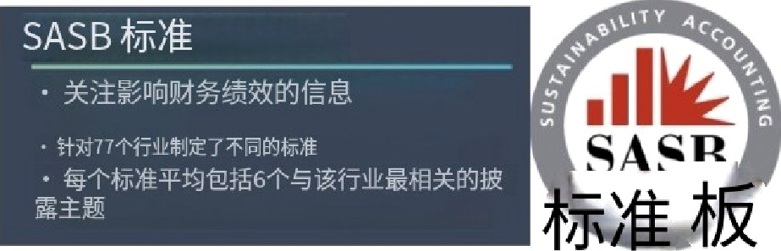SASB5audadsidenñ§thesusC%nabiligrelatedissuesmoflreévanCtoinveaordeGsion-makingin77industrieslSASBstandards,2024)

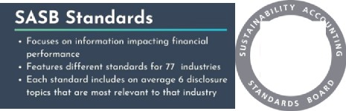

SASB

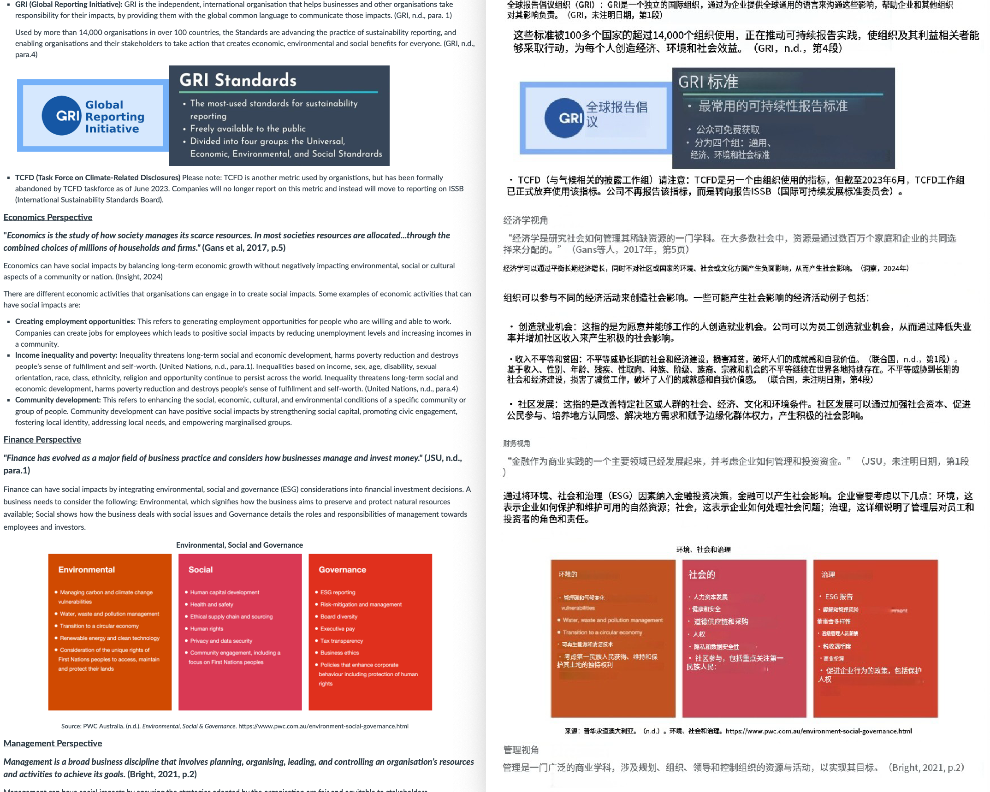

Manap ment Perspective

*****Management is a blood business* discipline tAot invo/ves planning, *or$anisi*rtg*,* leading, and contra/ling on *ofi$anisatlon's* res*o*u*rces* and activities to achieve its goals. (Bright, **2021, p.2)**

Management can have social iiripacs by ensuring the strategies adopted by the organisation are fair and equitable to stakeholders.



* Creating shared value: Creating shared value is a framework for creating economic value while simultaneously addressing societal needs and



* Dfvenky, Indusfon, Equality: These are three related but distinct concepts that aim to promote the fair treatment and Nll participation of all people, especially those 'ho have historically been underrepresented or subject to discrimination because of their background, identity, disability. (BBS01t: Week 5 - Equality, Diversity, Inclusion, 2024)



* Ethical practices: These are actions that conform to moral principles or standards of conduct that govern an organisation*s behaviour. Ethical practices can have positive social impacts by preventing corruption, ensuring fairness, respecting human rights. protecting privacy, and promoting integrity.



* Sustainability: This is the ability to meet the needs of the present without compromising the ability of future generations to meet their own needs. IBrundtland Report, 1987)

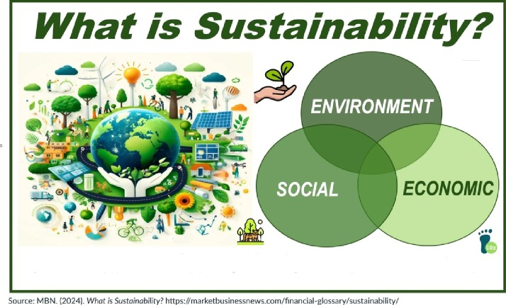

***The Practle of Weetln$* Orr Crrrent *Reedf*** wftnout Compromising the Af›iiity of futrre *Generations* to fleet theirs

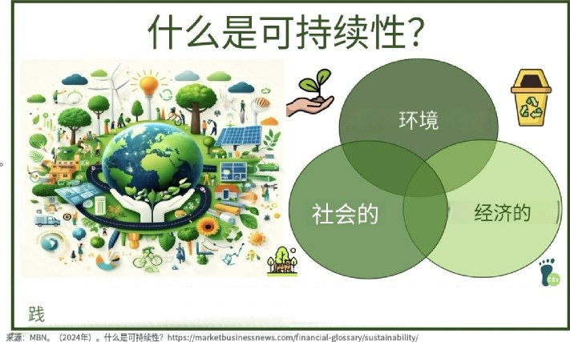

Marketir\g Perspective

**"Marketing is the process *of cm.otia8,* delivering,** and excñongirtg **value** far **customers, dients, partners, and society at lodge."**

fEiiiott et ol, J0J«, p.J)



* Cause-related marketing: Cause marketing is a type of marketing where organisations partner with non-profits and charities to support a good cause while raising their public profile. It's a collaborative type of marketing that relies on mutual input from both the profitable organisation and the non-proht organisation. tElliott et at, 2023, p.287)
* Corporate social responslbtlky (CSRI: this is a self-regulating business practice that requires the organisation to act in the interest of the societies that sustain them, through delivery of overall positive impact. Business needs to act ethically, lawful and in the interests of all stakeholders. (Elliott et at, 2023, p.12)



* Social marketing: is the adaptation of commercial marketing technologies to programs designecl to influence the voluntary behavior of target audiences to improve their personal welfare and that of the society of which they are a part. {,Andreasen, 1994, p.110)